# C#

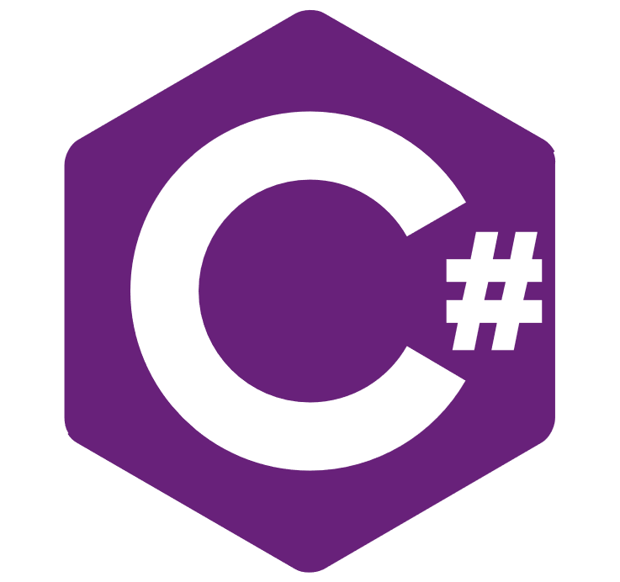

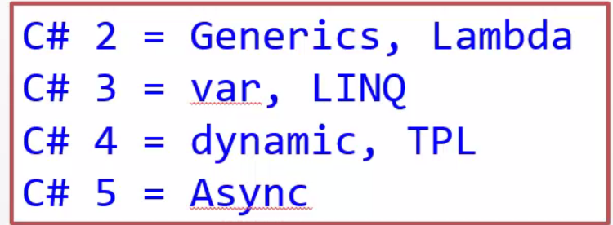

## Basics

### Binaryk Operation

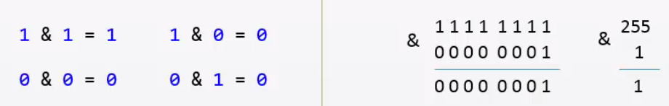

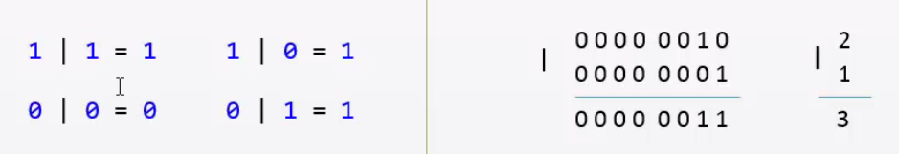

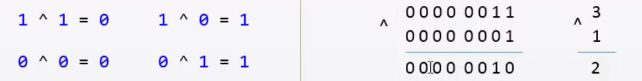

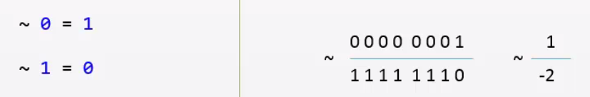

N= ~(-N)+1

test

### Variables

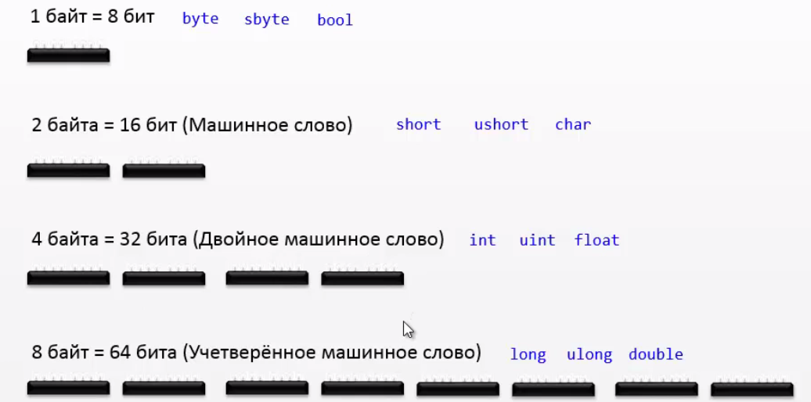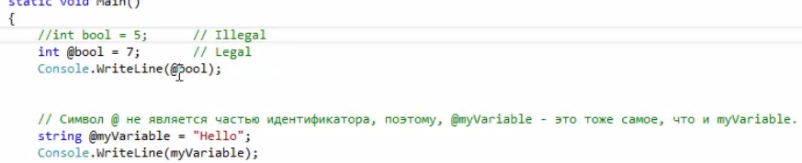

### Naming

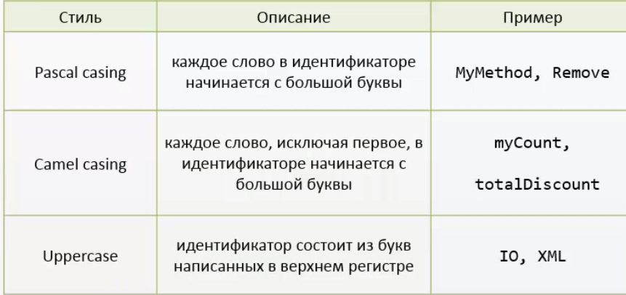

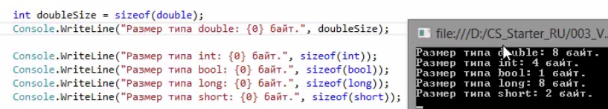

### Methods

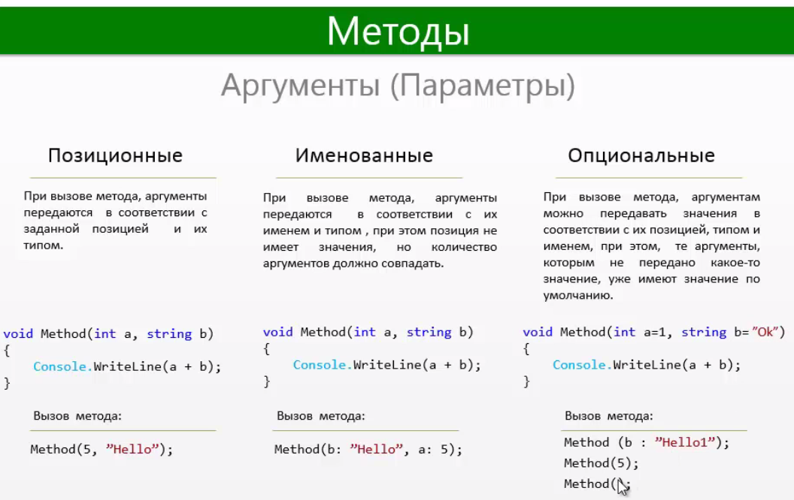

#### Extension Method

The Methods that can be used to extend existing class very useful

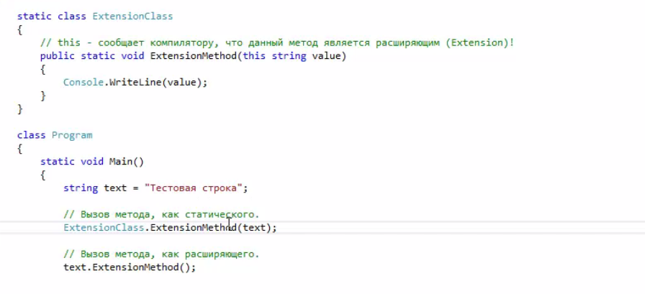

### Nested Class

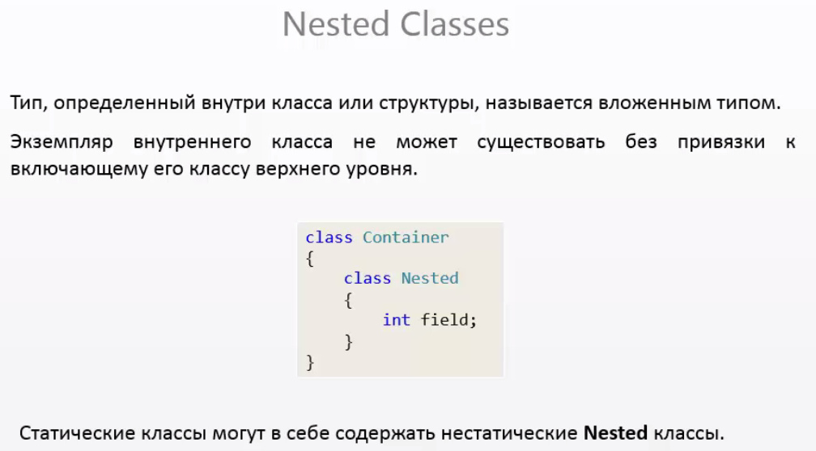

### Delegates

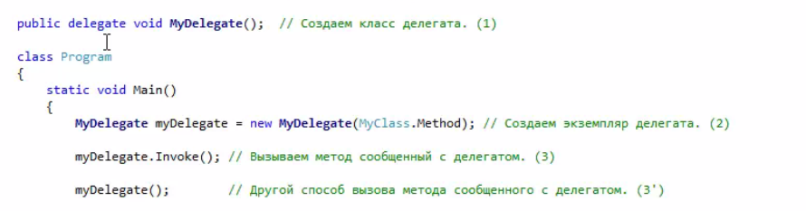

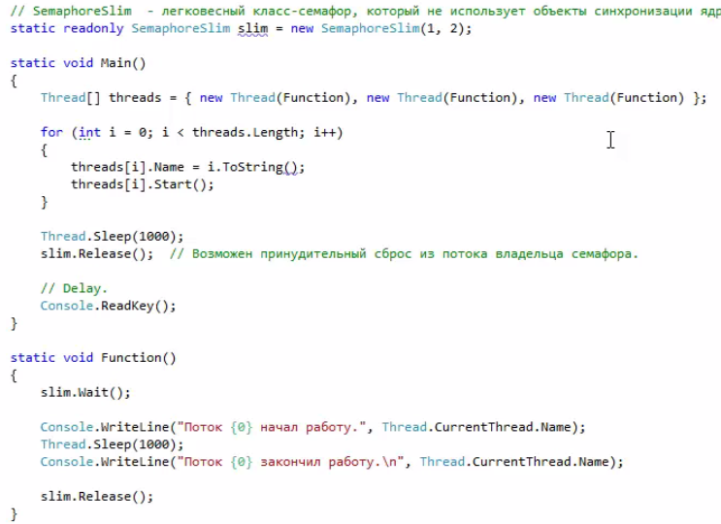

#### With paramethers

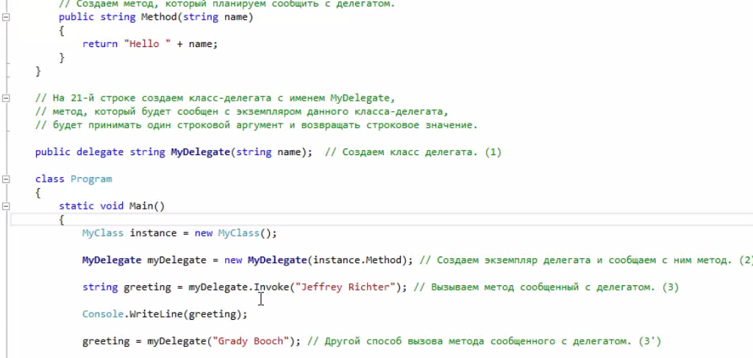

#### Multi Delegate

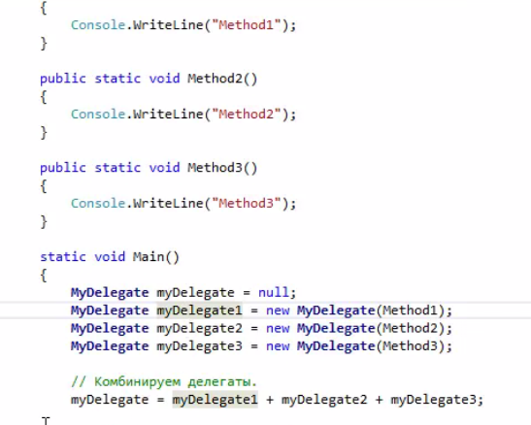

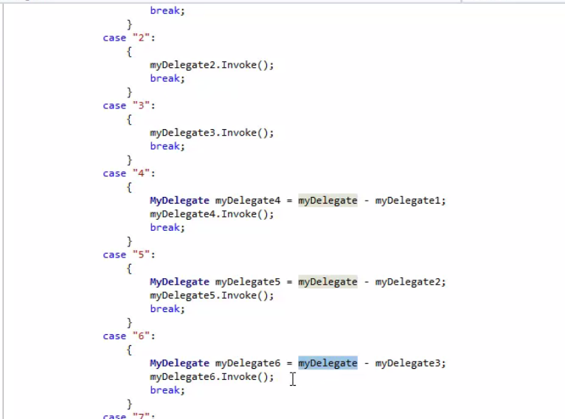

#### Unity example of Multi Delegates

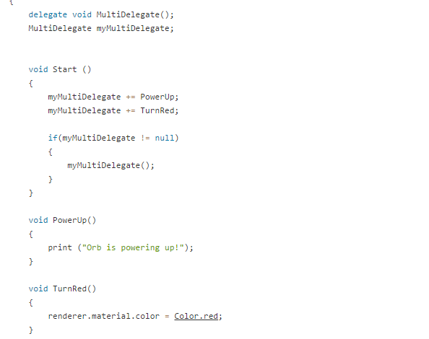

#### Anonymous method



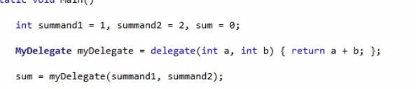

#### Lyambda

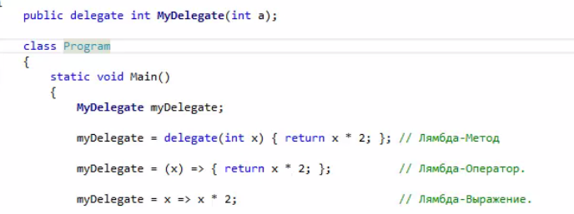

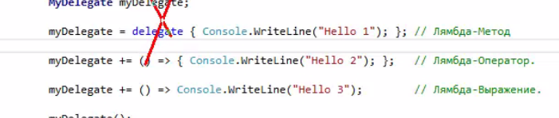

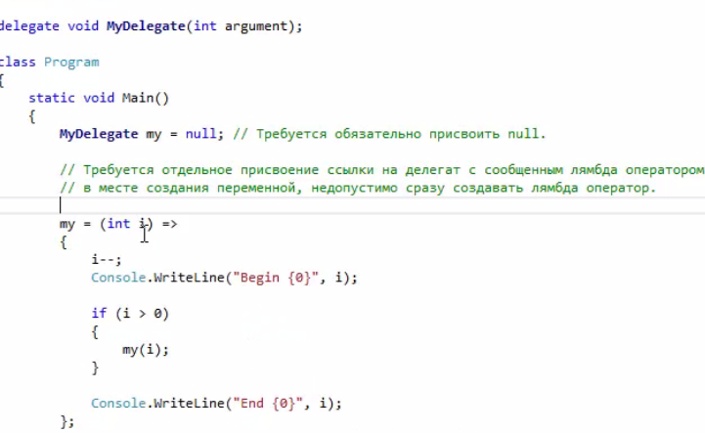

### Events

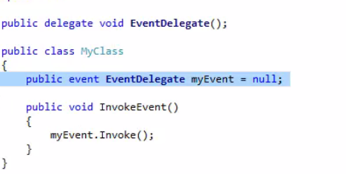

#### Control add and removing delegates on events

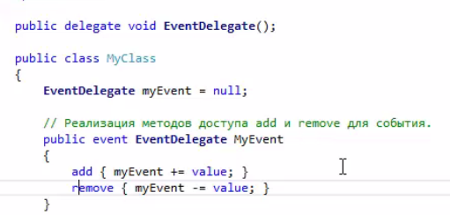

#### Add delegates

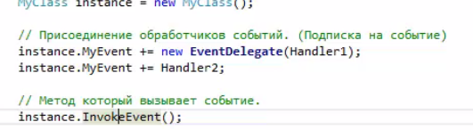

### Serialization

#### Binary

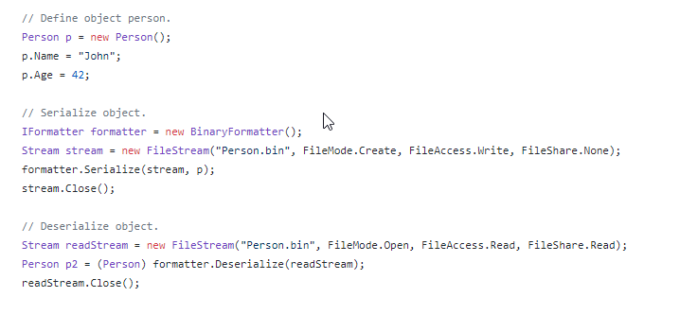

### MVP

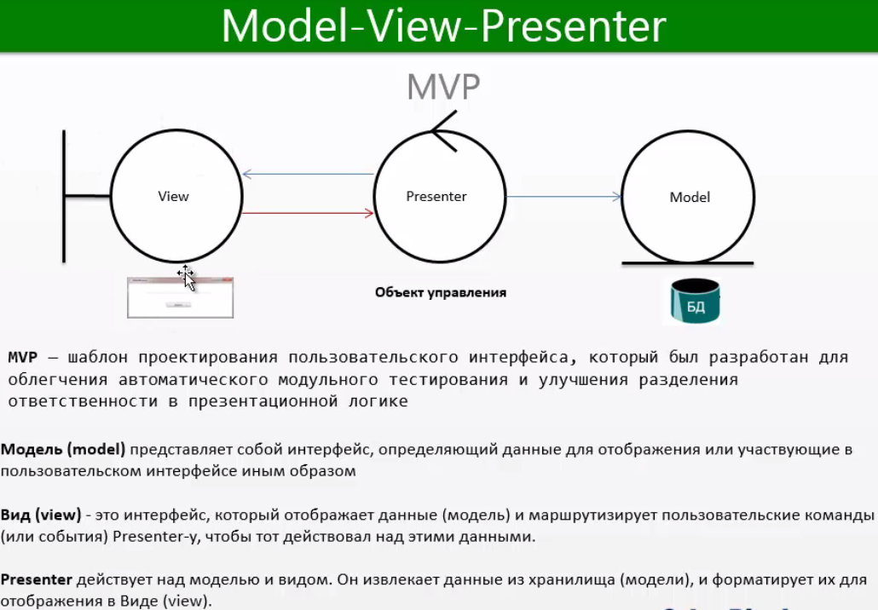

### Generics

#### Generic class example:

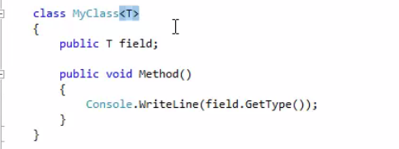

#### Generic Method:

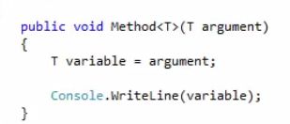

#### Calling generic Method

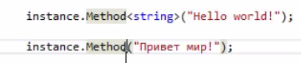

#### Generic of some type

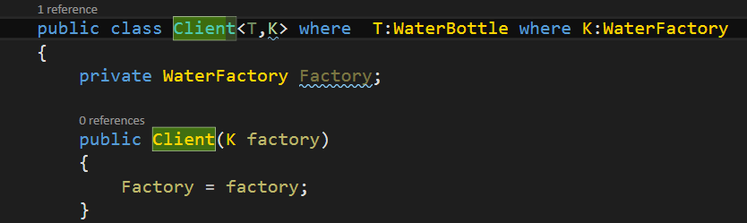

#### Generic Delegate:

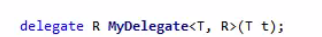

#### Calling Generic Delegate

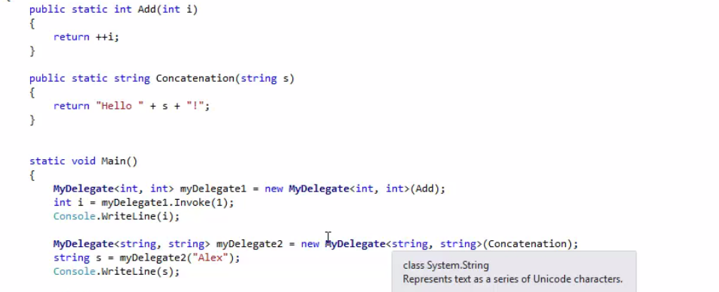

#### Covariation and conervariation INvaraition

Only Interface and delegate

Idea

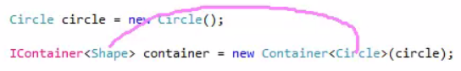

Out – ковариантность or upcasting of generic

In – downcasting of generic контрковариантность

##### Out

Using out means that we will use it only for getting out such class but only for upcasting

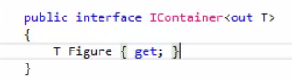

Without this one upcasting do not work

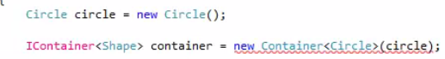

##### In

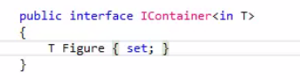

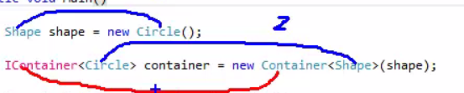

We use it for downcasting



#### Where

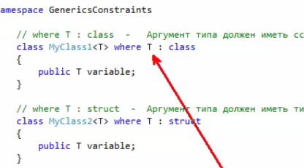

##### Constructor

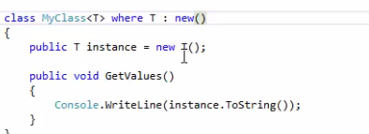

### Null type

Give us opportunities to use null type as structure type

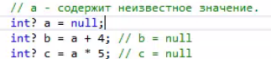

#### Checking of null

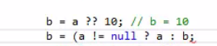

### Collections

IEnumerable means that we got method GetEnumartor() inside or class

IEnumerator means that we can use it for foreach() cycle

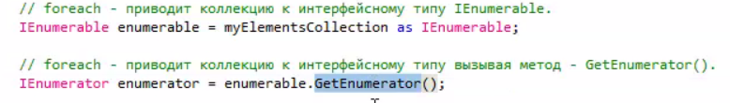

#### Hashtable

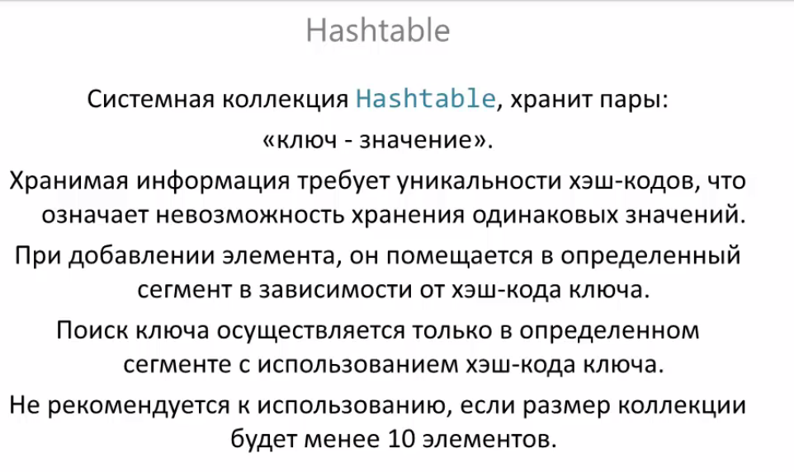

#### SortedList

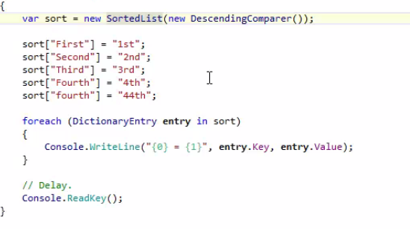

#### ListDictonary

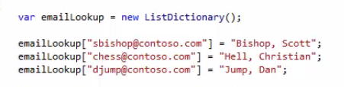

#### HybridDictionary

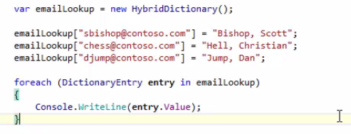

#### BitArray

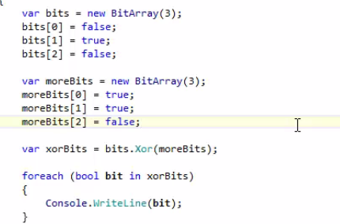

BitVector32

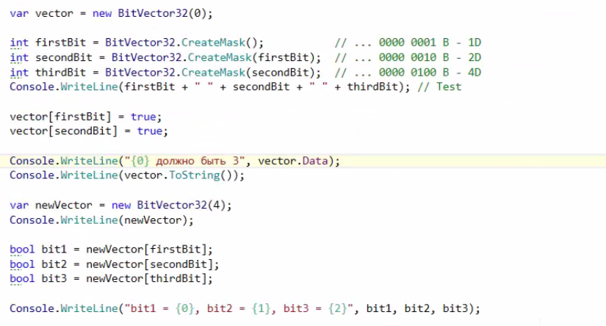

### LINQ

#### Anonymous types



#### LINQ query 1

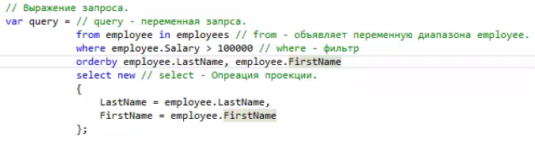

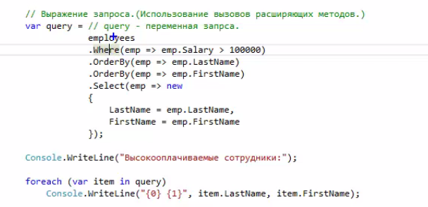

#### LINQ 2 Join

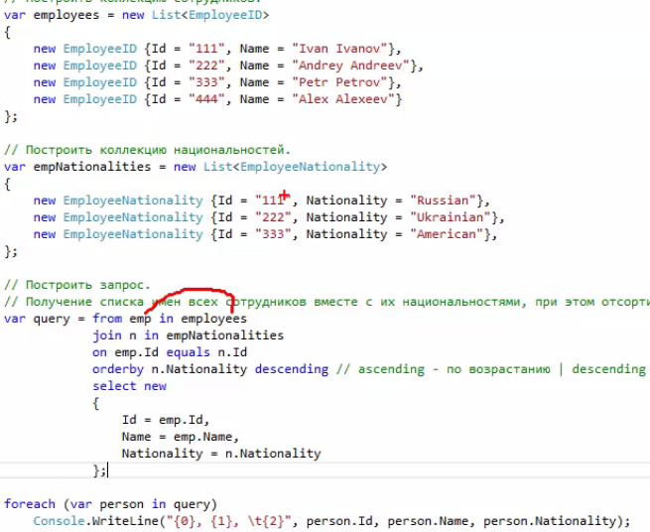

#### LINQ 3 changing result

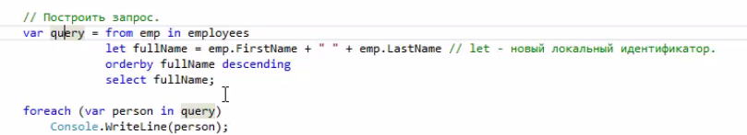

#### LINQ 4 Grouping

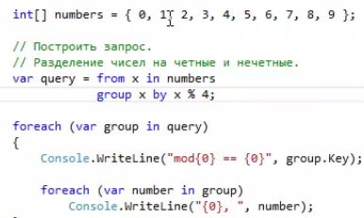

#### LINQ 5 let



#### PLINQ

PLINQ it is opportunity to do linq task in parallel way



##### Ordering parallel collection

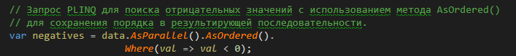

##### Canceling

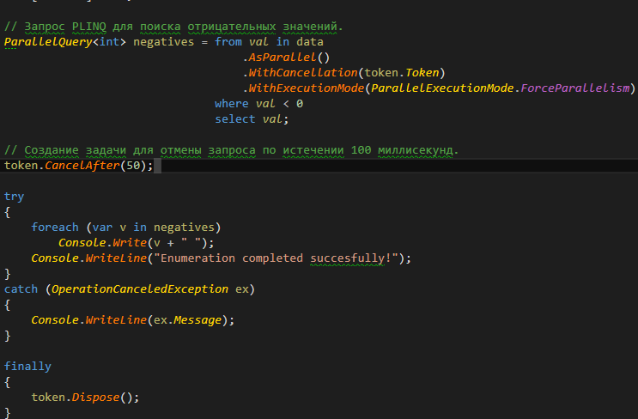

### Dynamic

Mean that that filed can change the type while programming runs

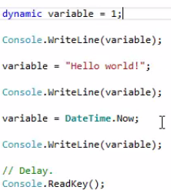

#### Using

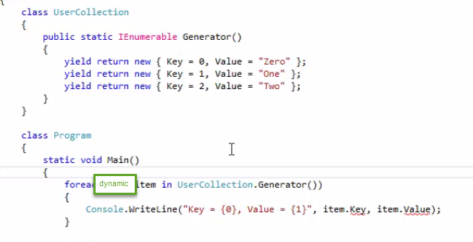

### Namespace

Making pseudo name

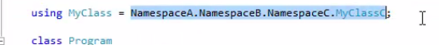

### Exception

#### throwing upper

To throw our exception upper we just use operator throw;

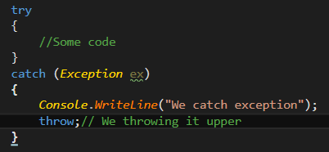

### Editions

#### Overloading

We use to overload normal operation

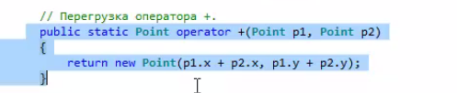

But for increment and decriment and we use only one argument

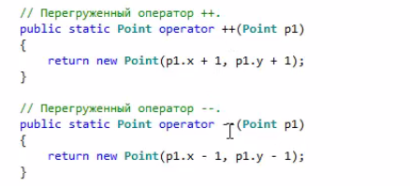

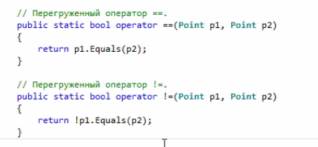

For > or < , >=, <= we should use IComparable

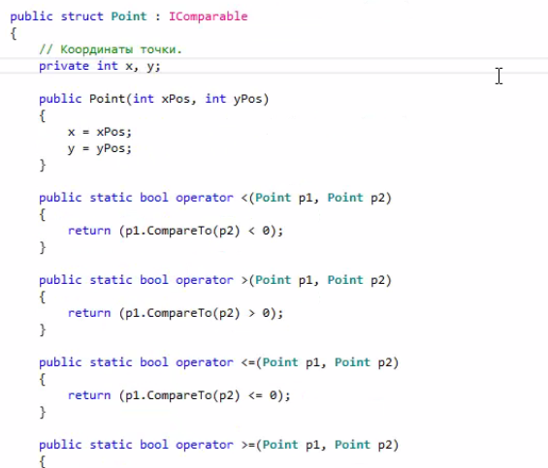

##### Converting

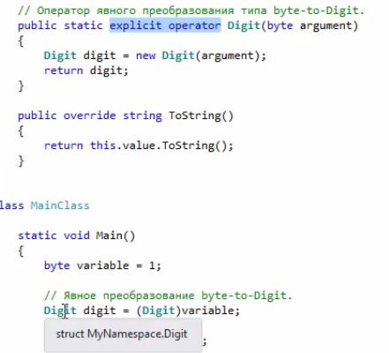

#### Clone

Usually cloning is made by the interface IClonable

And we will create method Clone what we will call the original contructor and set all member to the same value as in the original

But other way is by using MemberwiseClone(); what is much more faste

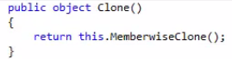

#### Boxing and Unboxing

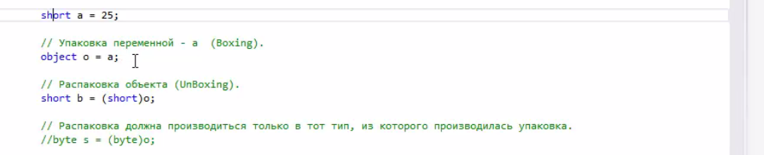

#### DataTime

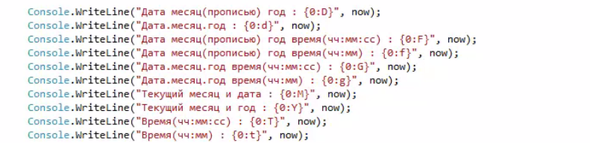

#### Enum

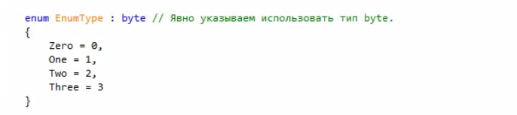

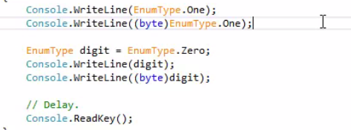

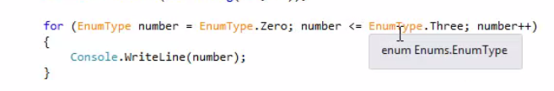

## Advanced

### File System

#### Environment



#### Basics

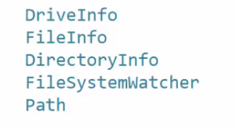

#### DiriectoryInfo

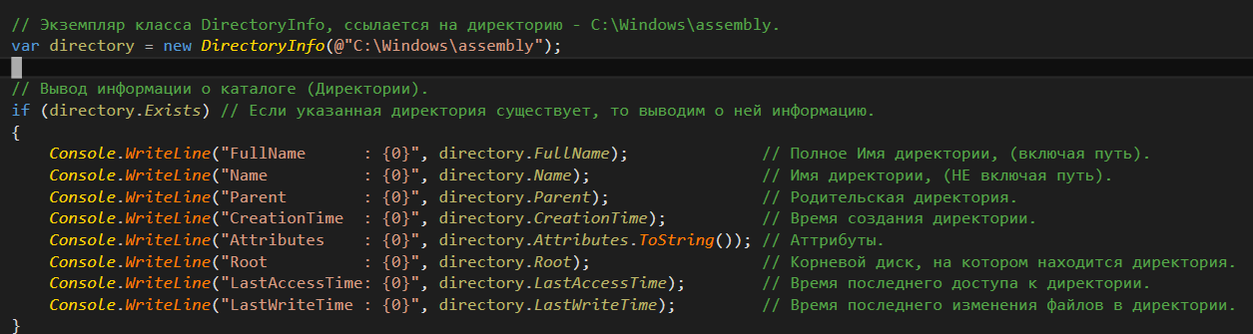

##### GetFiles

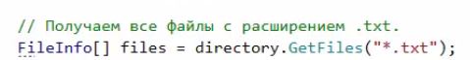

##### Create Subdirectory

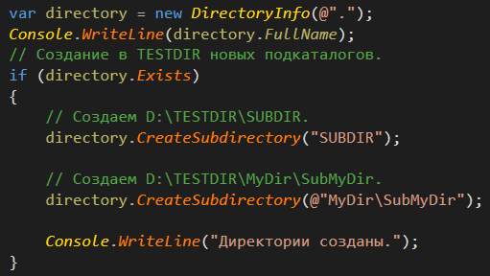

##### Delete Directory

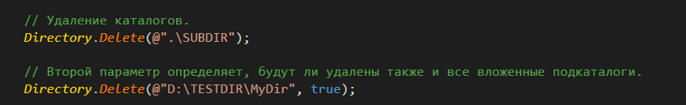

#### FileInfo

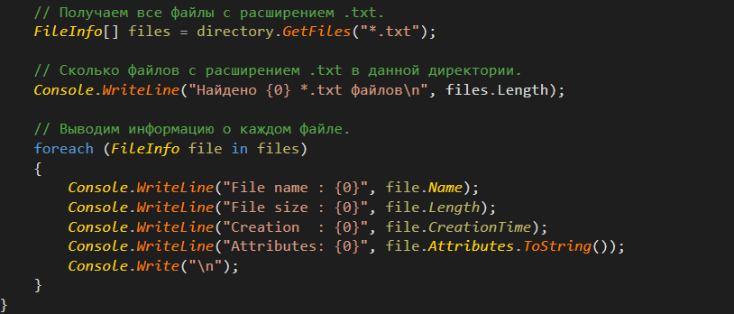

##### Create and delate

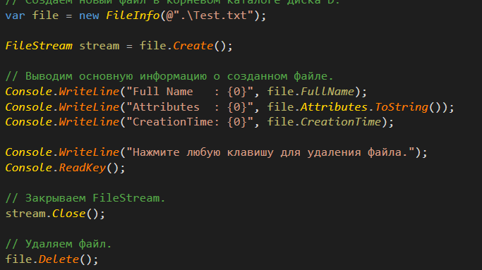

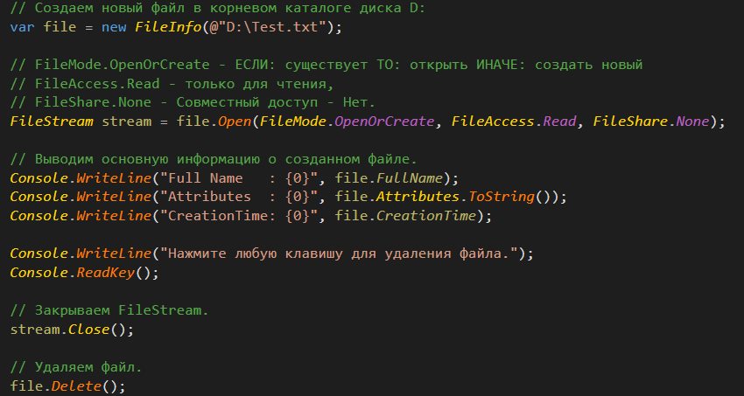

#### Streams

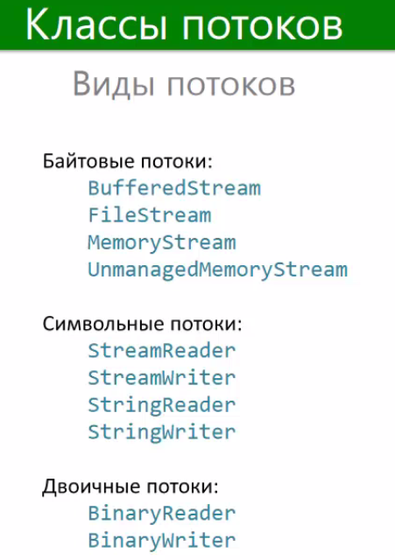

##### MemoryStream

###### Example 1

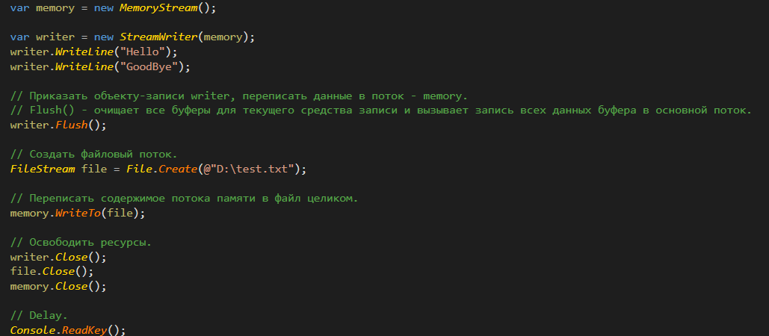

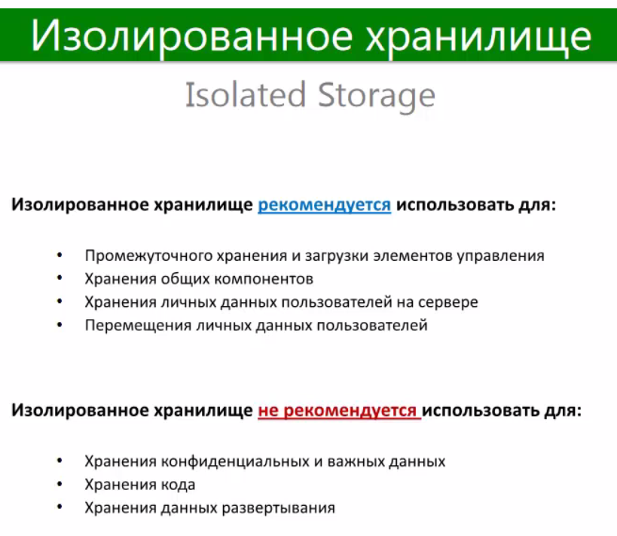

###### Example 2

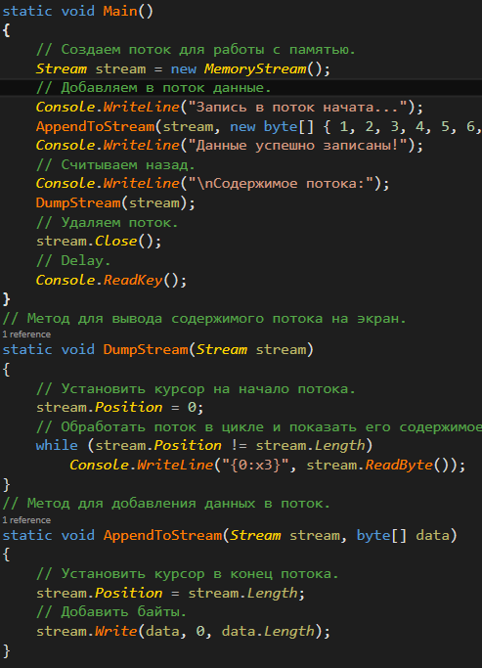

##### Write Text

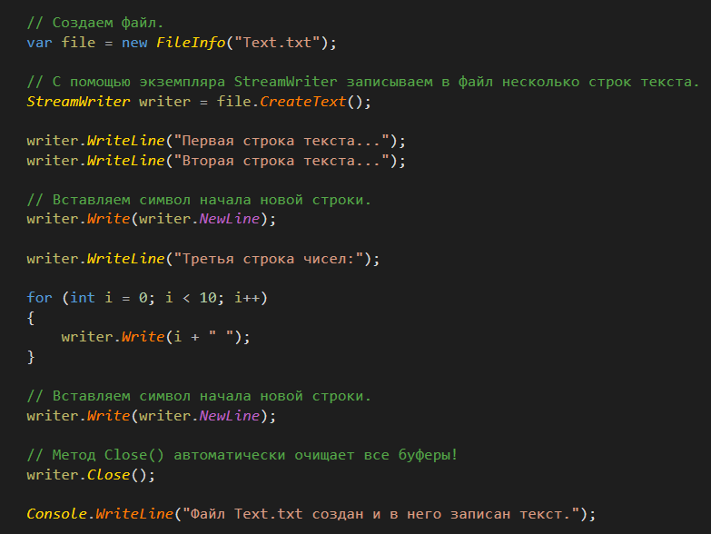

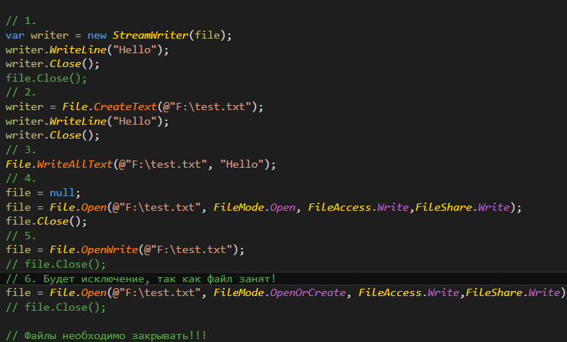

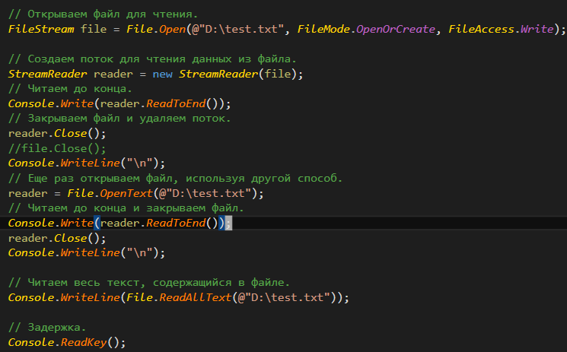

##### Append and Restart

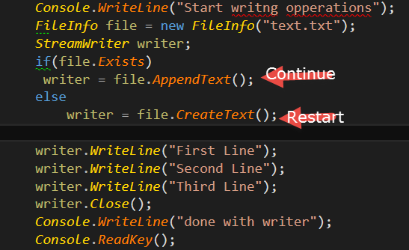

##### Read Text

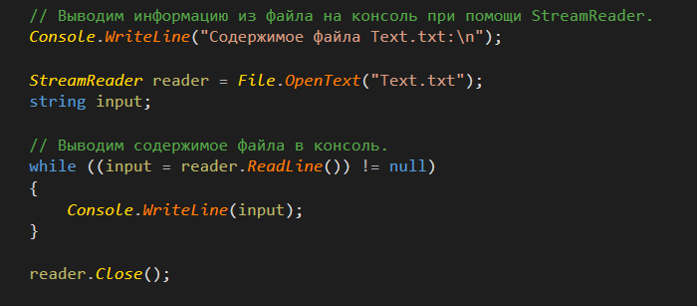

##### Search in file

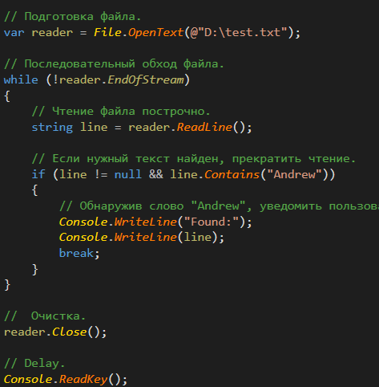

##### String Reader and Writer

###### Reader

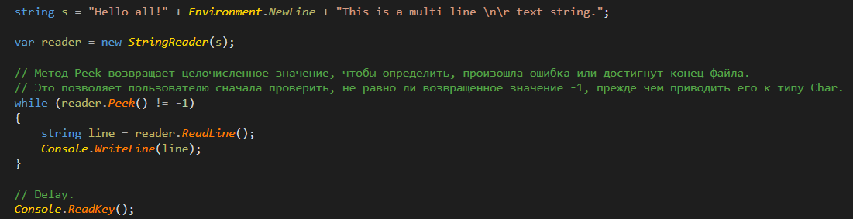

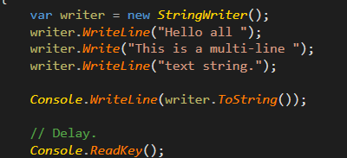

###### Writer



##### Binary Reader and Wrier

###### Wrier

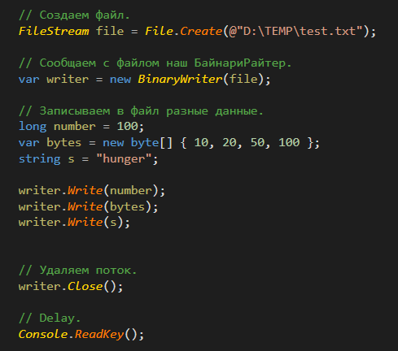

###### Rider

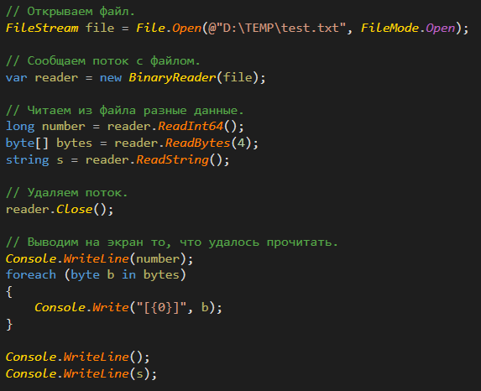

#### System Watcher

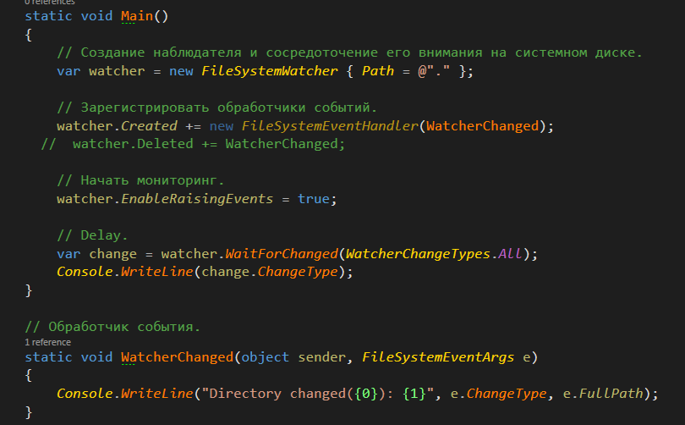

#### Path

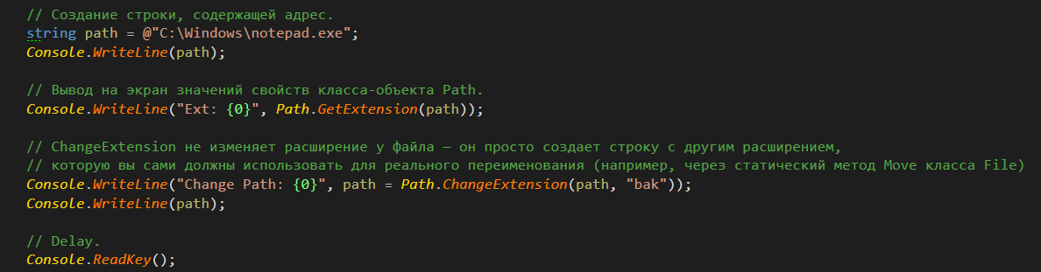

#### Isolated Storage

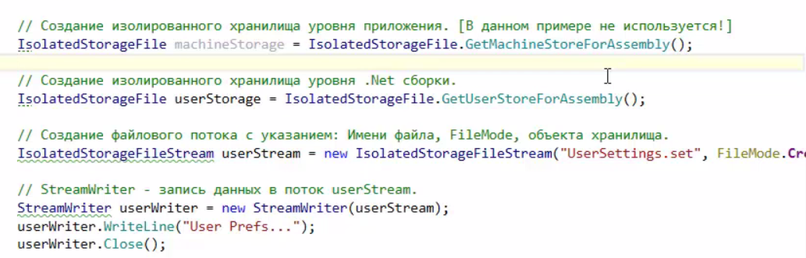

Local and so on

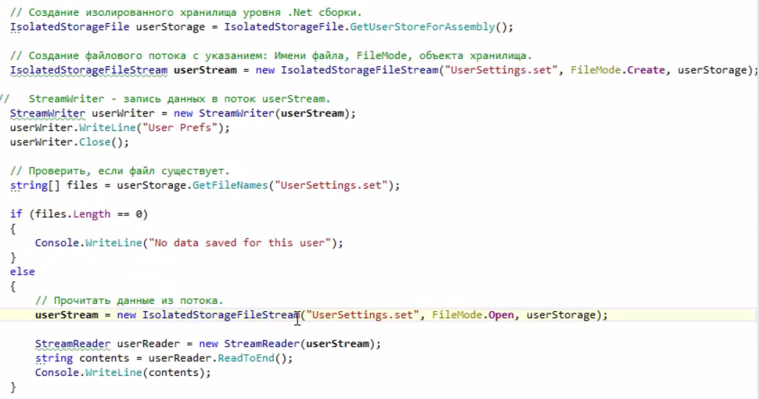

s

### Threads

#### Starting Thread

Multiprocessing – Different programs works in the same time.

Multithreading – Incide the one program.

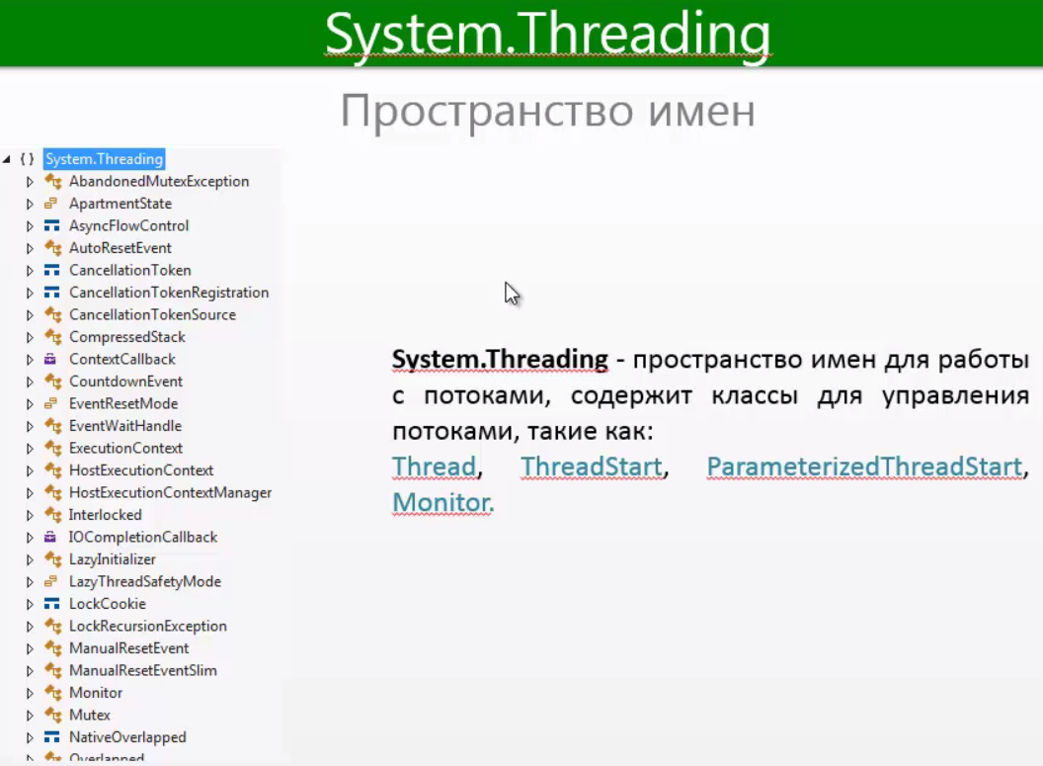

##### Starting thread without parameters

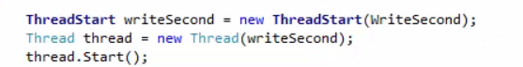

ThreadStart – Делегат который содержит метод который будет выполнятся в другом потоке

##### Start Thread with parameters

ParametrizedThreadStart – delegate for thread with parameters.



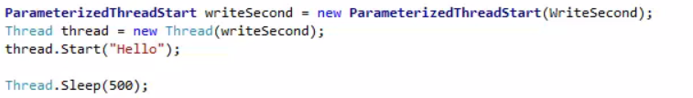

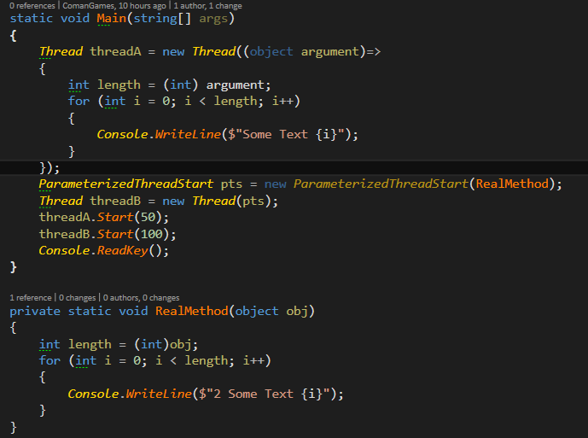





Method Join () Mean that we will finish firsе first thread and then start second

Creating the thread

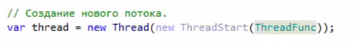

#### Abort

Aborting thread it is just throwing exception ThreadAbortExctpion into our working thread.

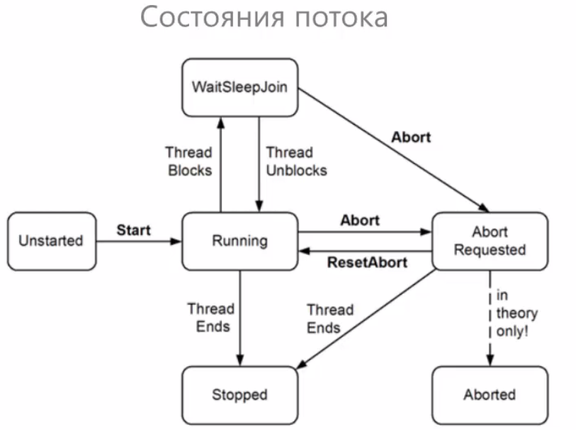

Thread.Abort()- to stop other thread

The method abort just throwing new ThreadAbortException() into our thread.

##### Cancel Abort



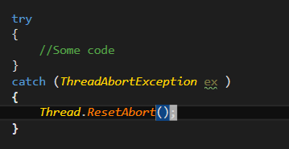

#### CurrentThread

Thread.CurrentThread() – return to us example of thread in which we are currently working.

#### IsBackGround

If we got true it is mean that we will not way till the background throw will ends

By default isBackGround = false;

 - When main thread will end all others will also ends.

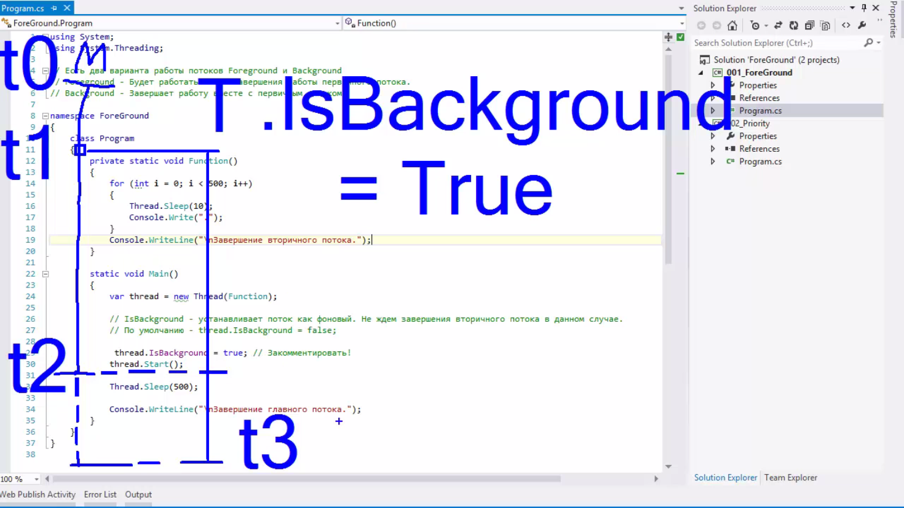

#### Thread Priority

Thread.Priority- sort our threads it theory it should give us more process time for process with higher priority. But it’s not guaranteed on the short work. Only in long

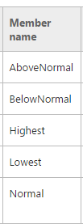

#### ThreadPool

Запустить задачу на выполнение при помощи потока, взятого в пуле, можно с помощью:

* класса ThreadPool: ThreadPool.QueueUserWorkItem
* асинхронных делегатов (пара методов делегата: BeginInvoke() и EndInvoke())
* класса BackgroundWorker
* TPL (Task Parallel Library, о которой мы еще поговорим ниже)

Следующие конструкции также используют пул потоков, но делают это неявно, о чем важно знать и помнить:

* WCF, Remoting, ASP.NET, ASMX Web Services
* [System.Timers.Timer](http://www.albahari.com/threading/part3.aspx#_Multithreaded_Timers) и [System.Threading.Timer](http://www.albahari.com/threading/part3.aspx" \l "_Multithreaded_Timers)
* EAP (the event-based asynchronous pattern, о нем поговорим дальше)
* PLINQ

Полезно держать в голове следующие моменты:

* Потокам из пула невозможно назначить имя
* Потоки из пула всегда фоновые (background)
* Блокировка потоков из пула может привести к запуску дополнительных потоков и падению производительности
* Вы можете поменять приоритет потоку из пула, но он вернется в дефолтное значение (*normal*) после возвращения в пул

#### Getting the count of threads in the pool



#### Check is thread in pool

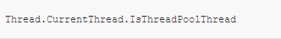

#### Synchronization

Говоря о синхронизации, обычно выделяют 4 вида:

* Блокировка вызывающего кода
* Конструкции, ограничивающие доступ к кускам кода
* Сигнализирующие конструкции
* Неблокирующая блокировка

##### Join

Thread.Join() – when we calling this methods means that we waiting till our thread will ends and only then we countinue to work in thread that called it

Without joining

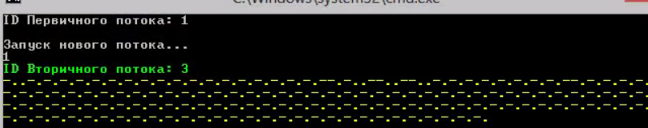

With joining

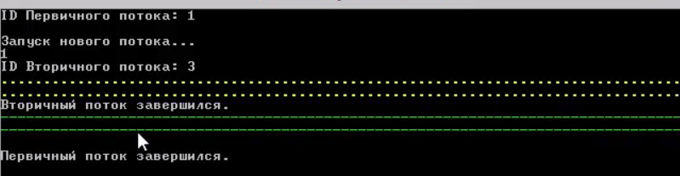

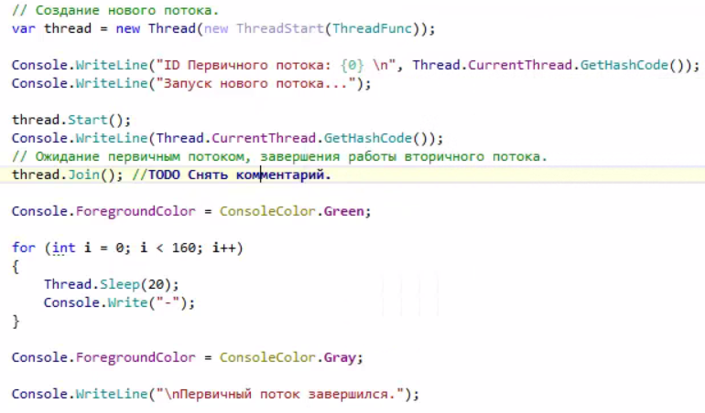

#### Thread pool

Thread is used for using threads optimal to do not create new thread every time when we need to use the thread



Starting the thread and add it to the pthread

#### Sharing Variables

##### Volatile



Thread Static for existing separate in each thread

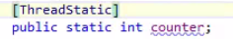

To share static variable between Threads.

To save us from caching that we don’t need

To share variable between threads we just making filed static.

##### Volatile Reading Writing

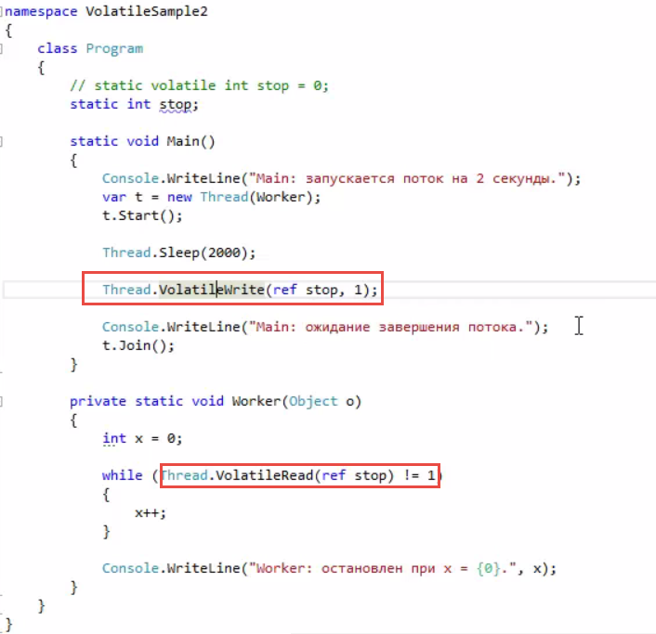

[ThreadStatic] – makes our variable exist separate in each thread

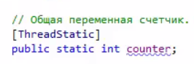

##### Interloocked

Very same

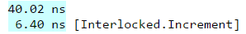

Interlock – is static class to access different fields from different threads.

Int I = 0;

Int x = Interloocked.Read(ref i); // Reading something from other thread

Interloocked.Increametn(ref i); // i++

Interloocked.Decreament(ref i); //i- -;

Interloocked.Add(ref I, 5); // i+=5;

Interloock.Exchange(ref I , 10);// i=10;

##### Monitor

Is the most easy example of Synchronization of threads.

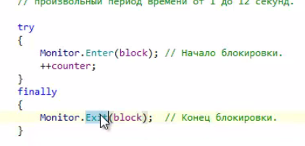

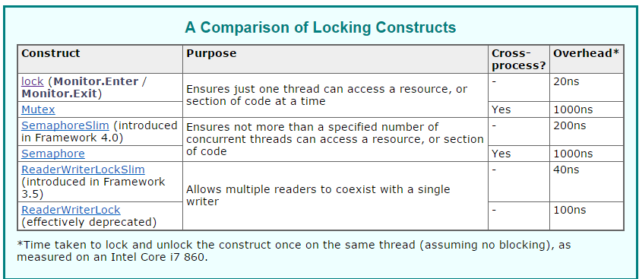

##### Lock

Look it is just calling two methods  lock,  *Monitor.Enter()* и *Monitor.Exit()*,

Lock(object)

{

}

Monitor.TryEnter(block, 3000); if you are not sure is there ability to enter into lock

Equals

Montior.Enter(object)

Monitor.Exit(object)

##### Collections

Полезно знать, что в пространстве имен *System.Collections.Concurrent* определено довольно много потокобезопасных коллекций для разных задач. Самые распространенные:  
  
BlockingCollection   
ConcurrentBag   
ConcurrentDictionary<TKey, TValue>   
ConcurrentQueue   
ConcurrentStack   
  
В большинстве случаев нет смысла в реализации собственной подобной коллекции — намного проще и разумней использовать готовые протестированные классы.

#### Advanced Synch objects of Windows core

Independent for multi Programs

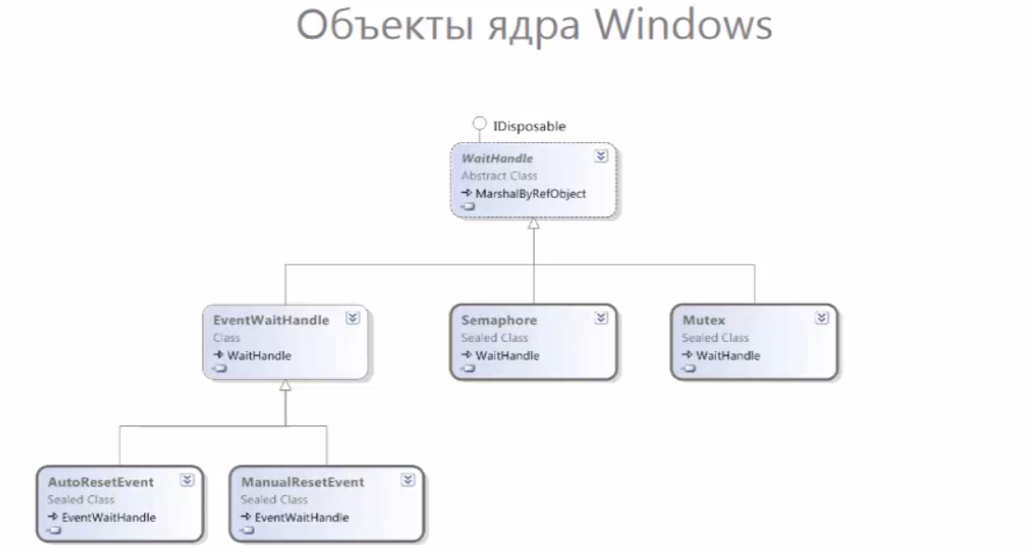

##### Signaling

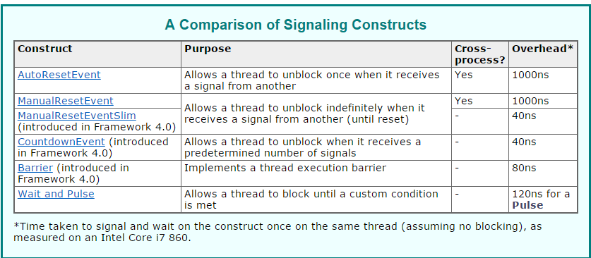

##### Wait Handle

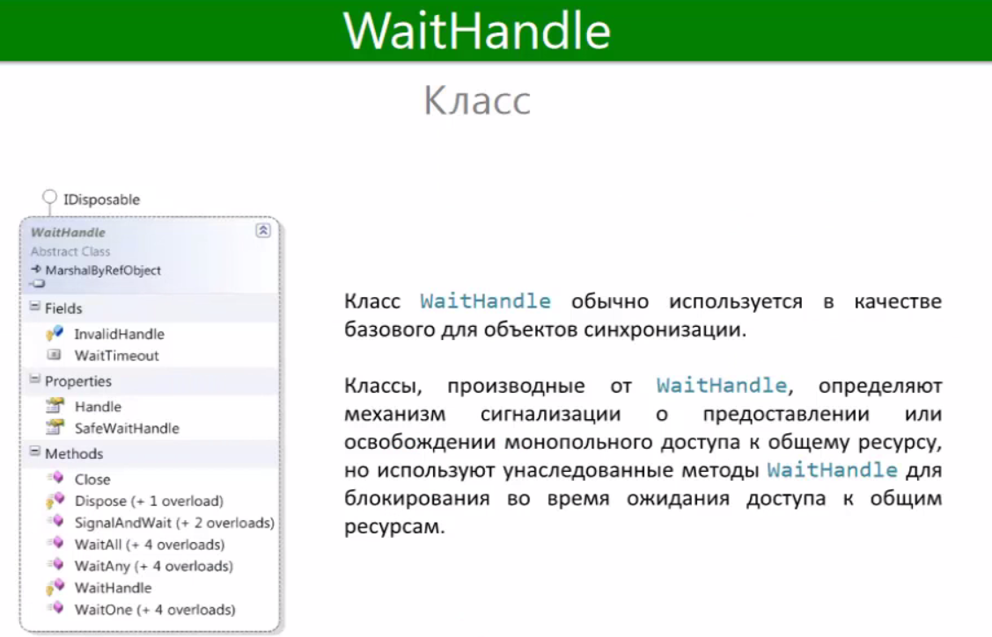

##### Mutex

Works even if you got few instances of one program running on the same computer still we use only one thread.

We use it when multiple threads want to access one resource.

Main difference from lock that we can use it in multiple programs

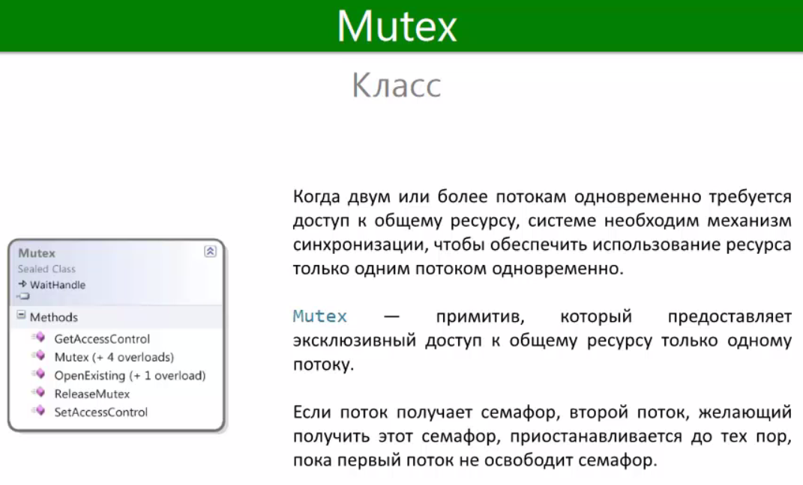

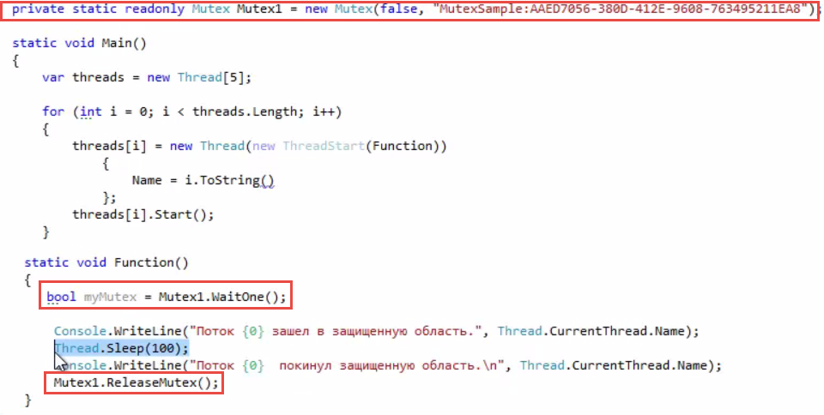

##### Semaphore

When we have pool of resources. Work on multiple programs

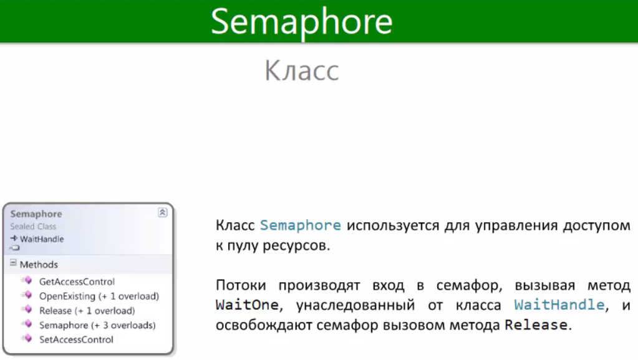

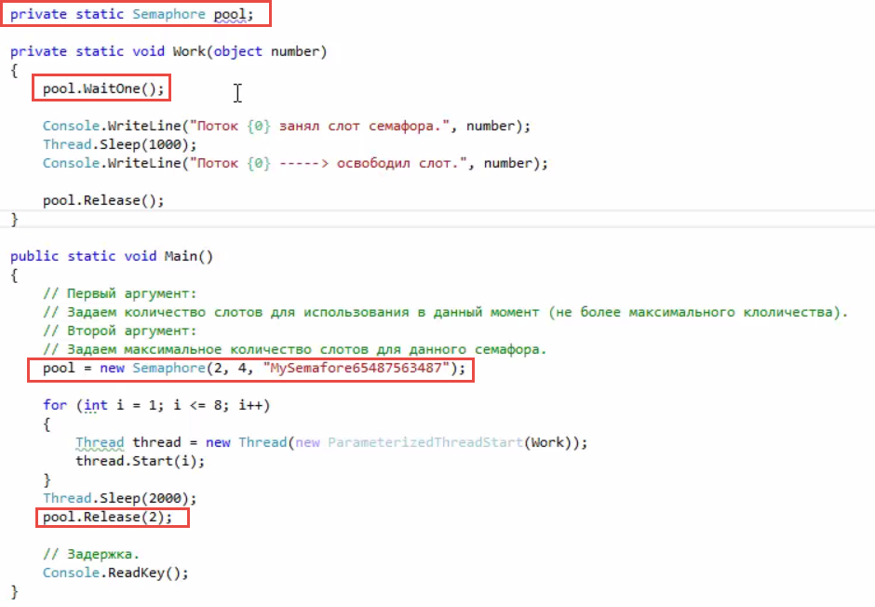

##### SemaphoreSlim

As semaphore but much faster but only incide the one program instance Faster but no multiprogramm support.



##### EvenWaitHandle

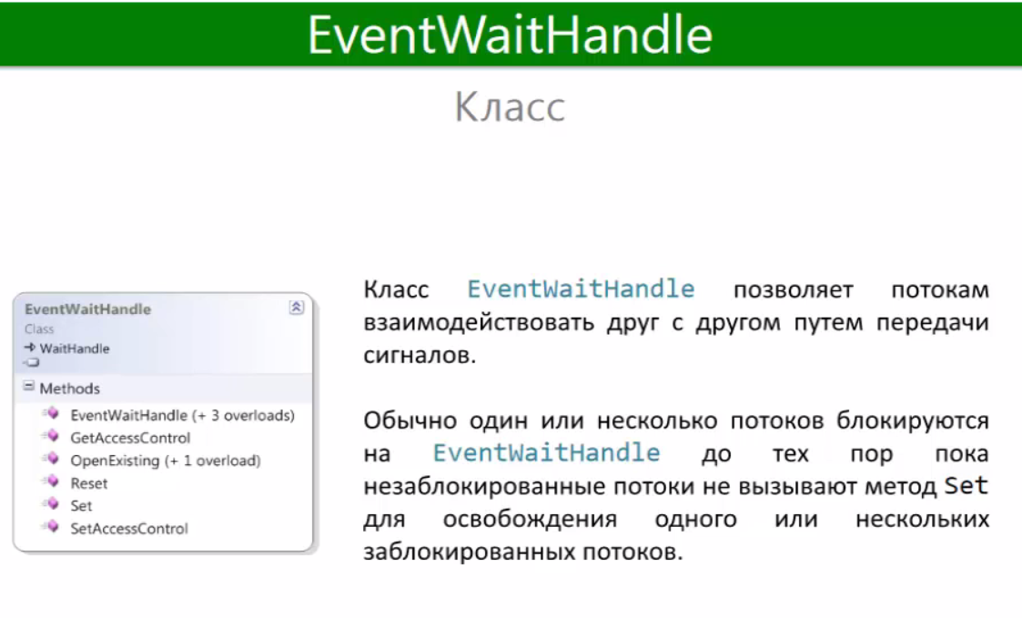

We sending signal to only one thread. To sync it with others.

##### AuroResetEvent

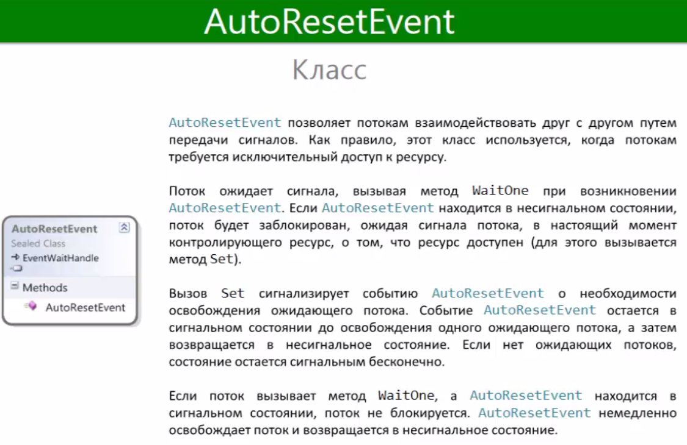

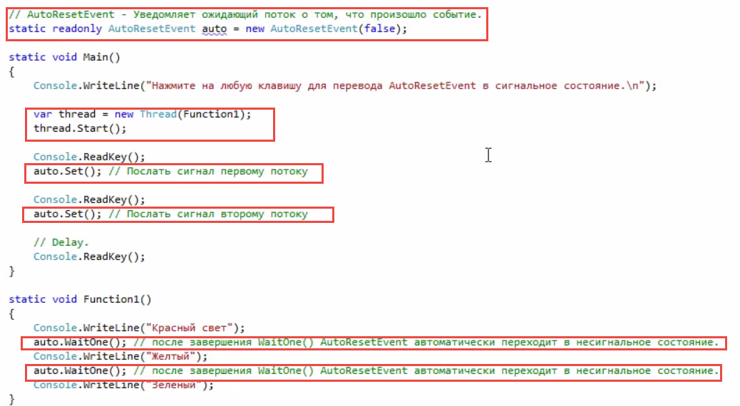

##### ManualResetEvent

We sending signal to multiple threads . It stay in signal state till you manually turn off it.

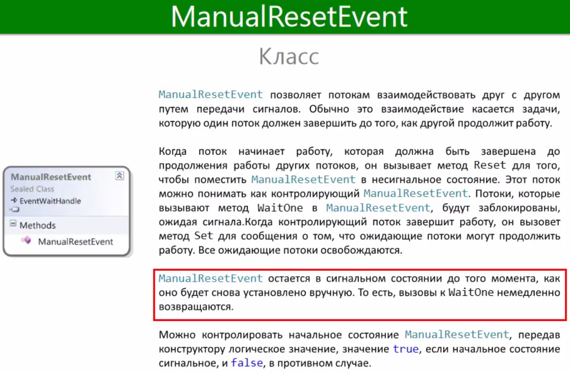

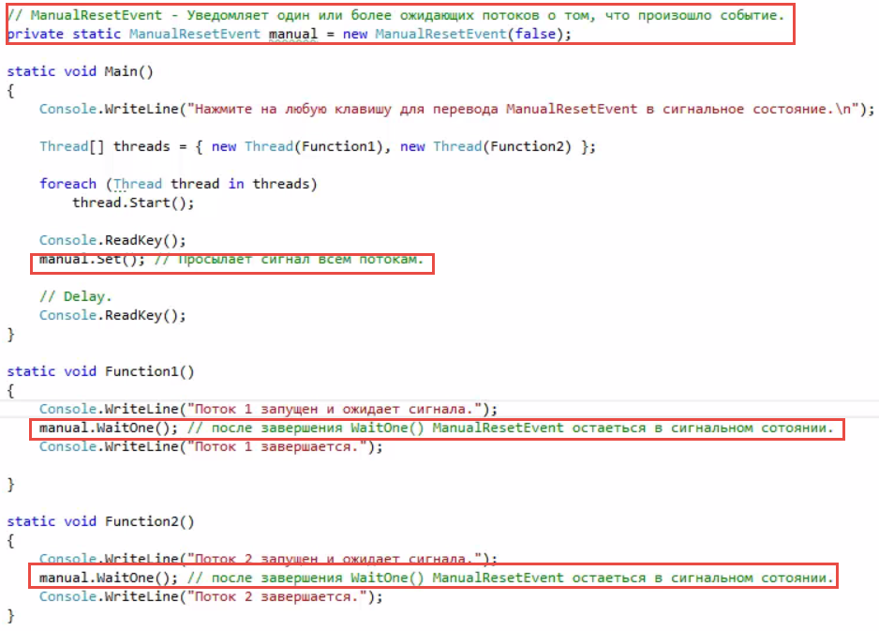

##### ManulaResetEventSlim

5x times faster ‘

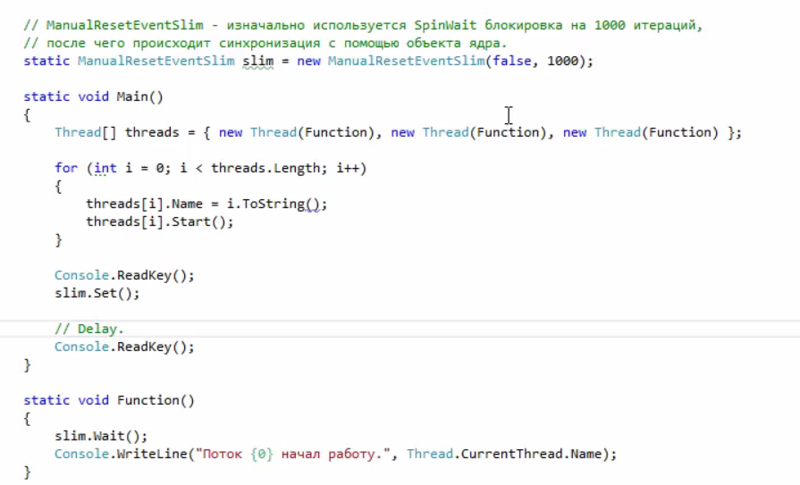

##### Register Wait Handler

Bv 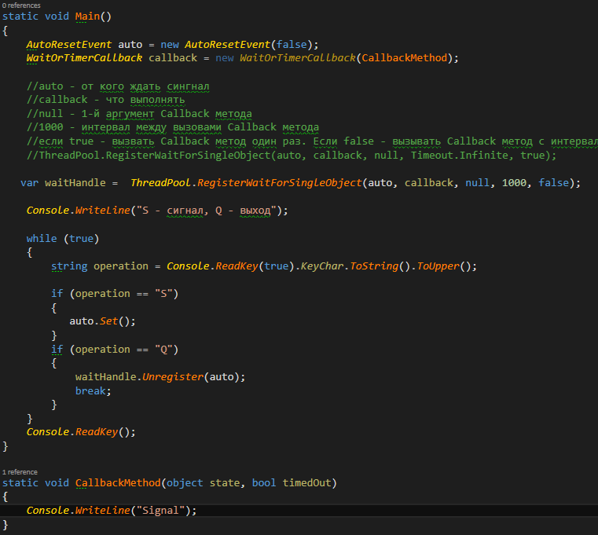

##### Timer

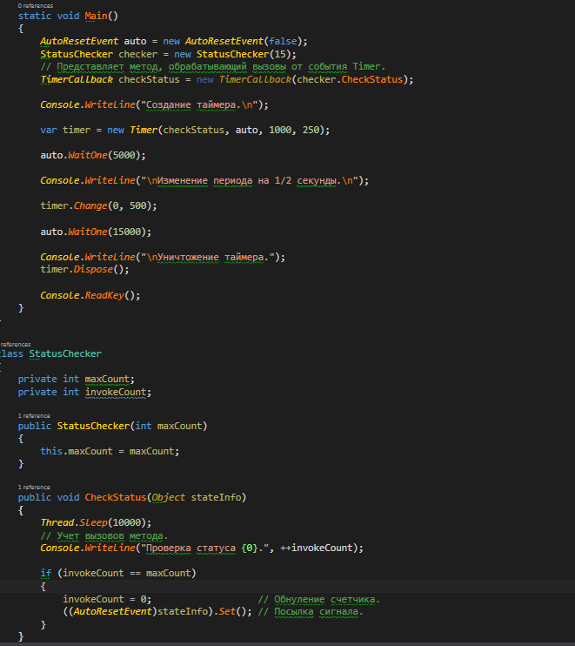

##### Global Reset Event

Starting Action in Multiple applications

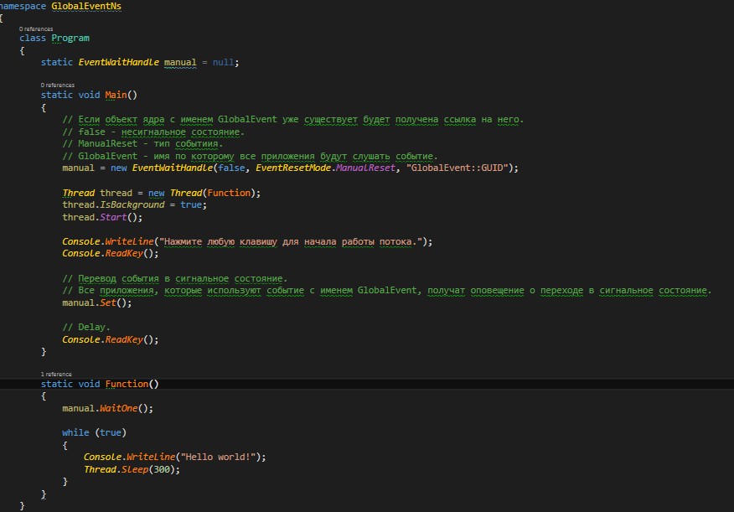

##### Wait Handle

Main thread waiting till end of two other threads

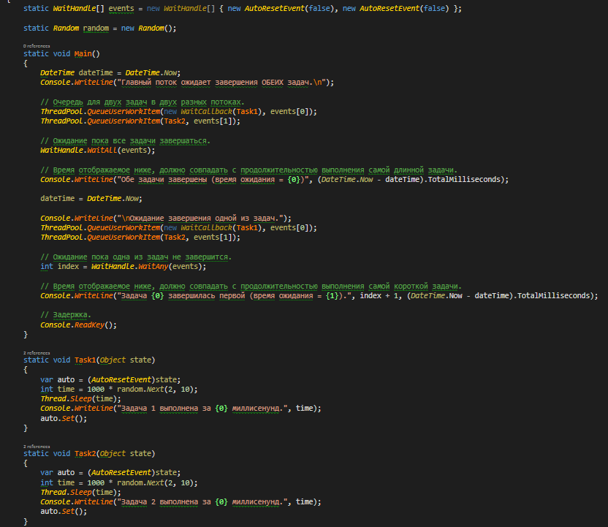

### Async model

#### IAsincResult

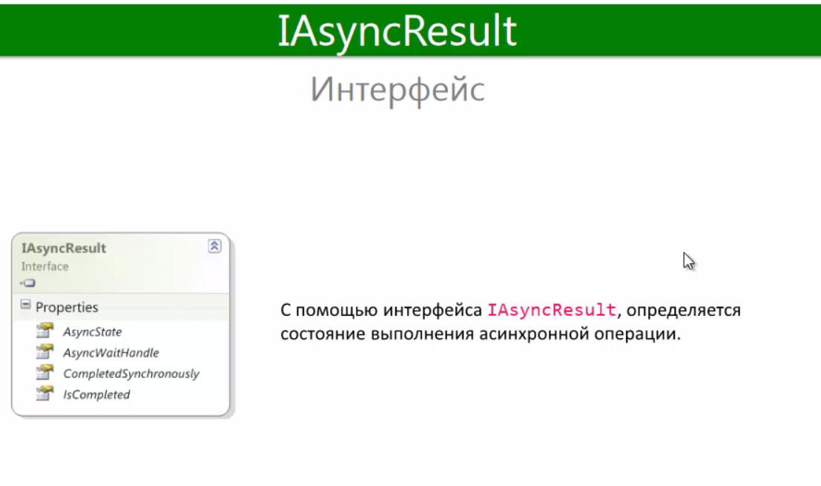

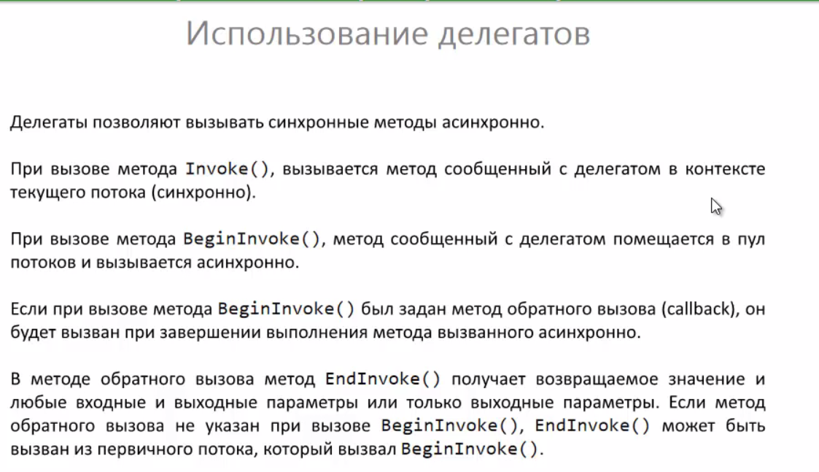

##### Getting Result

###### Way1: Using delegates

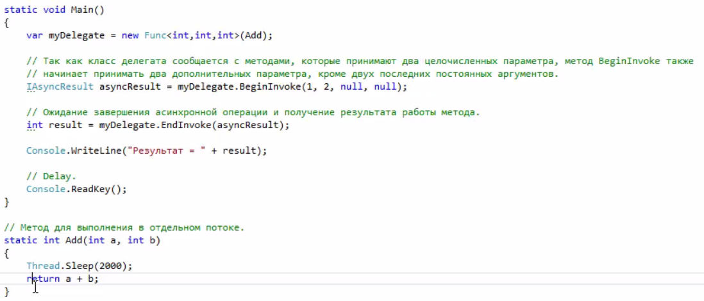

###### Way2

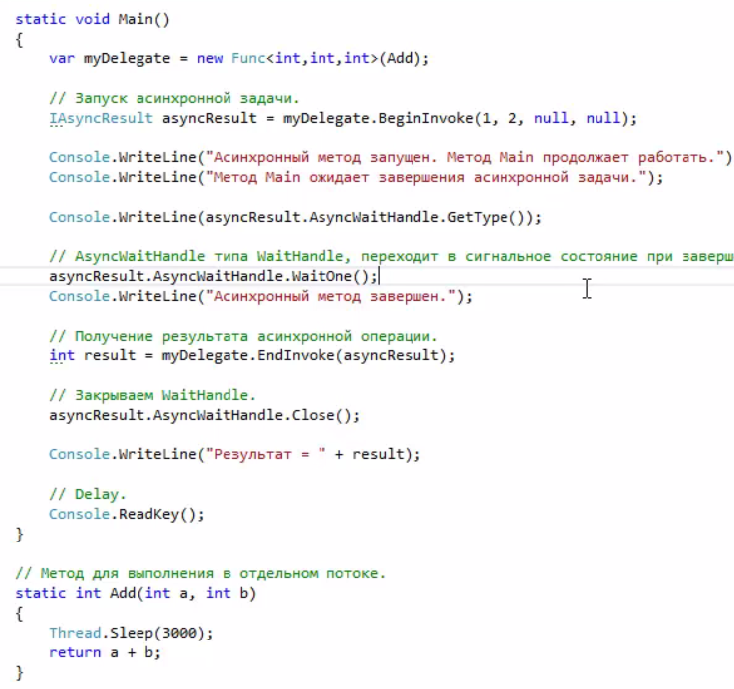

##### Wating thread to end

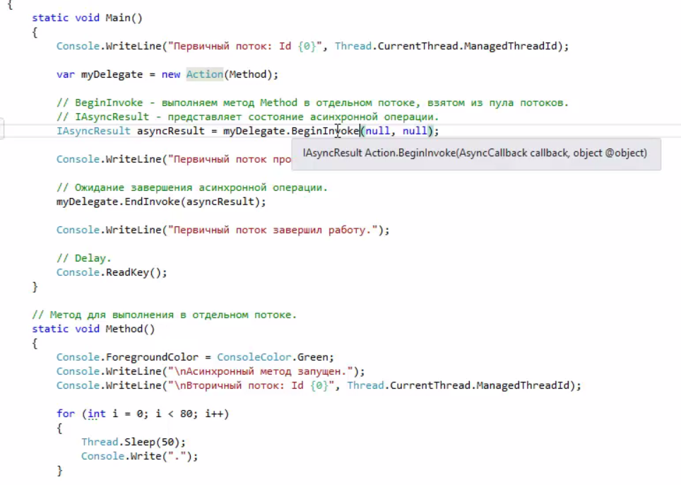

##### CallBack

In example we start one method and after we done first we start next. Awesome !!!

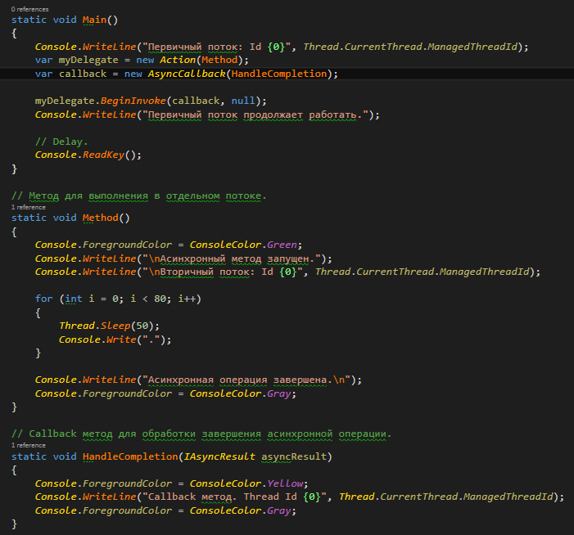

### TPL

Making work with multithreading super easy.

Starting from .Net 4.0

#### Task

Same as Thread but full automatic.

Task<TResult> - For method that should give us result

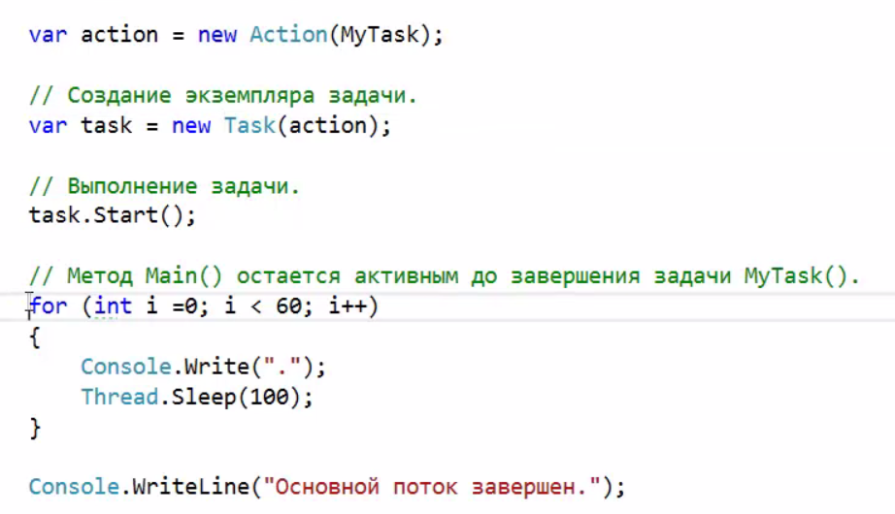

Task task = newTask(MyTask);

#### Creating using factory



#### Using with old AsyncModel

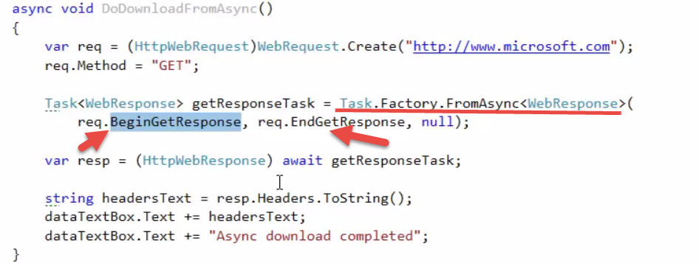

#### Wait

To ask thread from what we call to wait till we end with the method

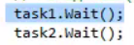

To wait all or to wait till first will end

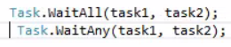

#### Disopouse

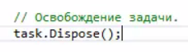

Calling Task after end of first

#### Result

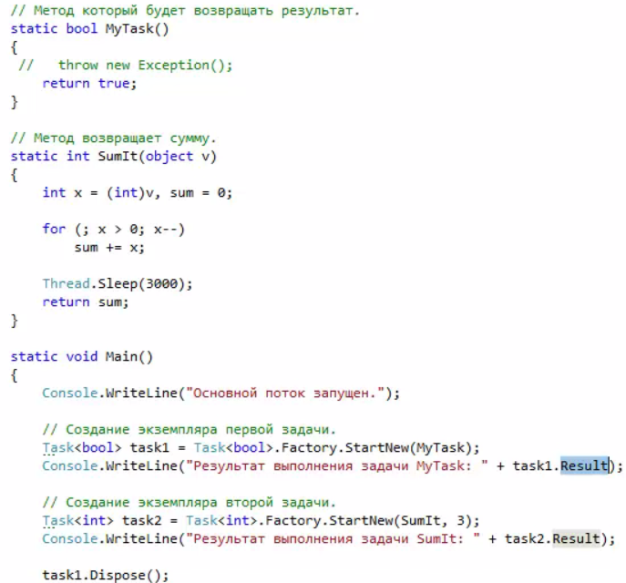

#### Canceliing task

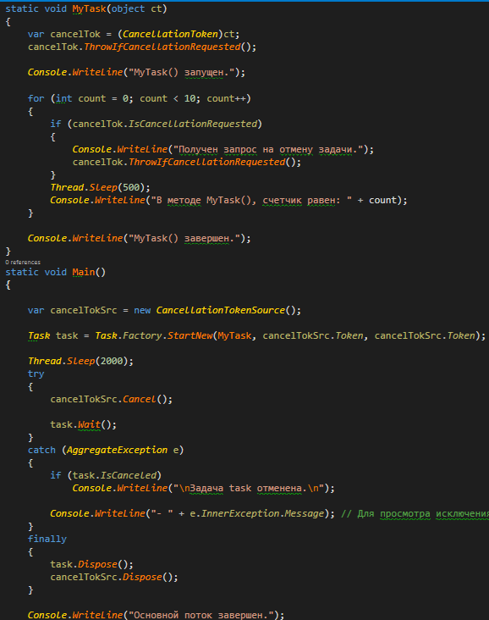

#### Continue with

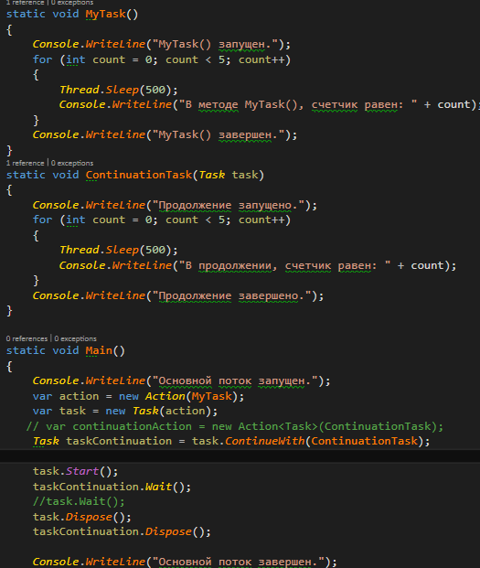

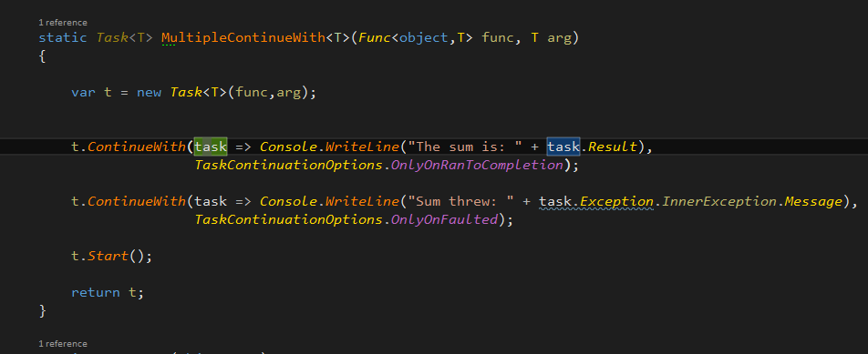

#### Parallel

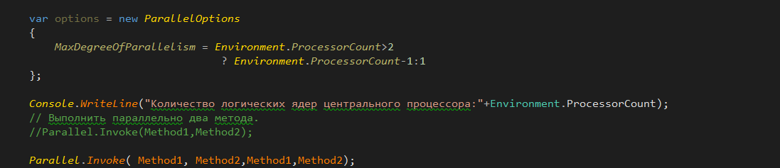

#### Parallel.For

Parllel version of for cycle

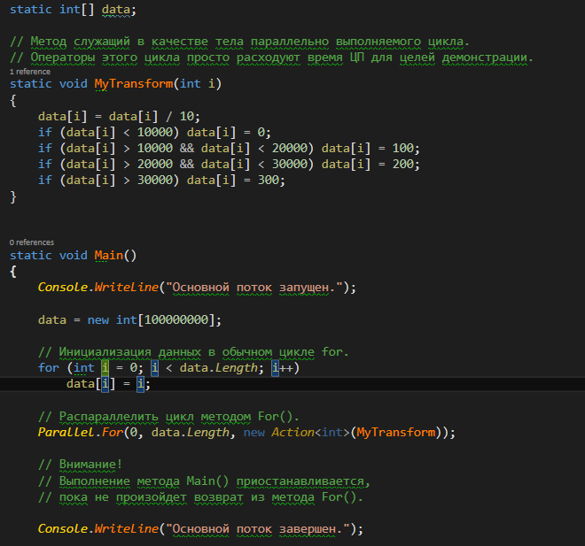

##### Break

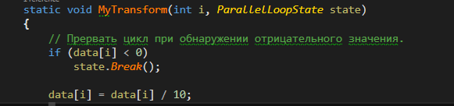

#### Parallel.Foreach



### async\await

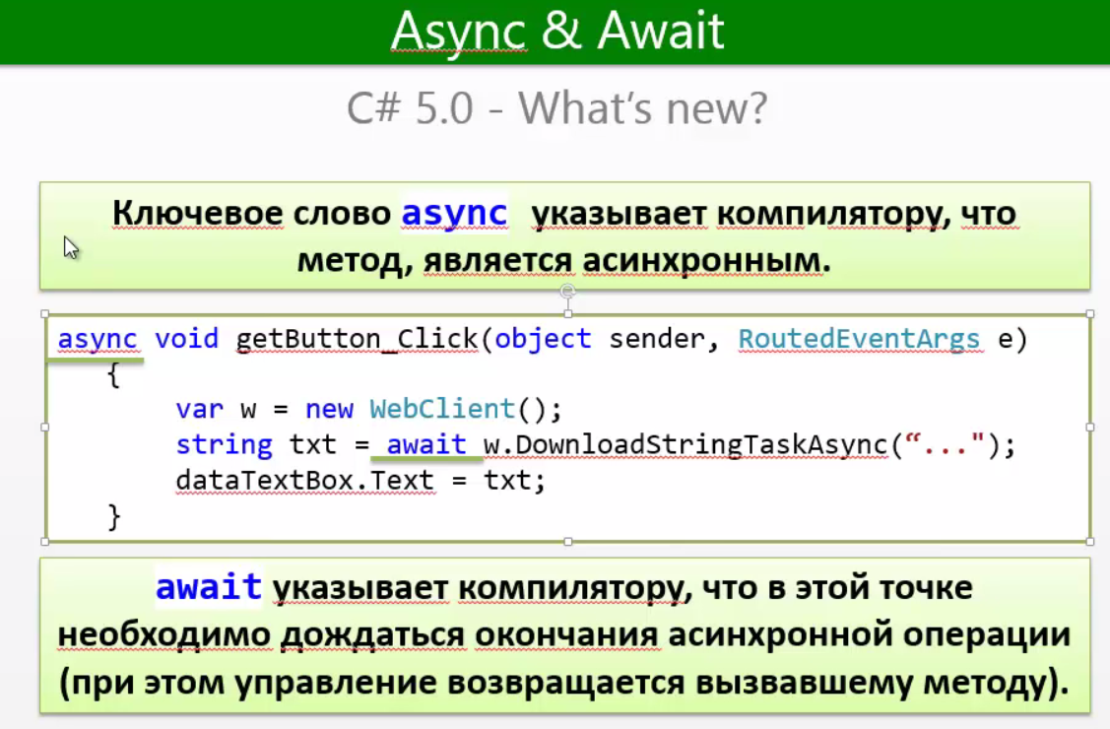

Async/Await automaticly back our control to the Main thread

#### Old

##### Sync call

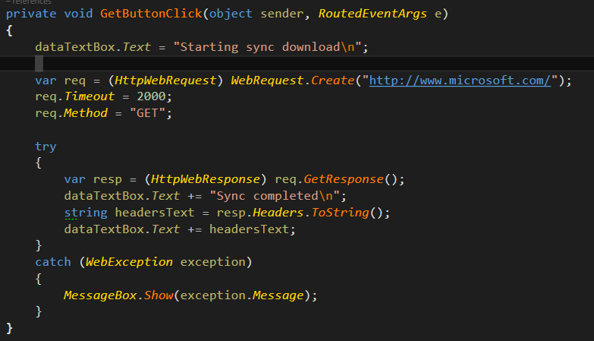

##### Async with problems

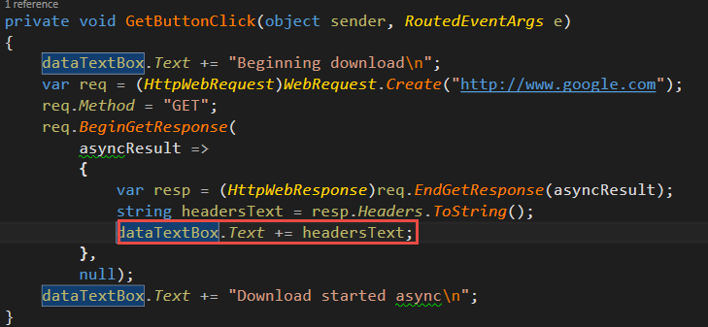

##### Old Async

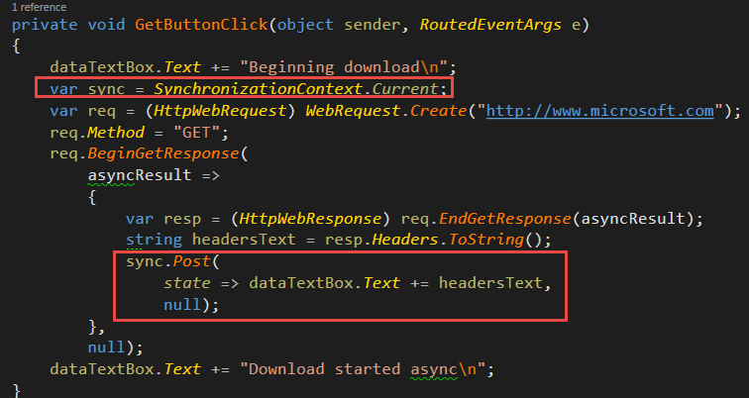

#### Async Example

Use Async to method what would be call Async and await for somethind that we doing Async

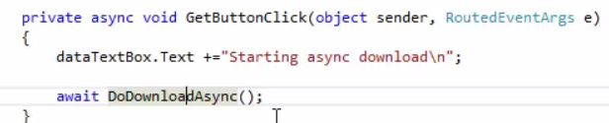

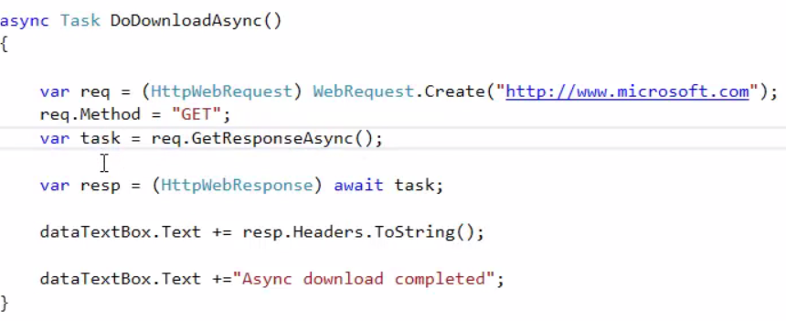

#### SyncronizationContext

Usually not needed when we use Async/Await

The problem is that with some threads we can’t work from background threads as example with UI in Windows Forms.

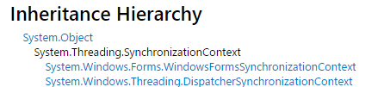

Also in C# we have UnitySynchronizationContext – incide our Alexzzz



##### Post

To add information to our current thread.

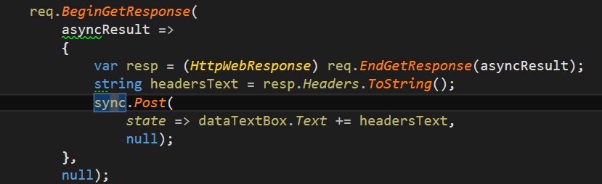

#### Canceling Task

For canceling task we use CancellationTaokenSource.



First we should create it.

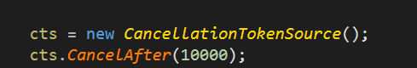

Cancel After mean that we will canel our task after some time

And our method should know about it

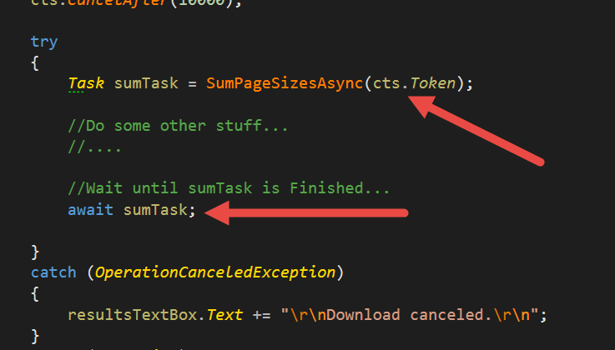

##### Explenation

* [CancellationTokenSource](http://msdn.microsoft.com/en-us/library/system.threading.cancellationtokensource.aspx) — создаёт маркёры отмены (свойство Token) и обрабатывает запросы на отмену операции (перегруженные методы Cancel/CancelAfter).
* [CancellationToken](http://msdn.microsoft.com/en-us/library/system.threading.cancellationtoken.aspx) — маркёр отмены; позволяет несколькими способами отслеживать запросы на отмену операции: опросом свойства IsCancellationRequested, регистрацией callback-функции (через перегруженный метод Register), ожиданием на объекте синхронизации (свойство WaitHandle).
* [OperationCanceledException](http://msdn.microsoft.com/en-us/library/system.operationcanceledexception.aspx) — исключение, выброс которого по соглашению означает, что запрос на отмену операции был обработан и операция должна считаться отменённой. Предпочтительный способ генерации исключения — вызов методаCancellationToken. ThrowIfCancellationRequested.

## App.config

Getting from app.config storage connection Info



App.config



Getting from Appsetting



App.config

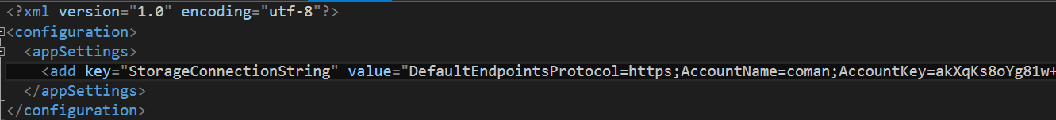

## C++ from C#

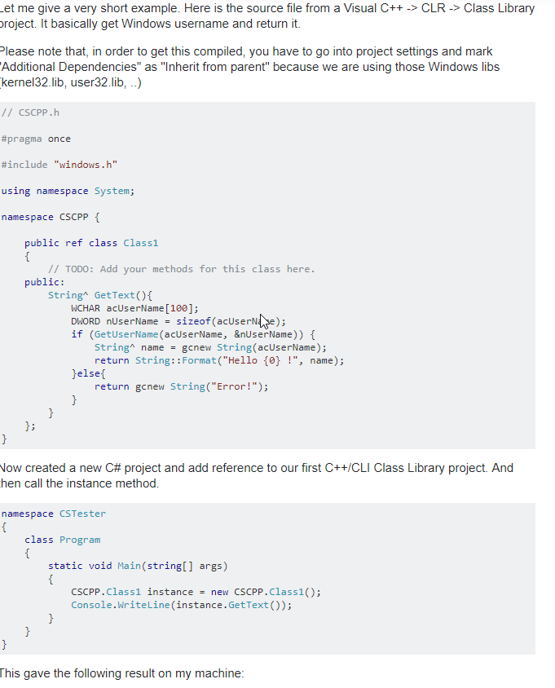

## Liber’s

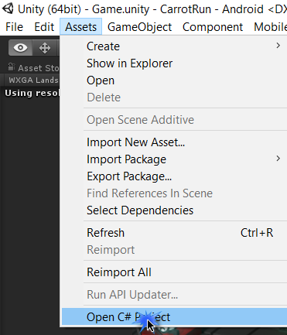

## Functional Programming

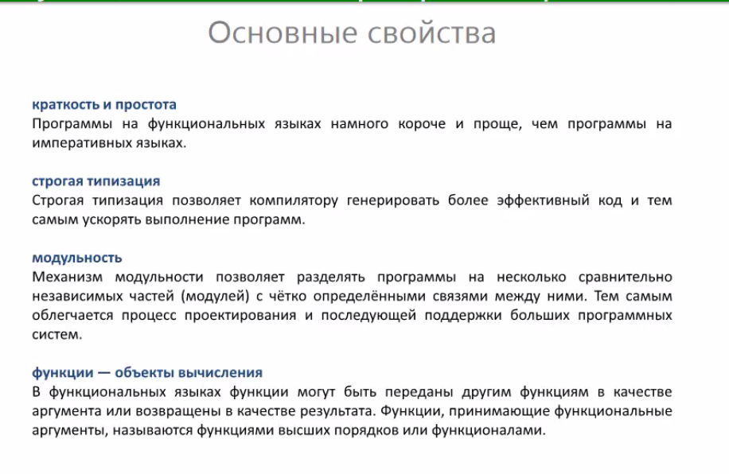

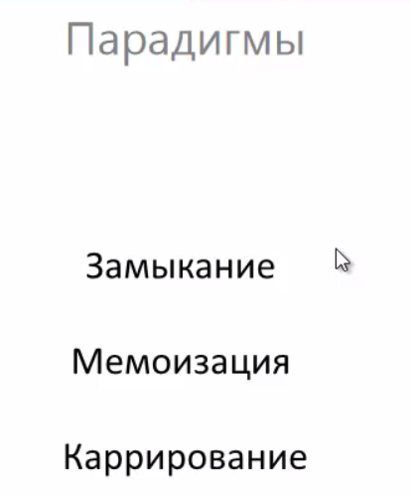

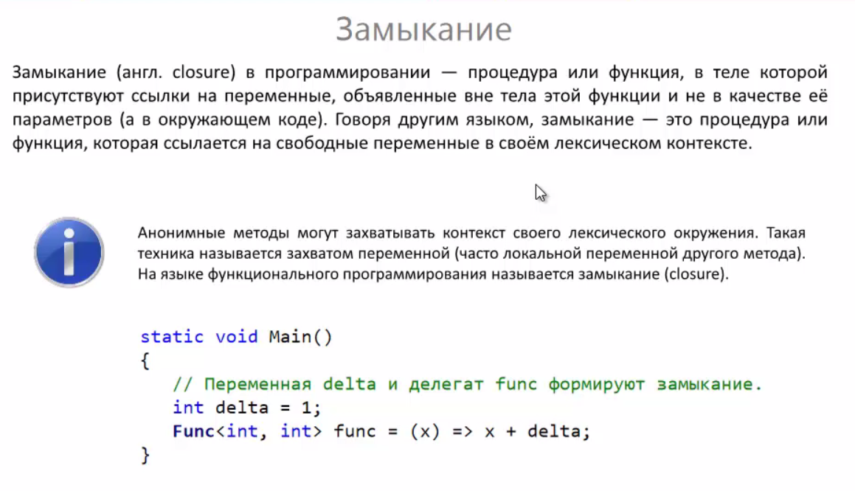

### Compile

We are complying code in runtime

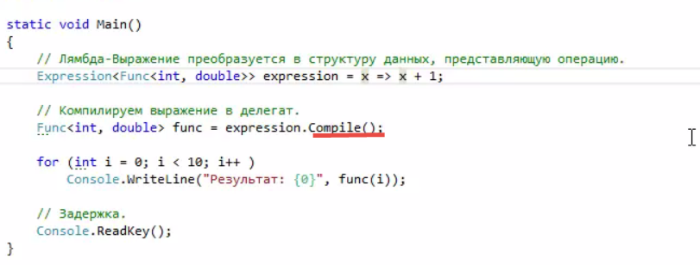

### Expression



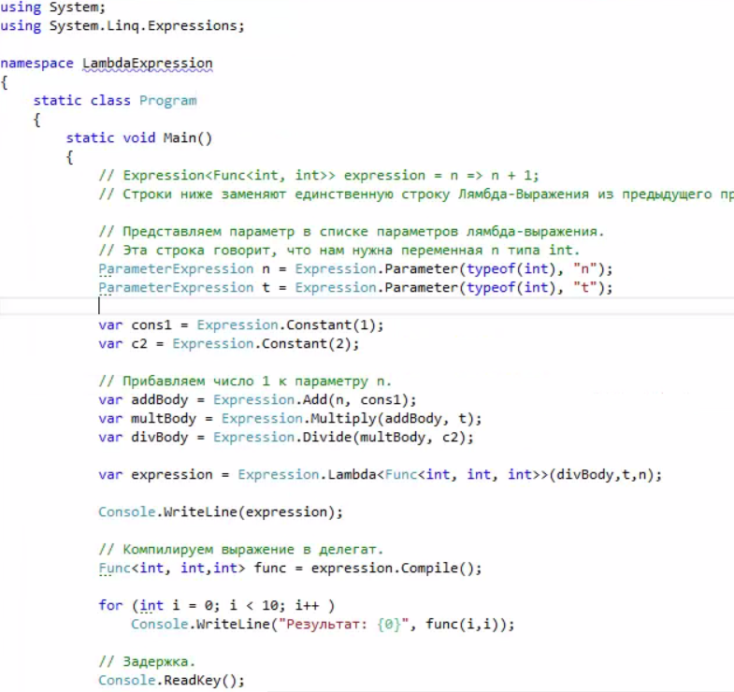

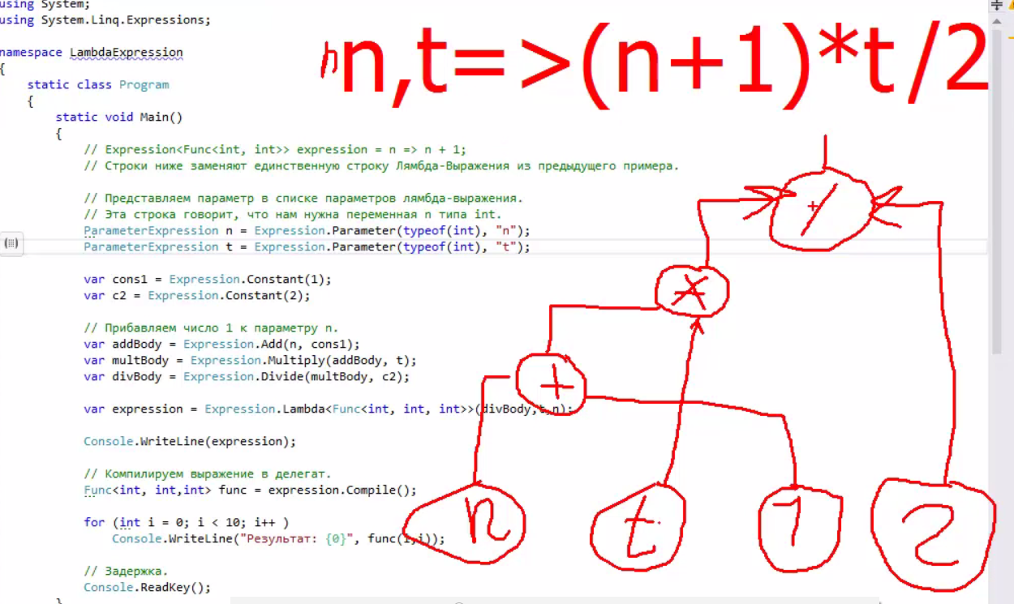

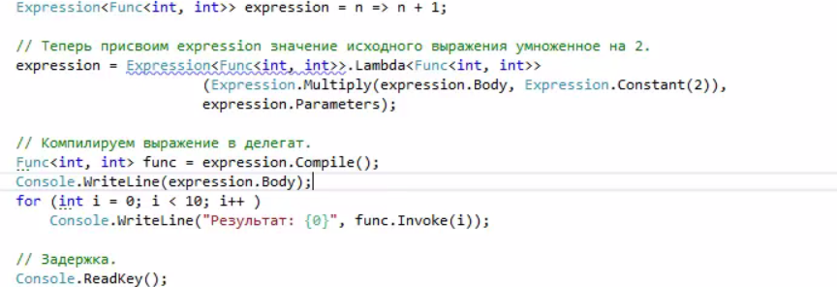

#### Body



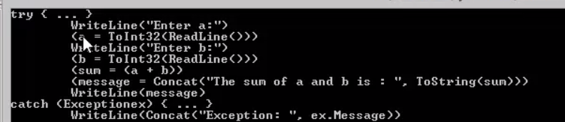

### Domain Apps

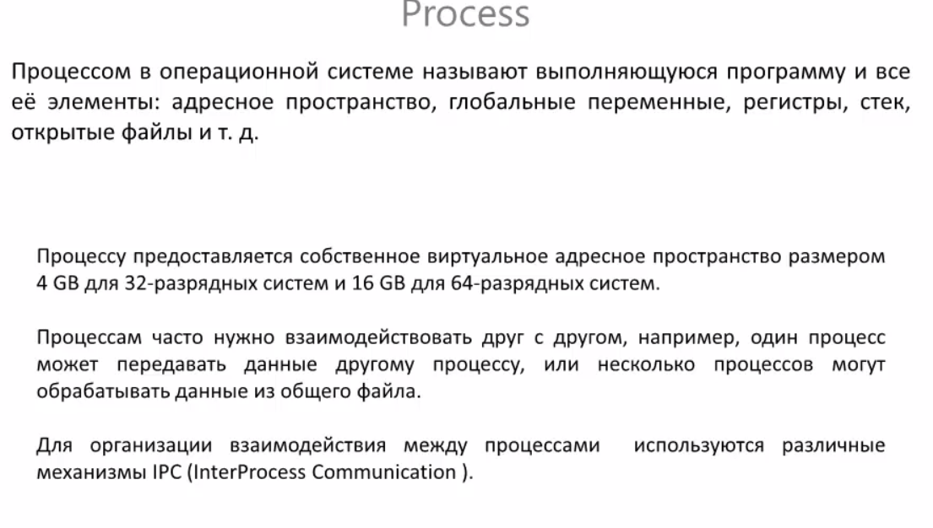

IPC(Inter Process Communication)

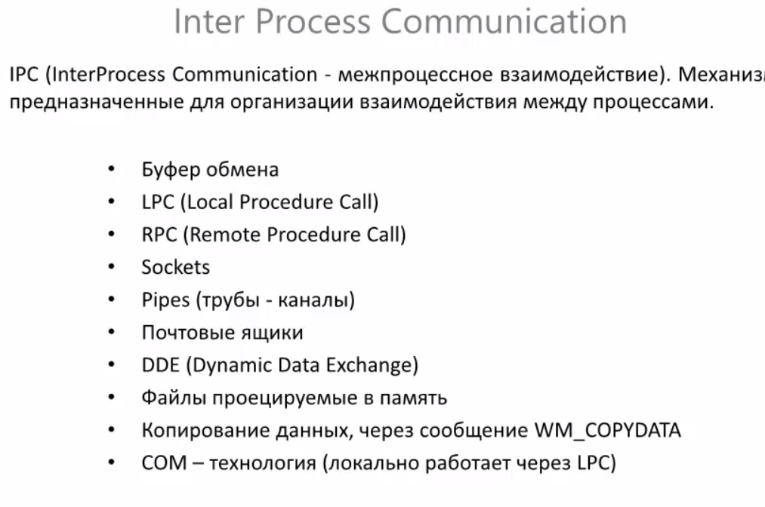

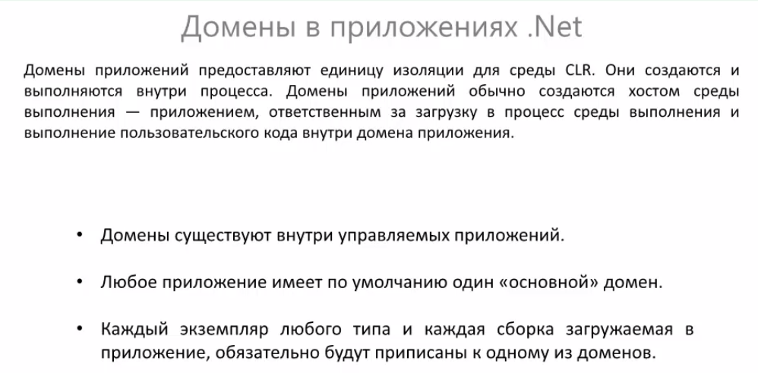

#### .NET Remoting

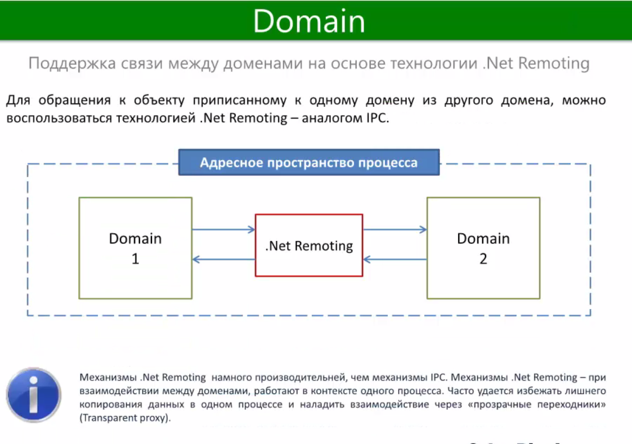

#### Domain and Threads

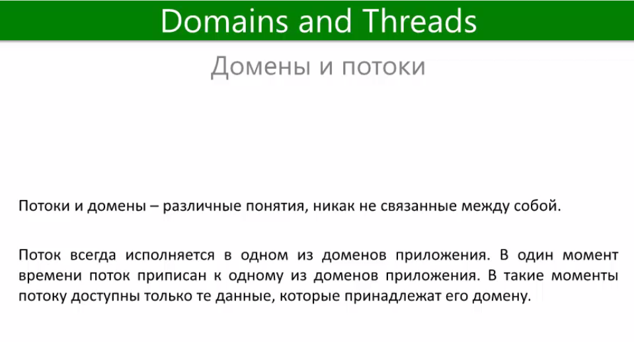

#### AppDomain

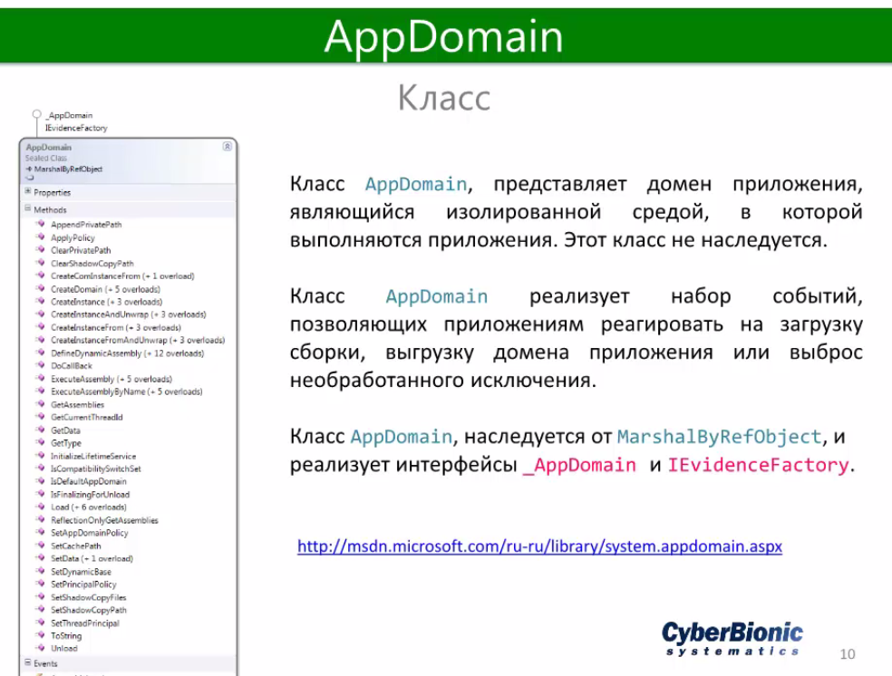

#### Example

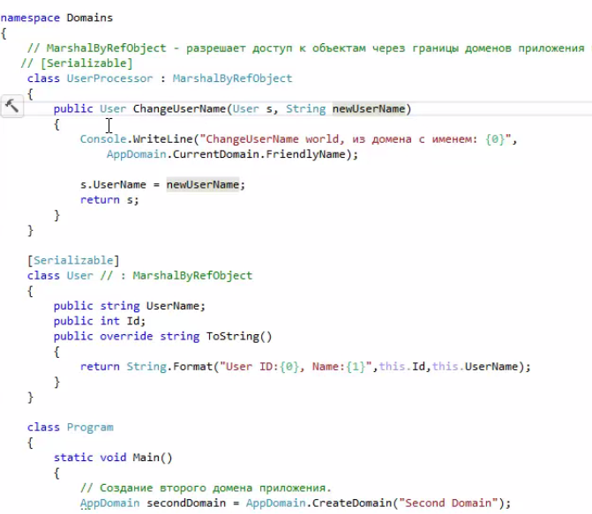

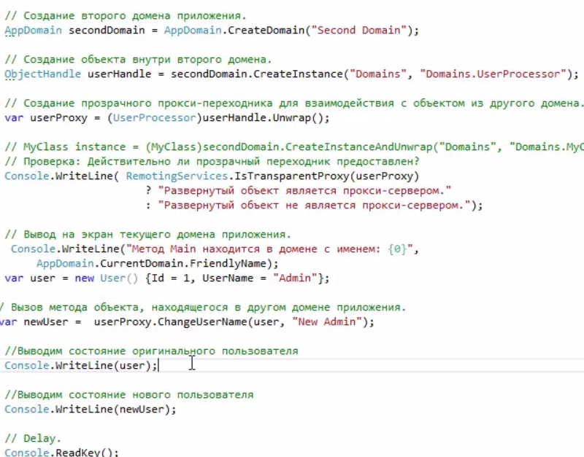

## Entity Framework

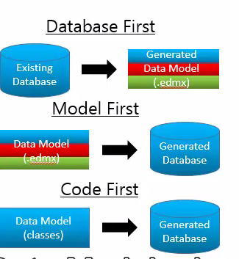

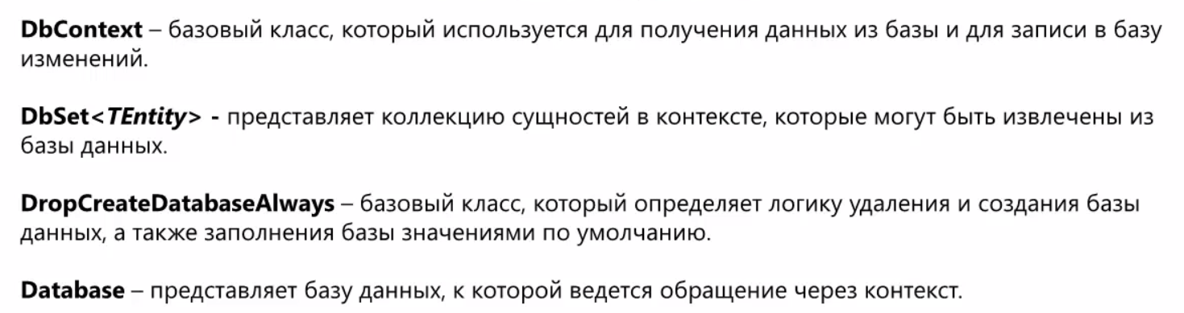

### CreateDB on app start

### Custom DB

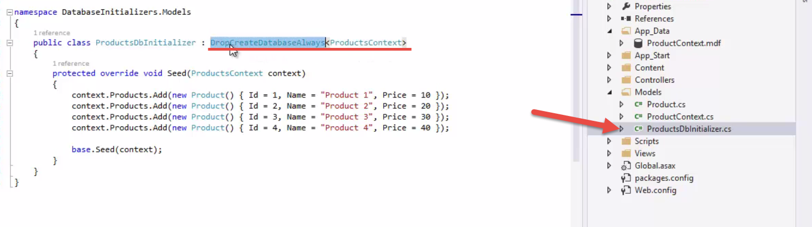

### Linq to entity

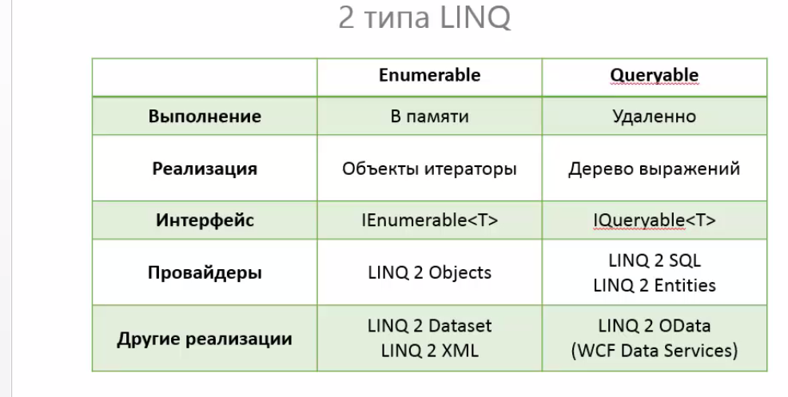

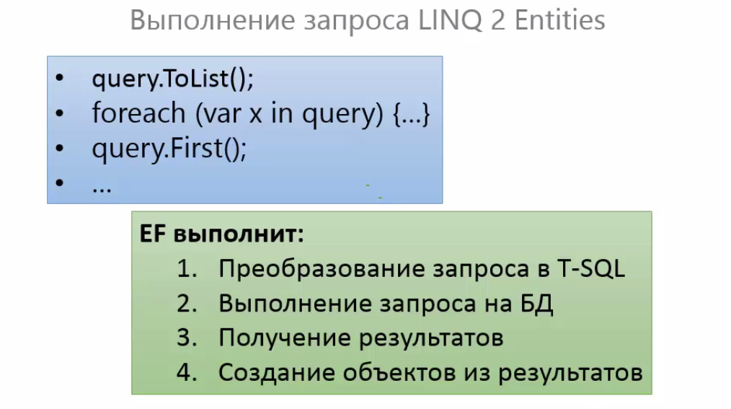

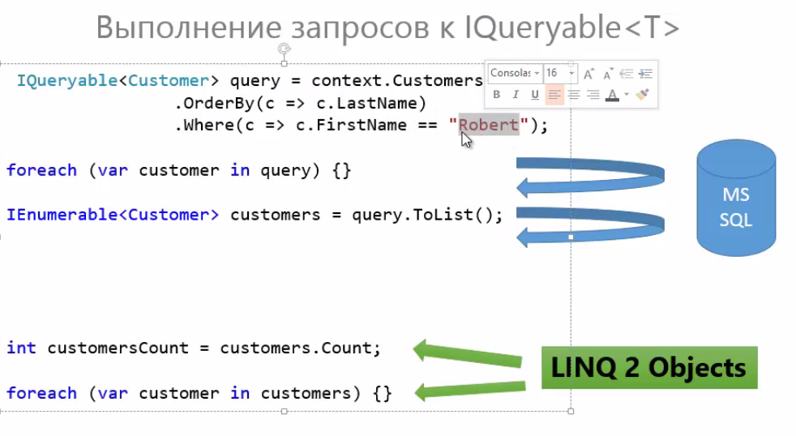

### Code First

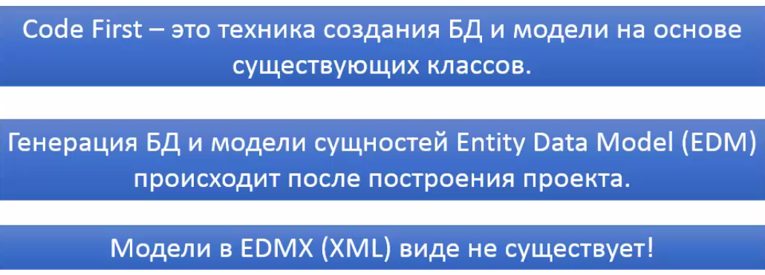

### Model Settings

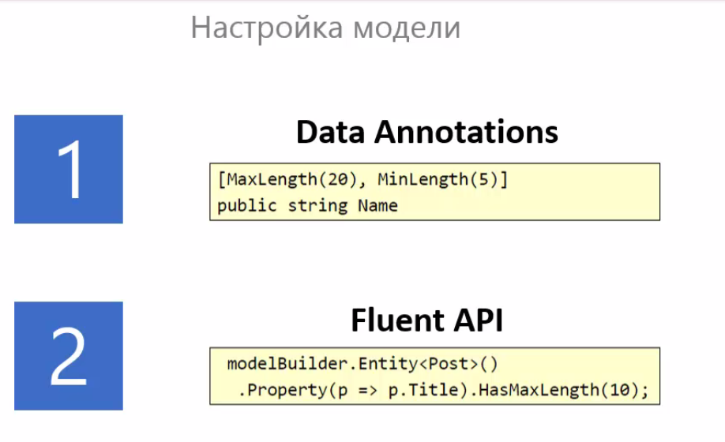

#### Data annotations

Perfect for simple DB

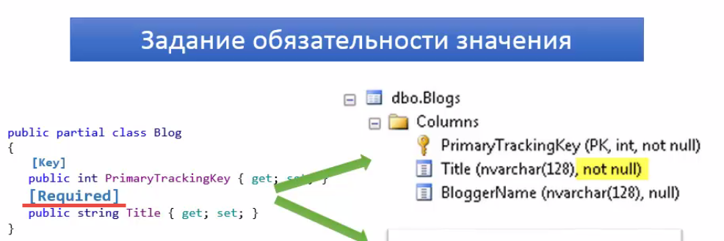

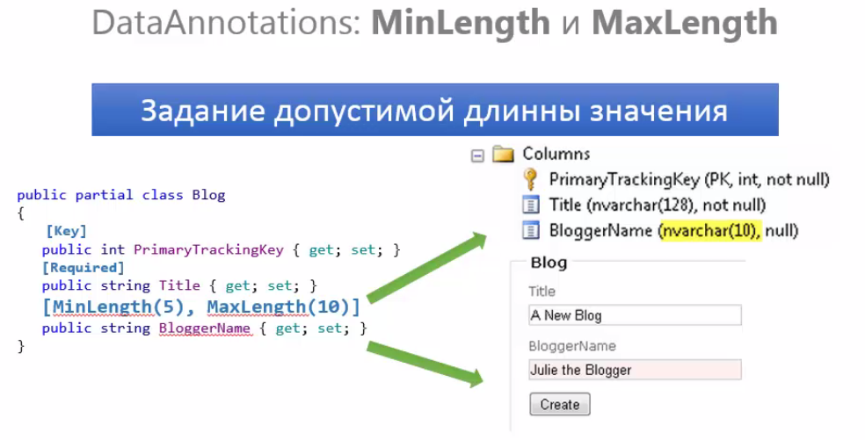

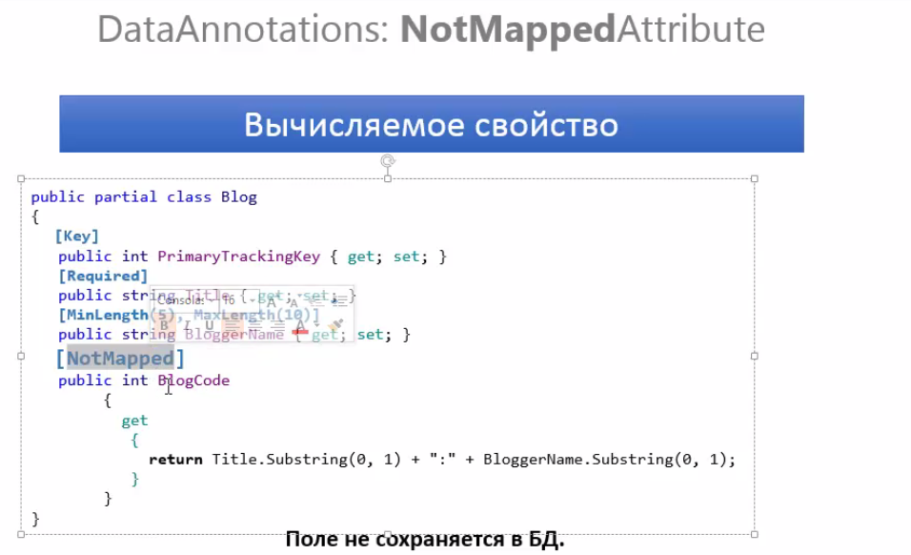

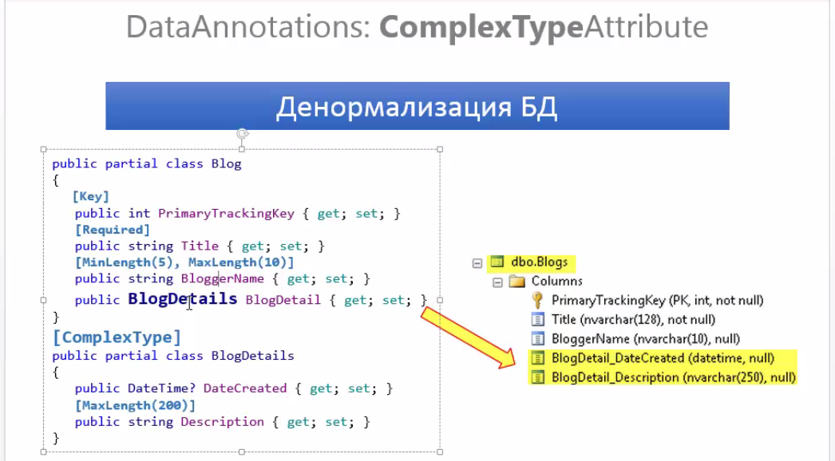

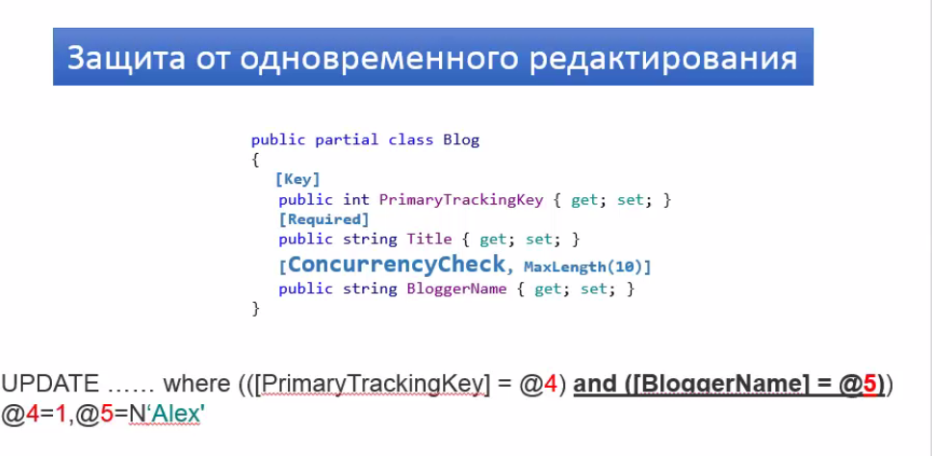

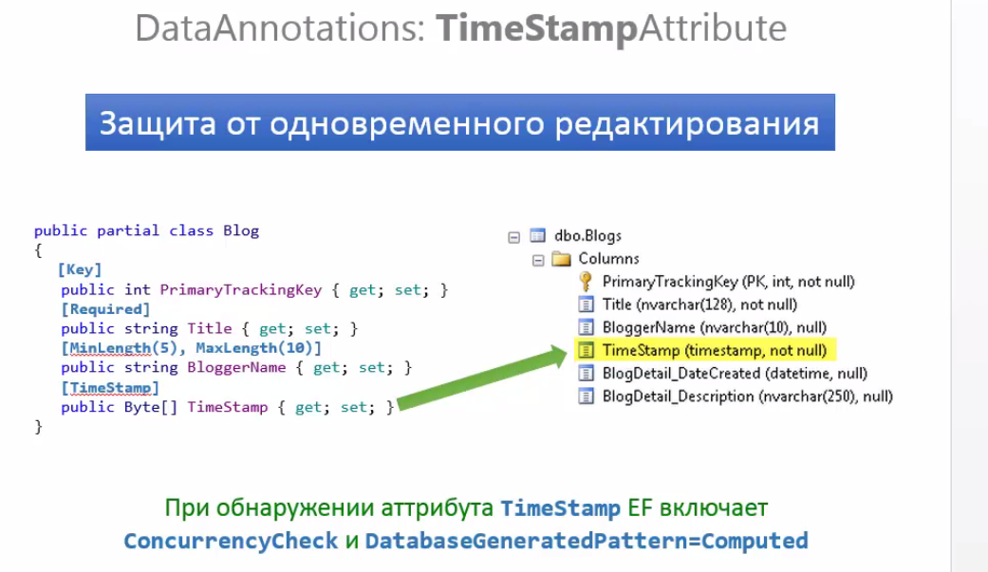

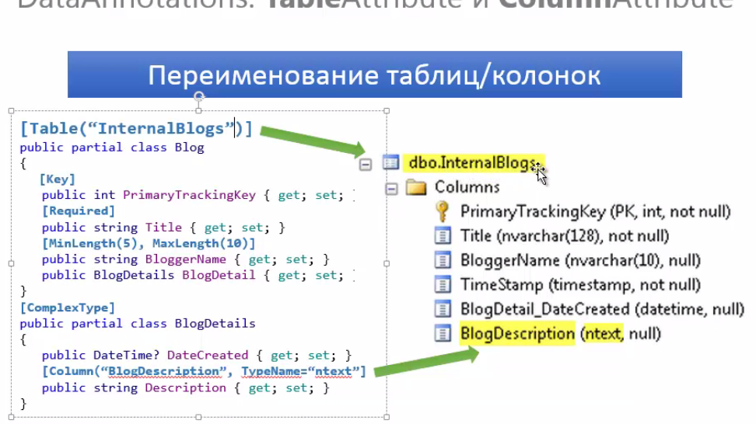

#### Fluent API

For complicated DB . Where you need where specific custom configurations.

### Create DB

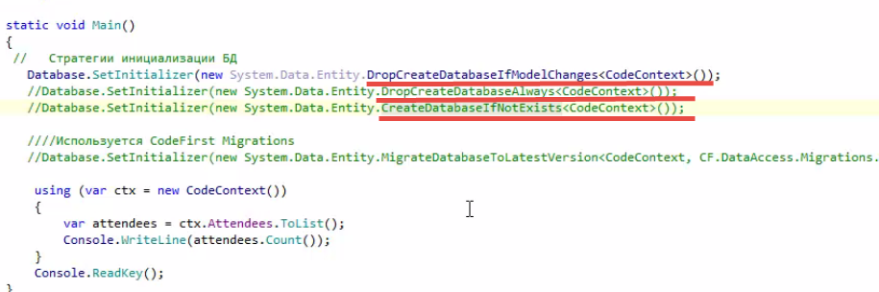

### DB context

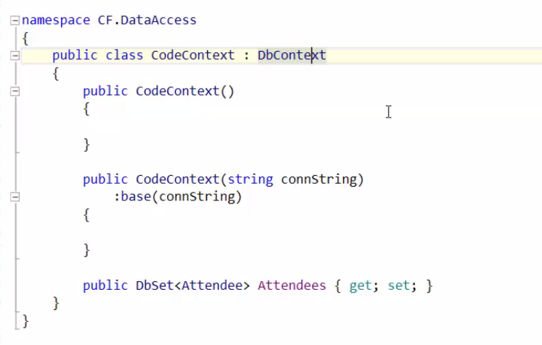

## ASP.Net

### Protocols

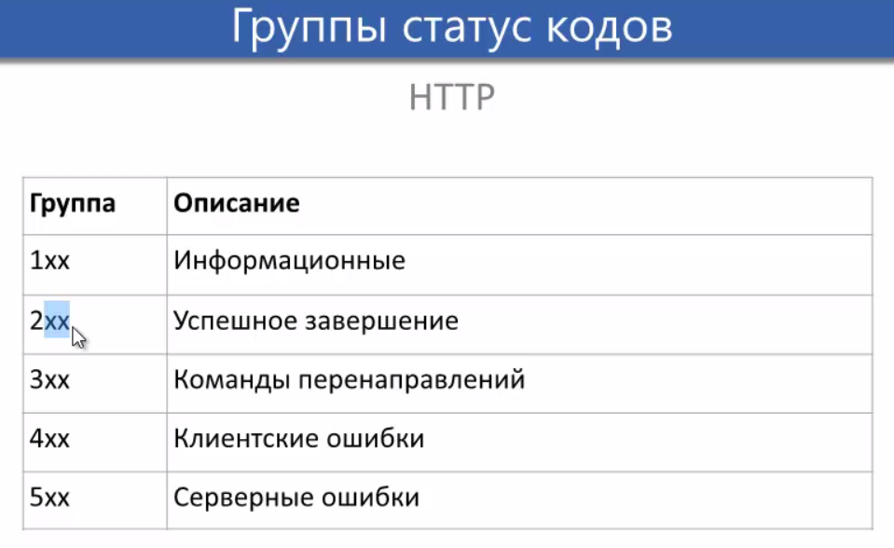

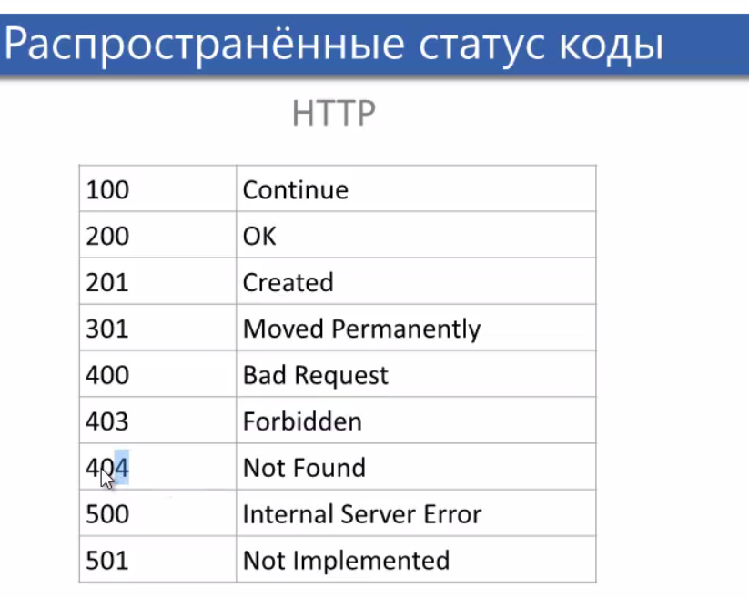

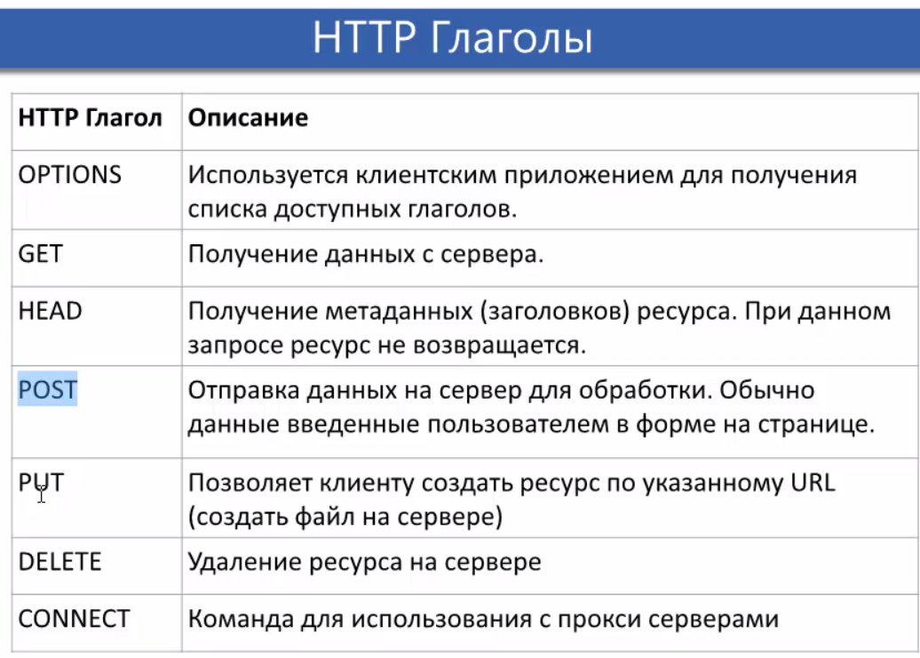

### App lifecycle

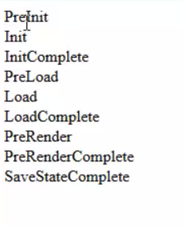

### Page prams



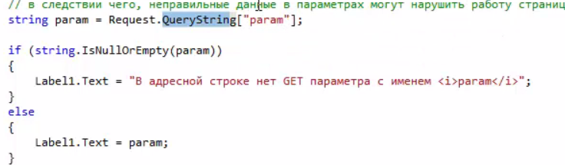

### Html Decode Encode

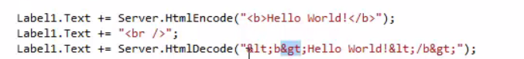

### Data storing

#### View State

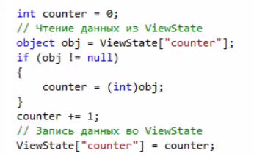

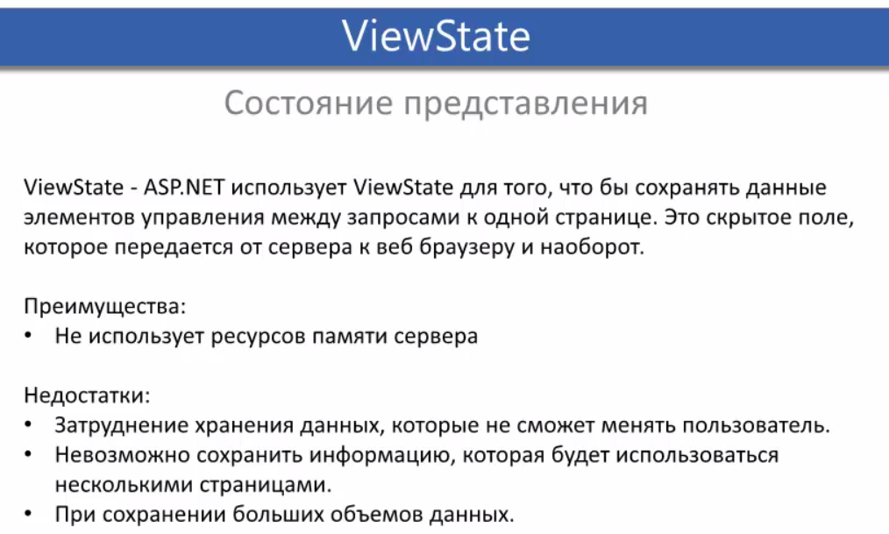

#### Page perms

[link](#_Page_prams)

#### cookie

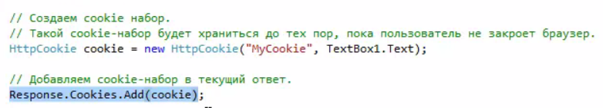

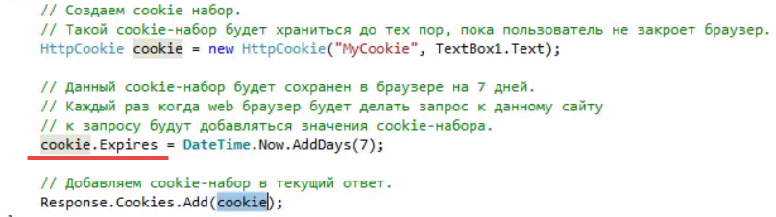

##### Remove cookie

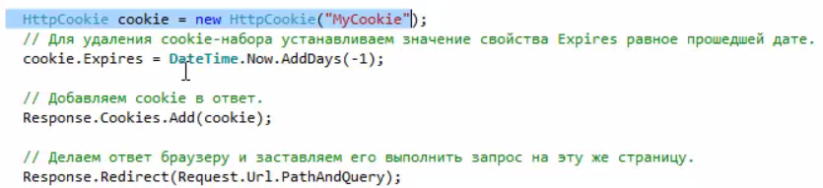

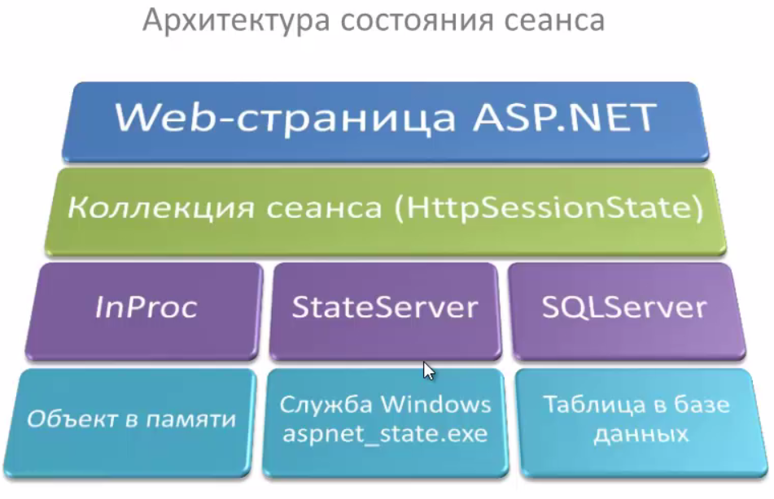

#### Session

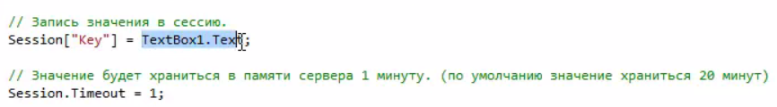

#### Application

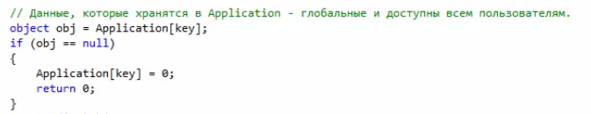

## ASP .NET MVC

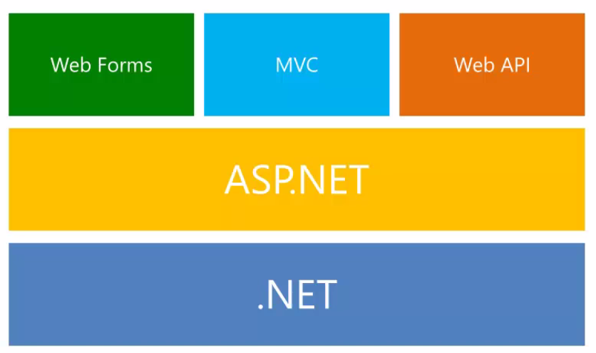

### Route config

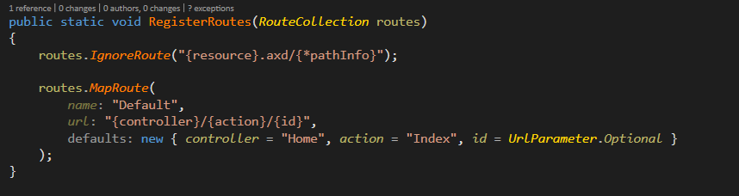

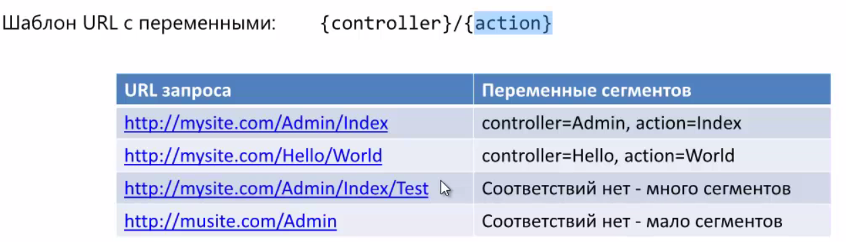

### Action Link

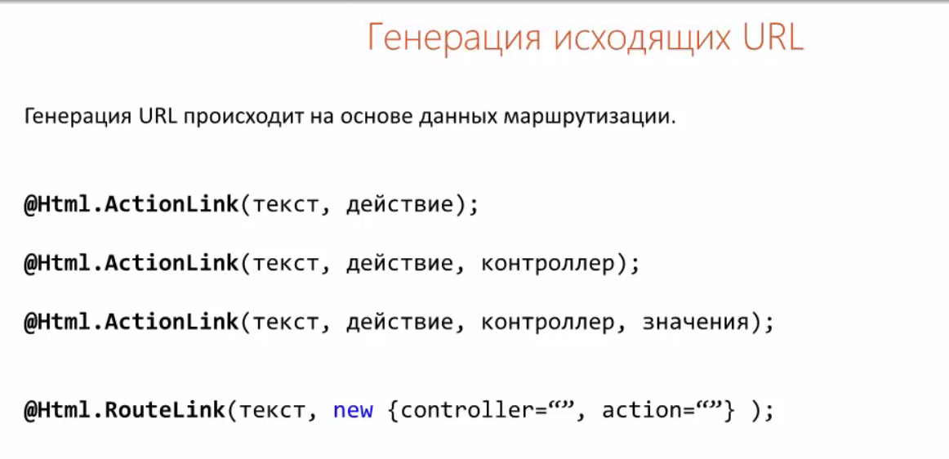



### Areas

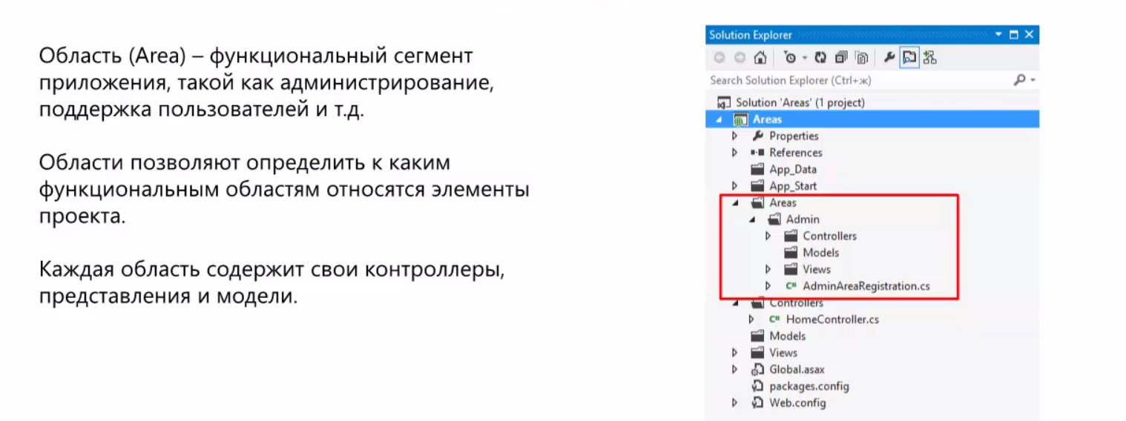



### HTML

#### Example

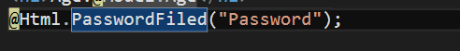

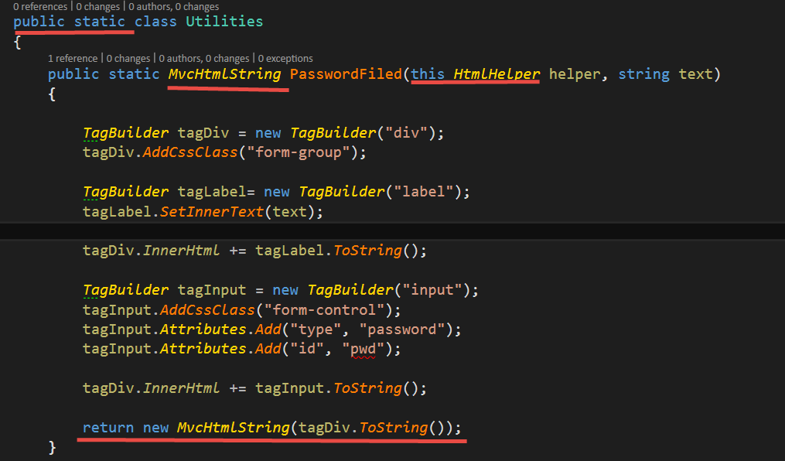

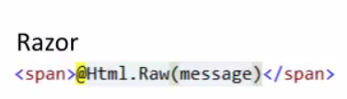 for decoding message

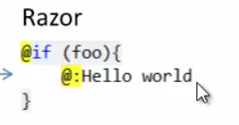

#### Methods

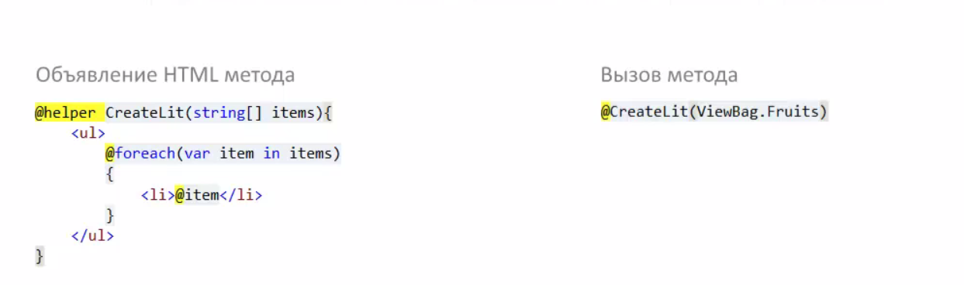

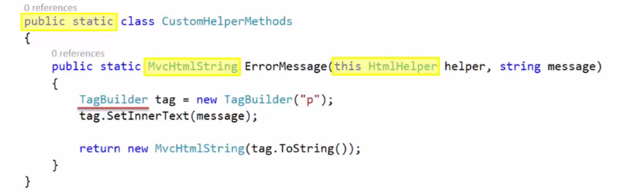

#### Set style

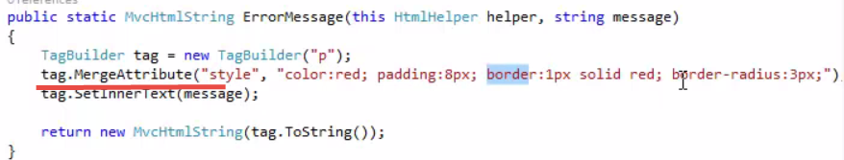

#### Elements

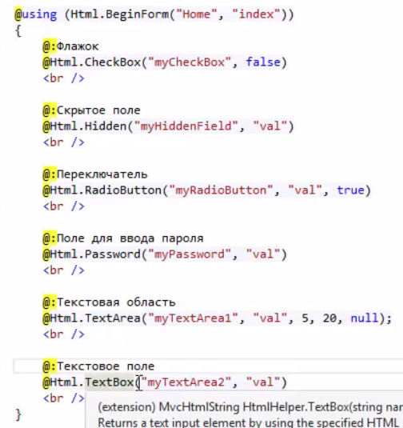

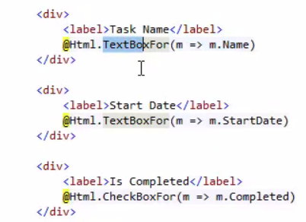

#### Grid

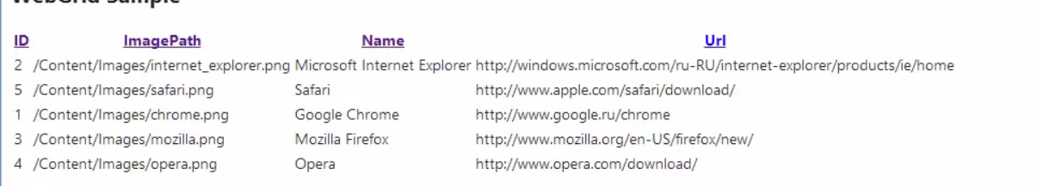

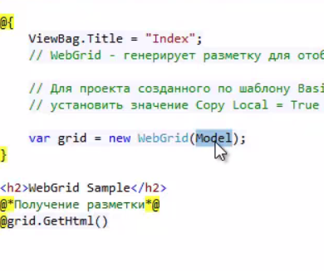



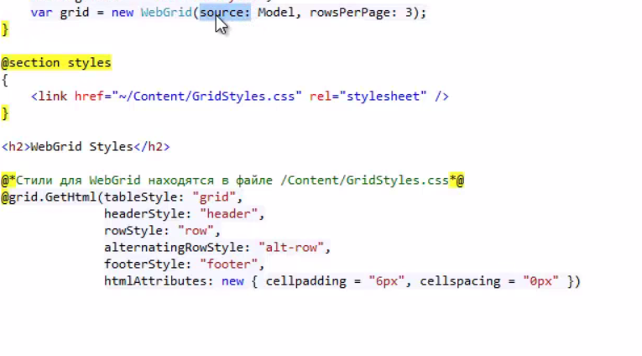

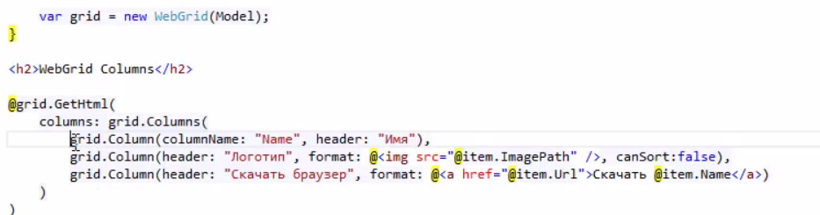

#### Form

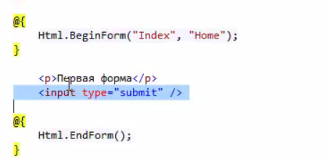

#### Form for Model

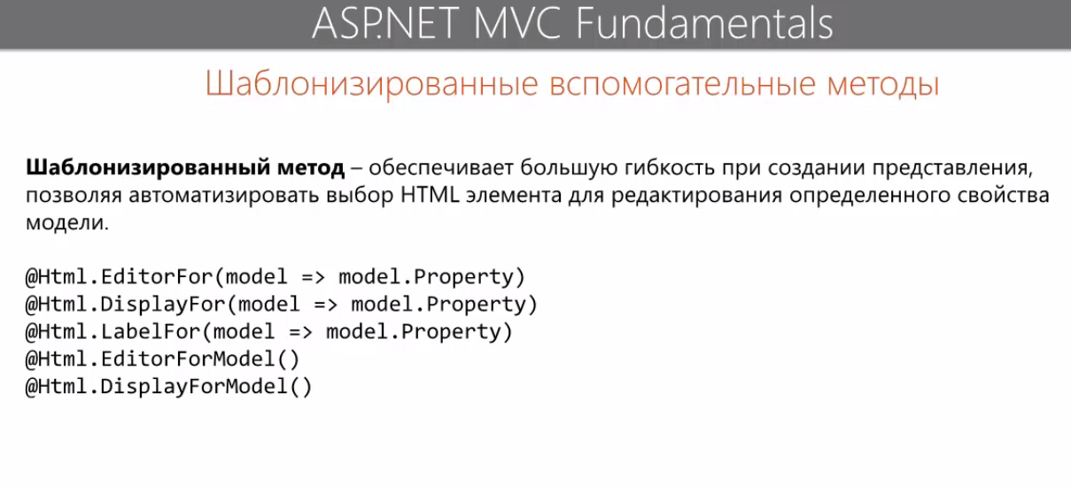

#### Form Lyamda

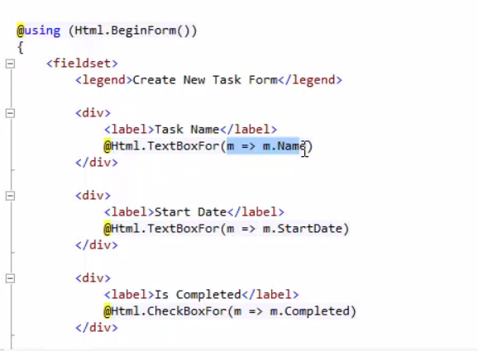

### Layout

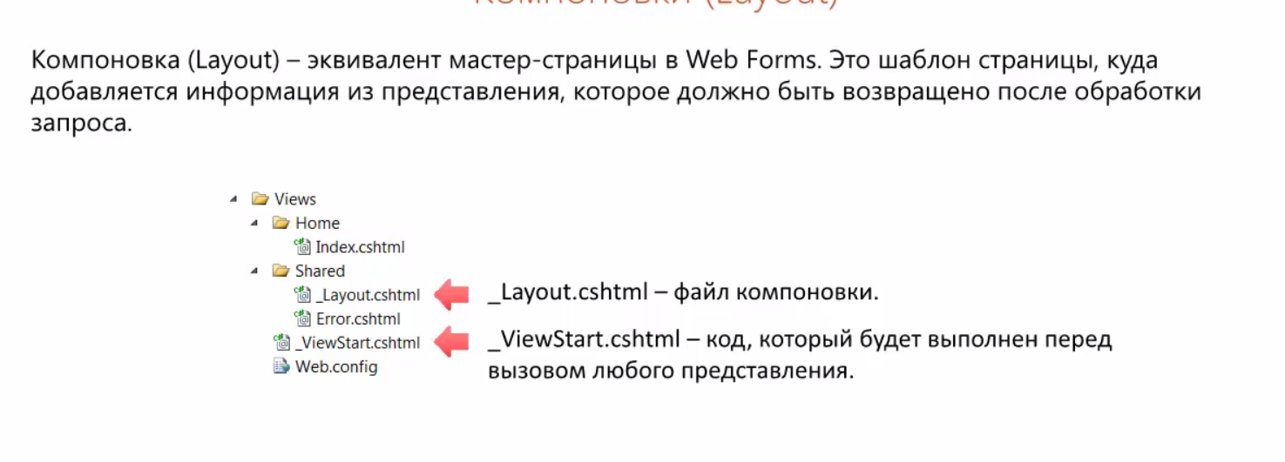

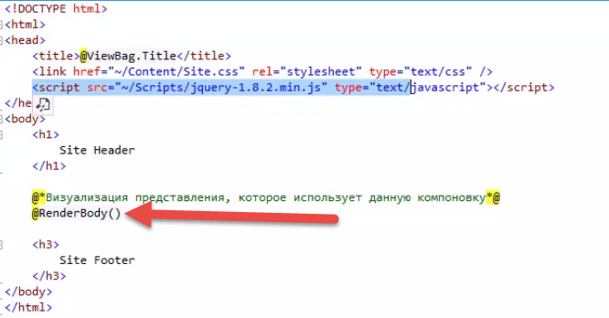

### View Start

Comman code for all pages

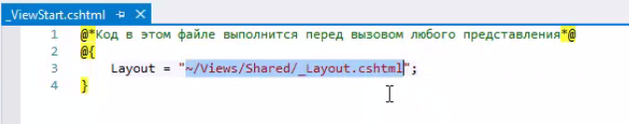

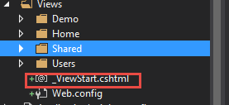

### RenderSection

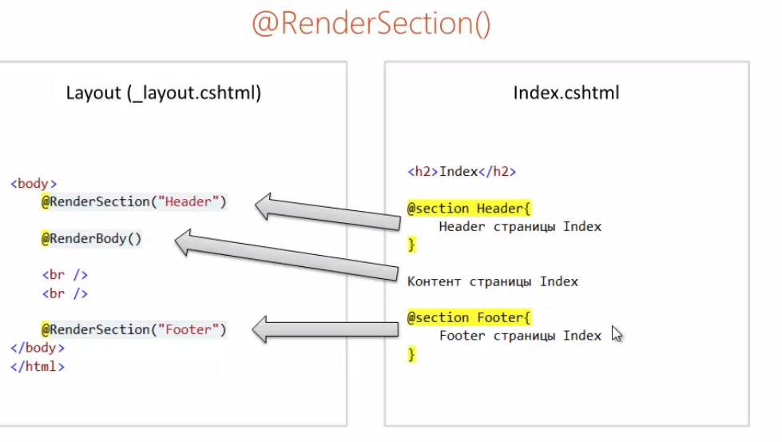

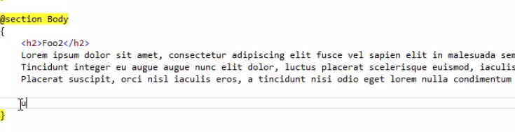

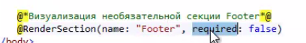

### Partial

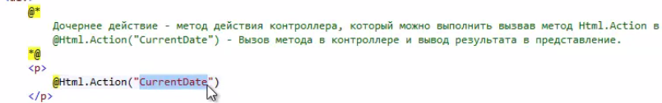

### Controller

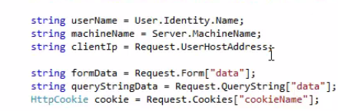

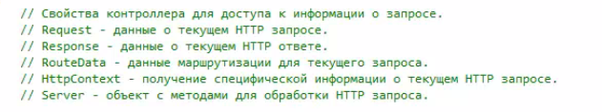

#### Sending data to server



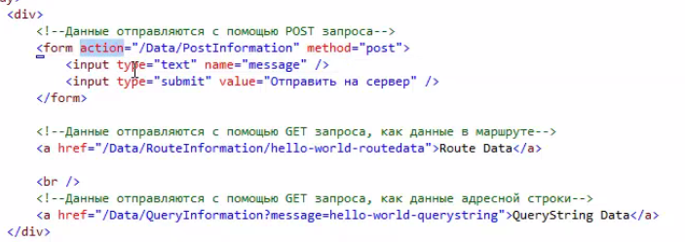

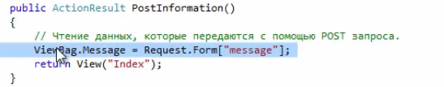

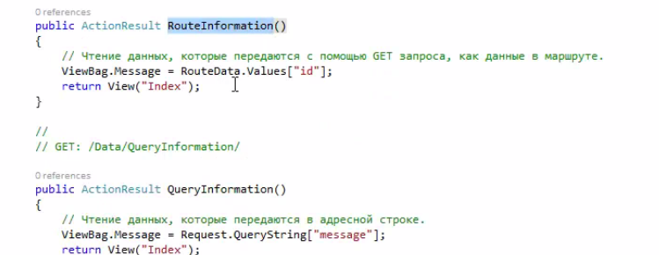 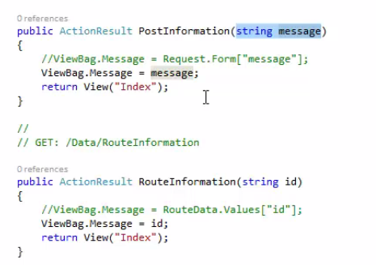



#### Controller to Model

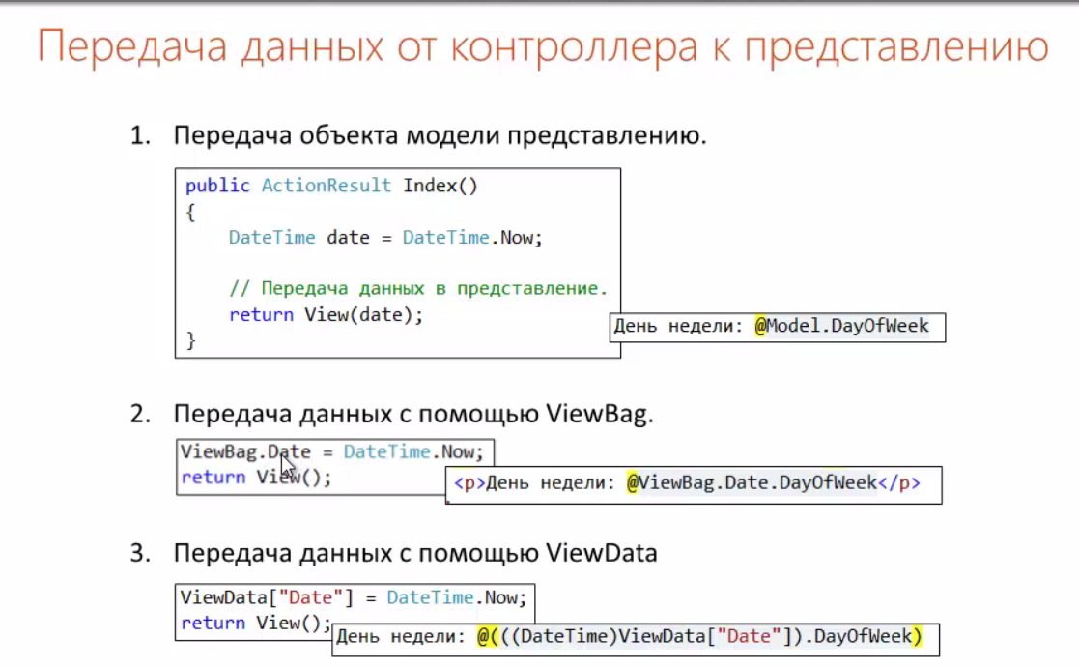

#### Example

##### Controller

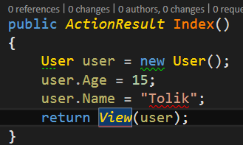

##### View

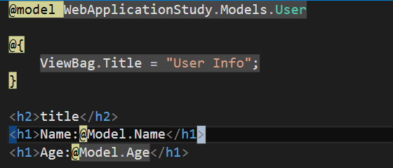

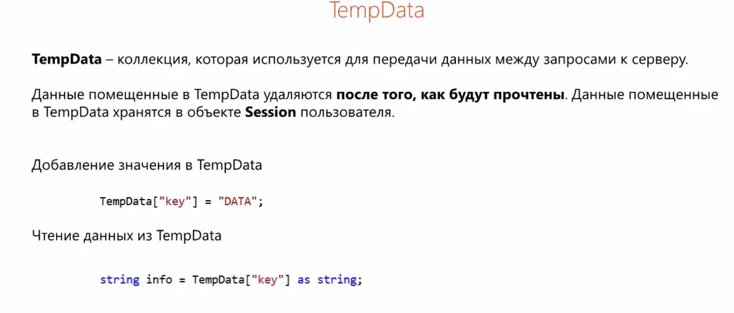

#### ActionResult

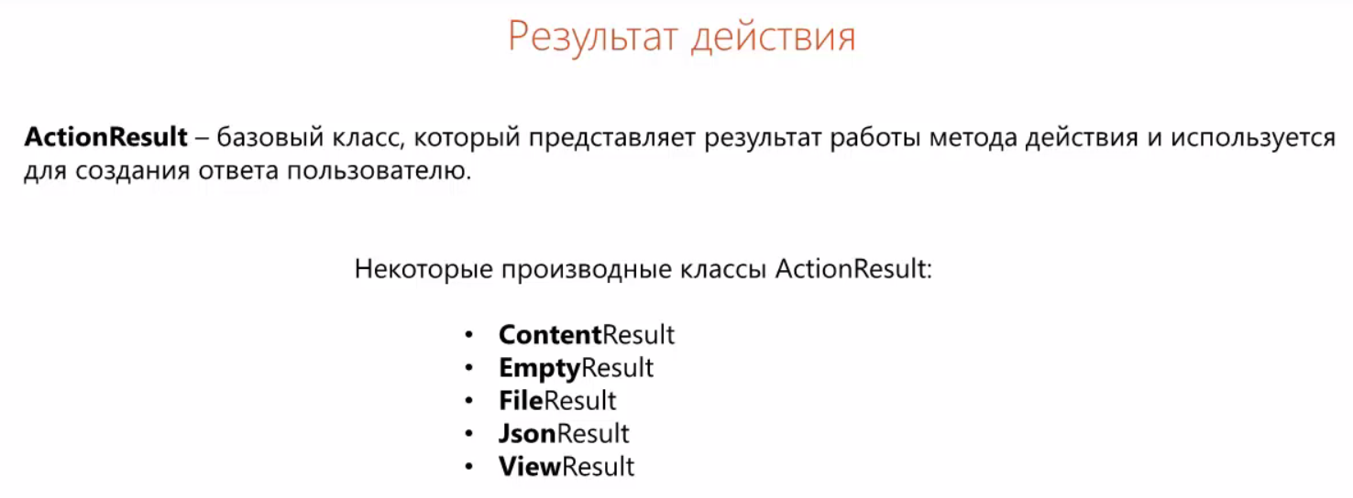

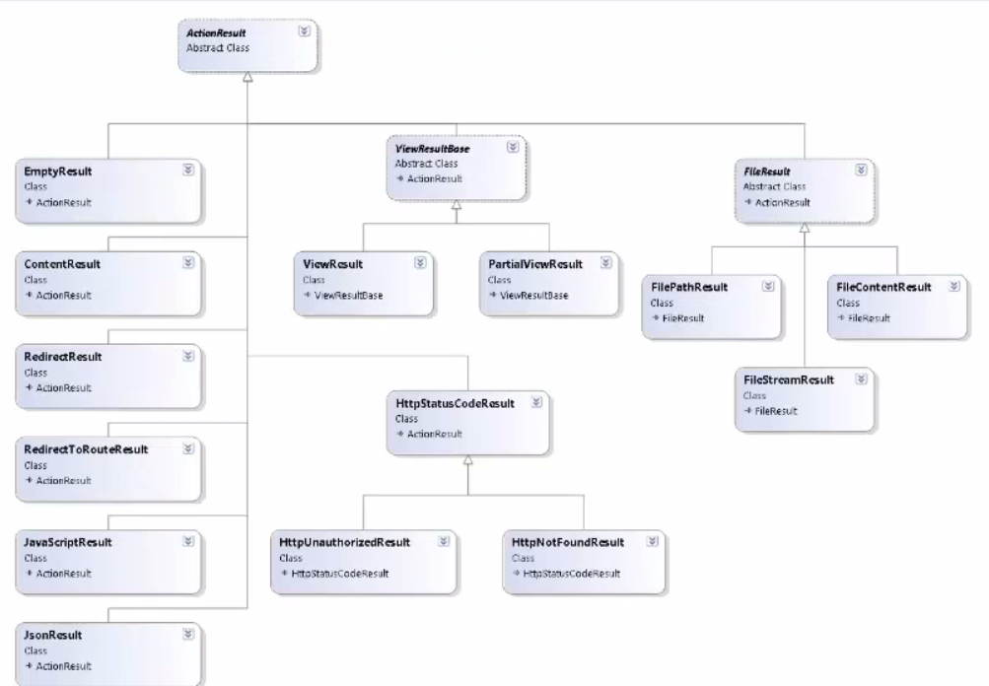

##### Redirect

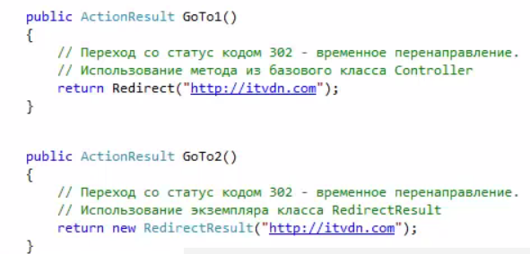

##### Content

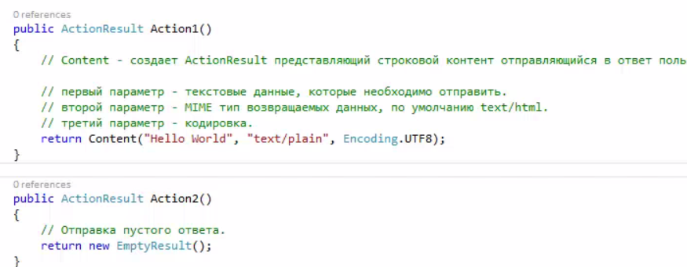

##### JSON

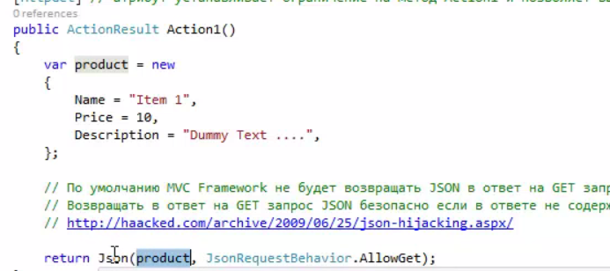

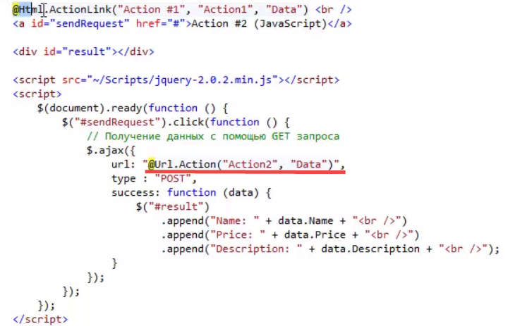

##### File

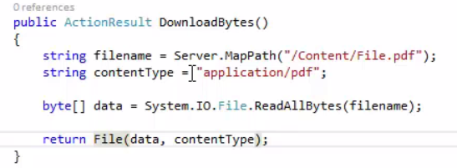

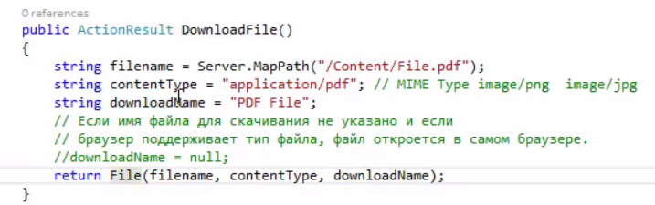

### Model

#### Basics

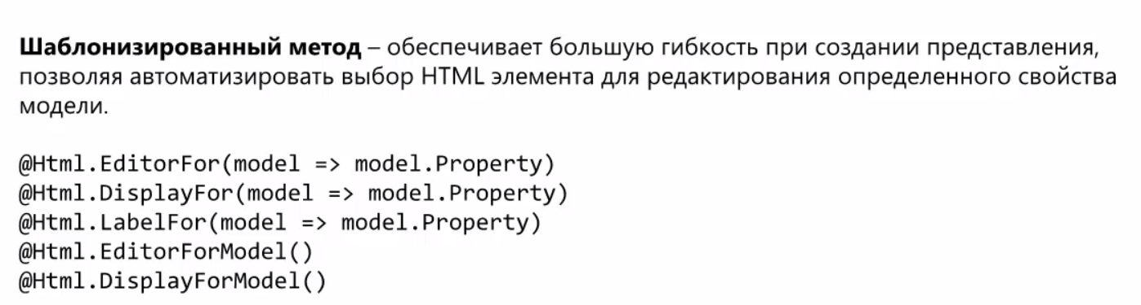

#### Example

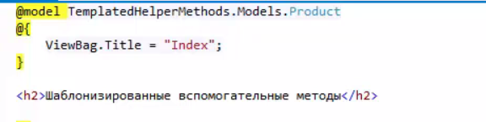

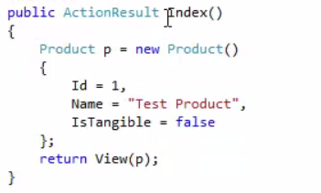

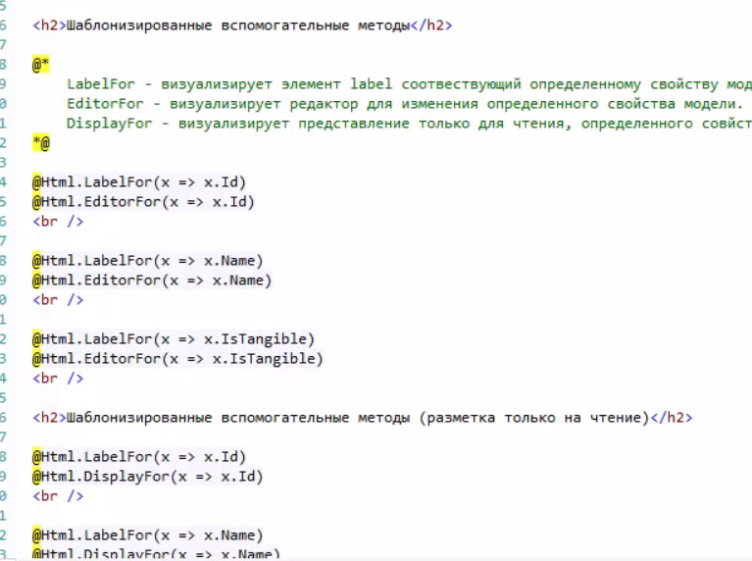

#### Tags

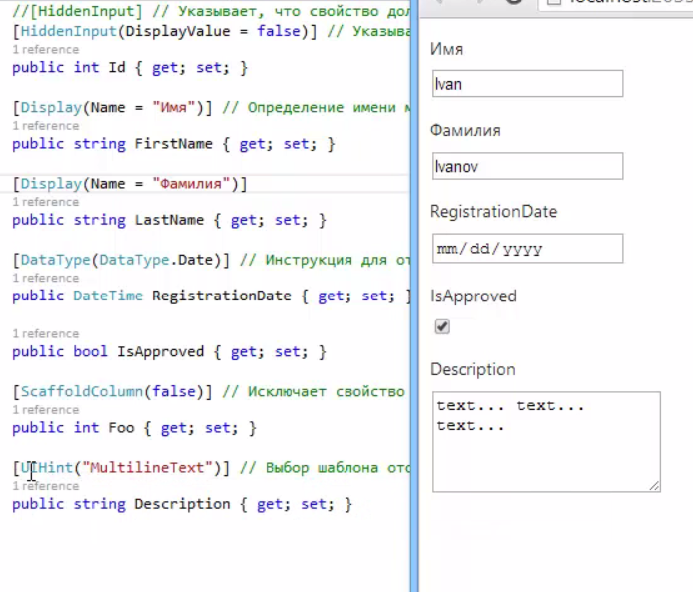

#### Methods

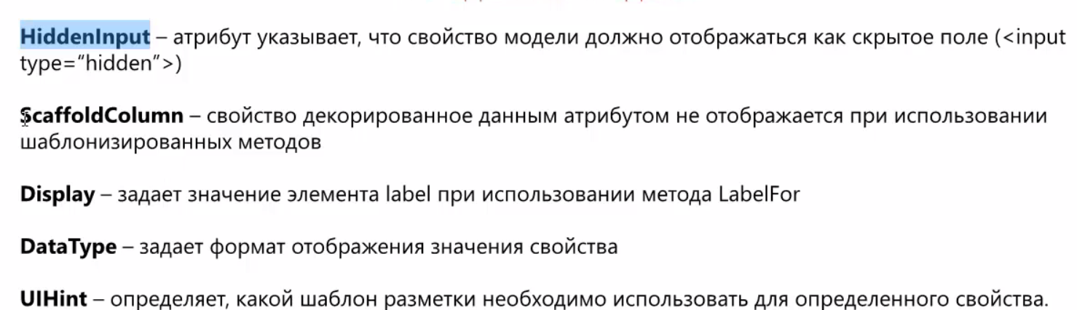

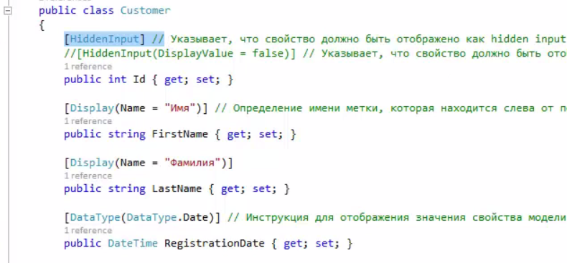

#### Custom Templets

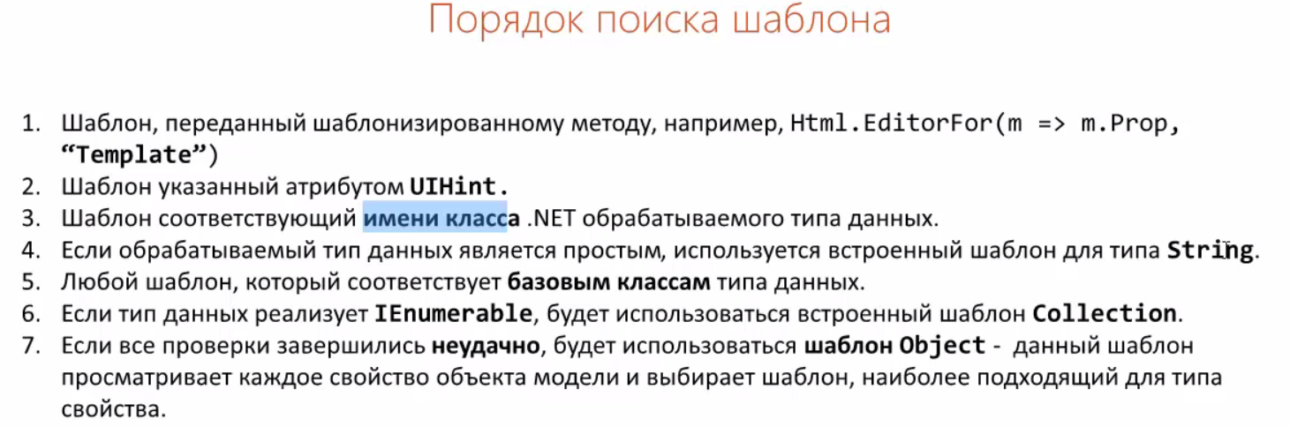

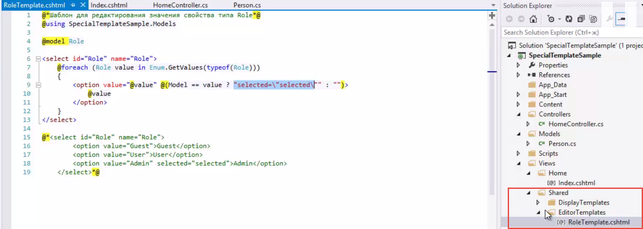

##### using



### Model Binder

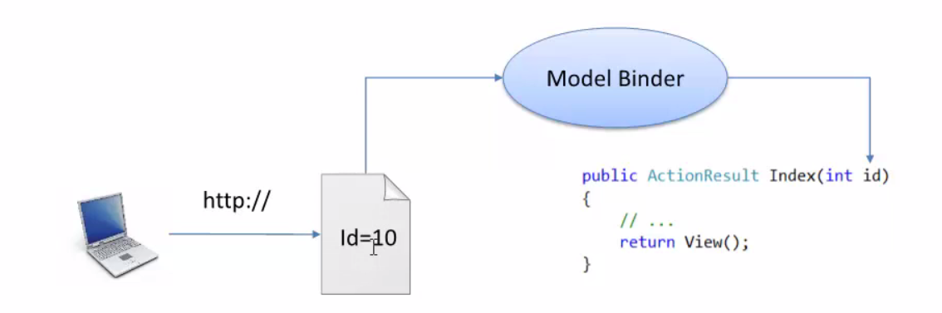

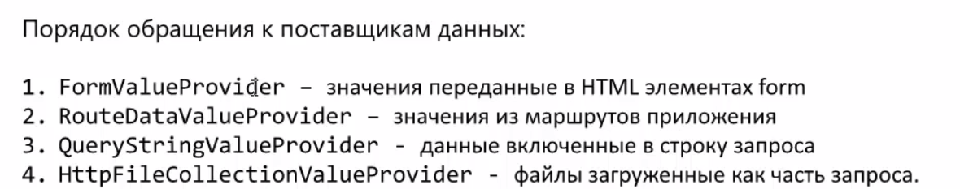

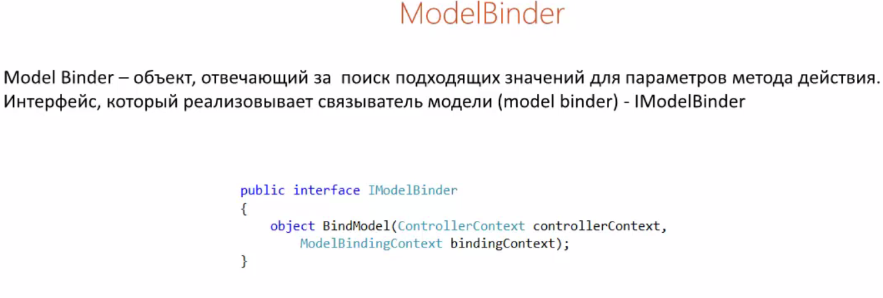

#### Complicated model

##### Two classes

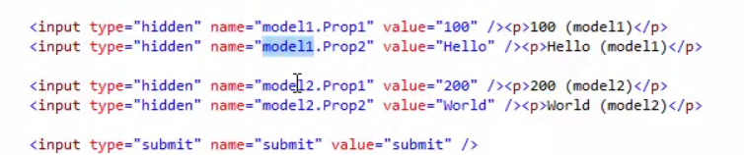

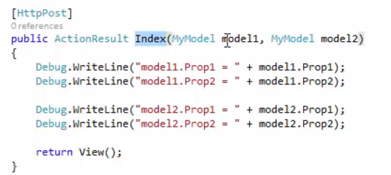

##### Array

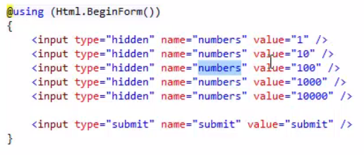

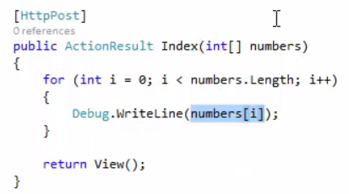

##### UpdateModel

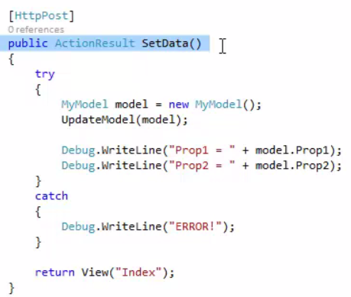

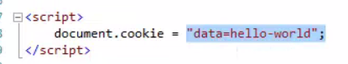

##### Custom Value Provider

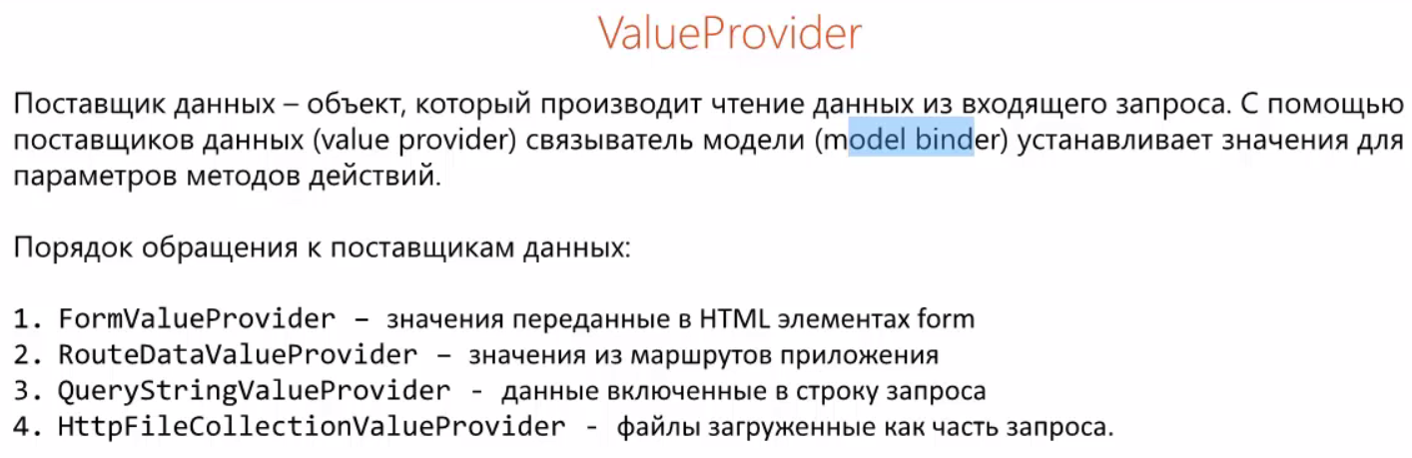

###### Value Provider

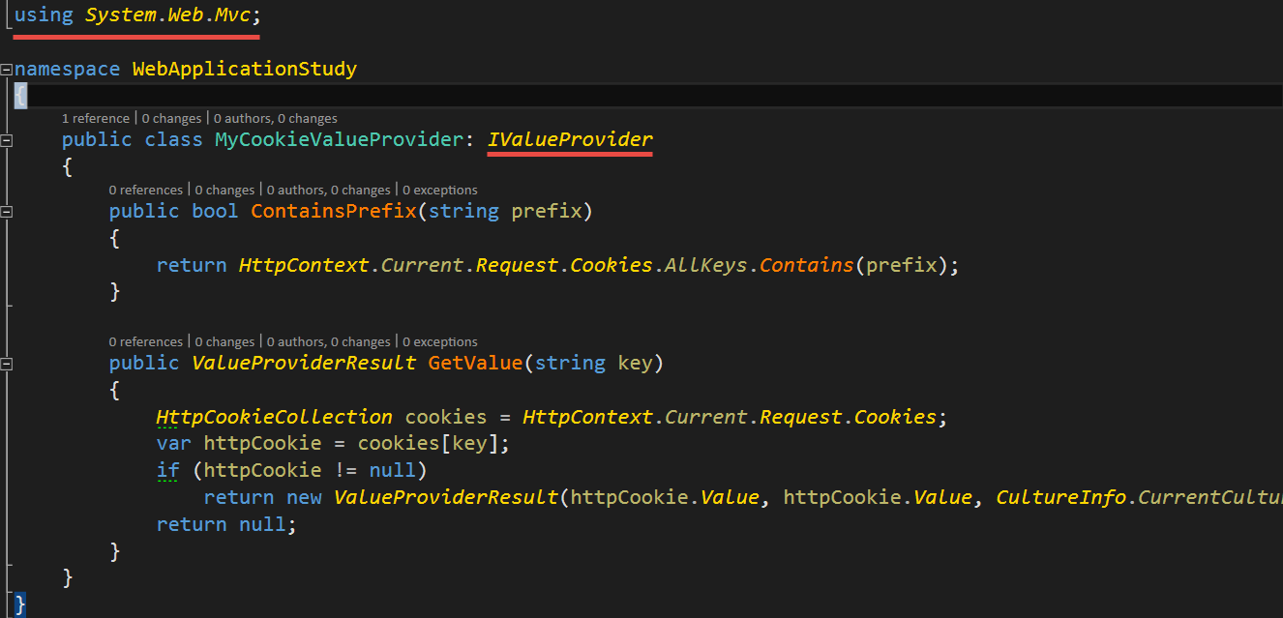

###### Value Provider Factory

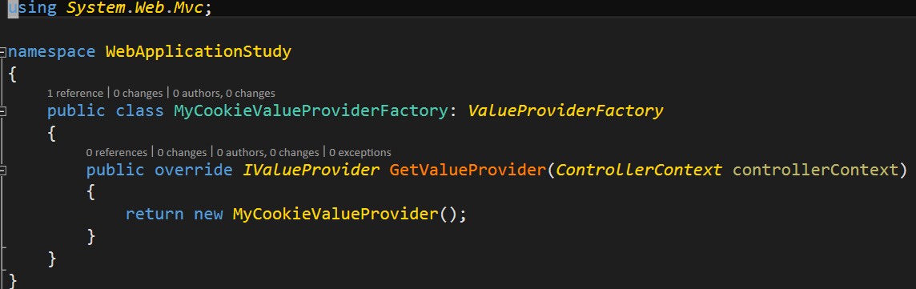

###### Global asax

Registration on the start

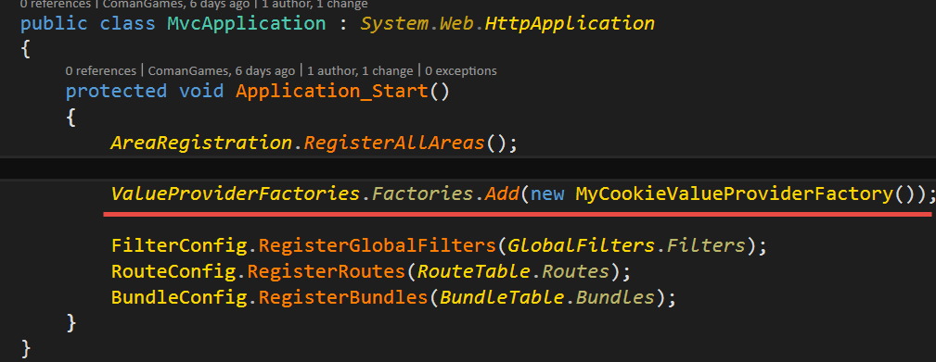

###### Example

Controller

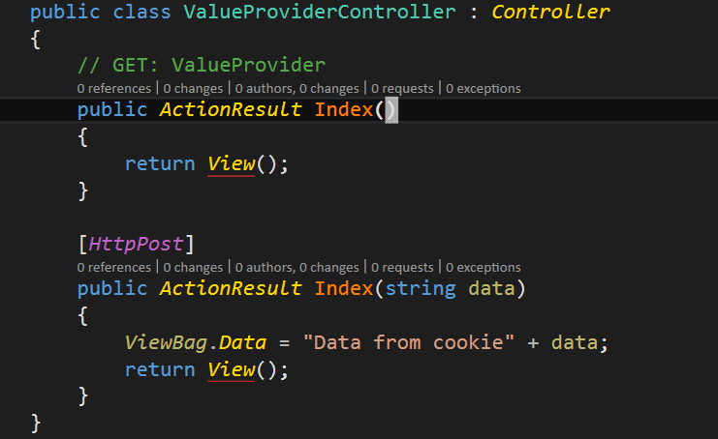

View

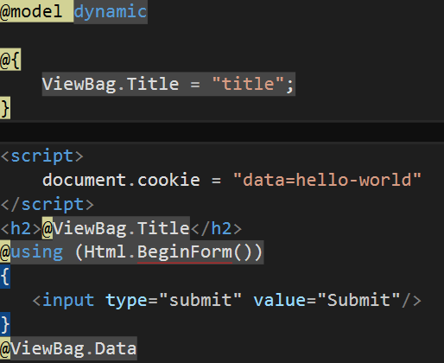

### Custom ModelBindling

#### MyModel

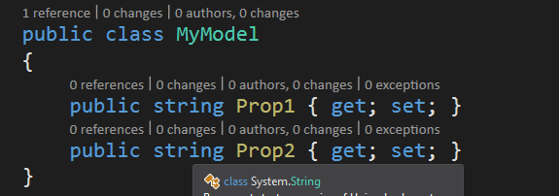

#### Controller

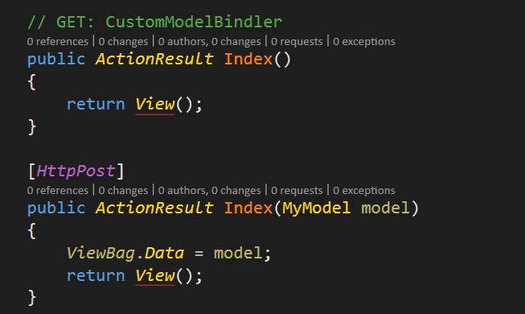

#### View

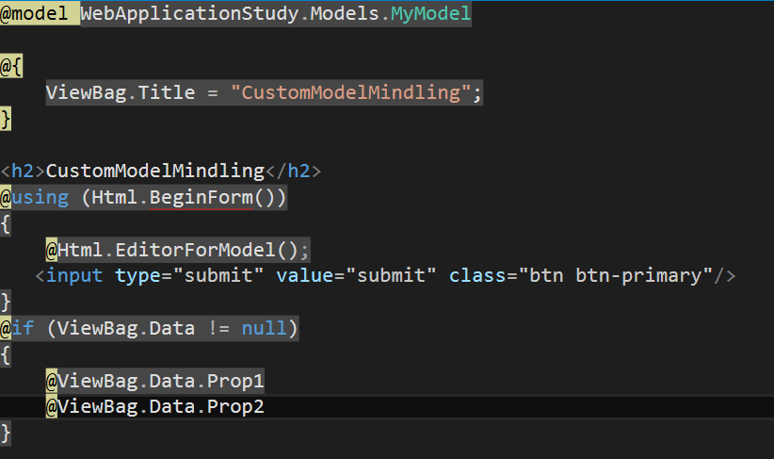

#### Model Bindler

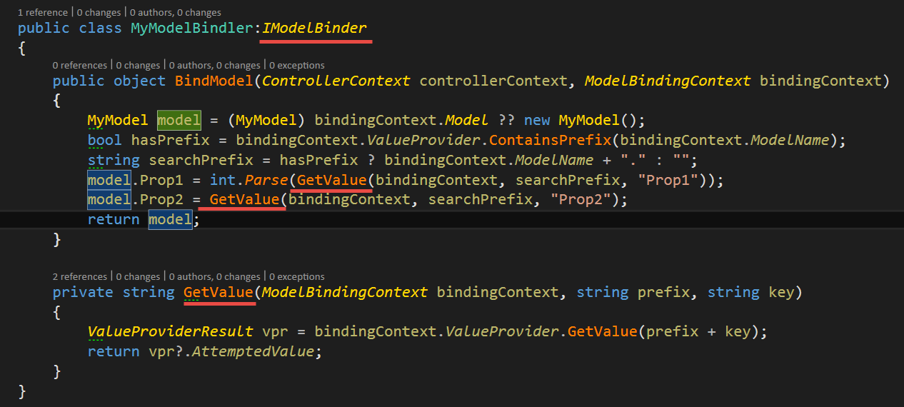

#### Global.asax

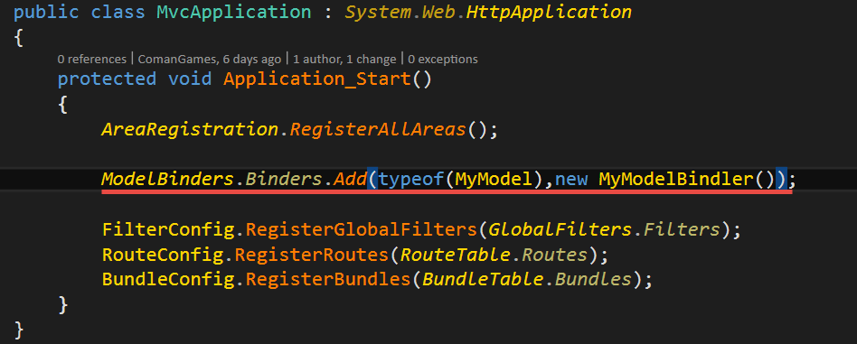

### Model Validataion

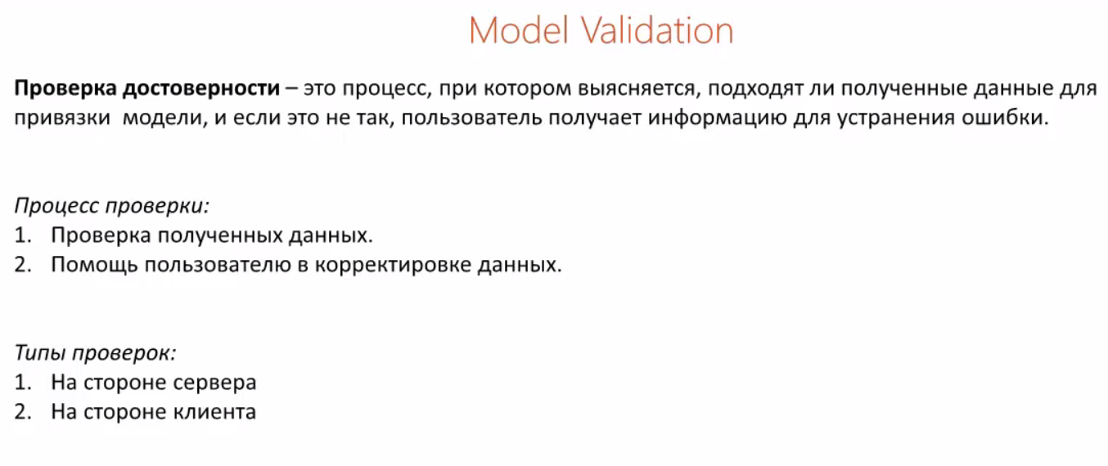

#### zzExample

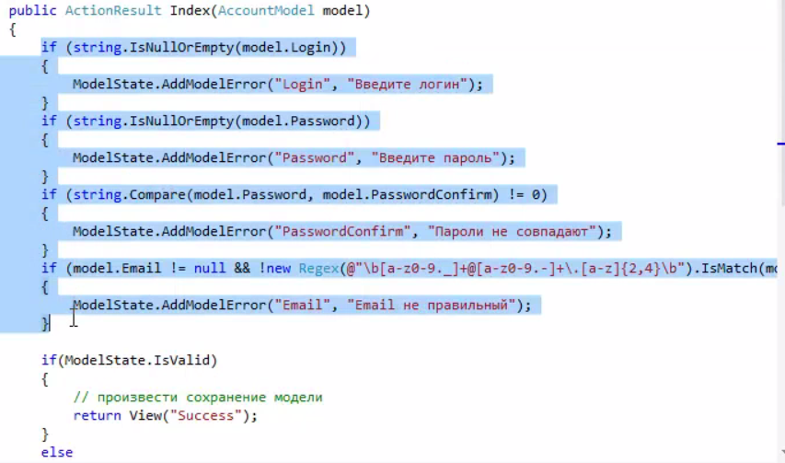

#### Global Validation Errors

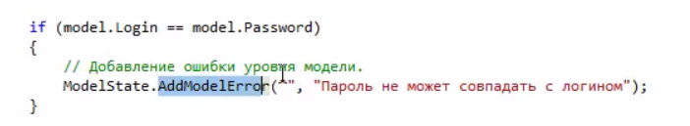

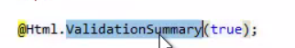

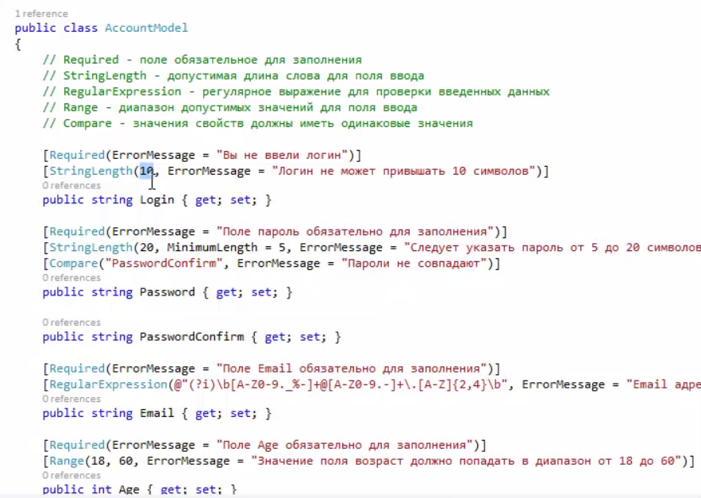

#### Custom Attribute

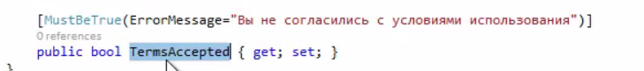

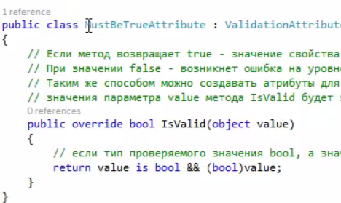

#### Validation on client side

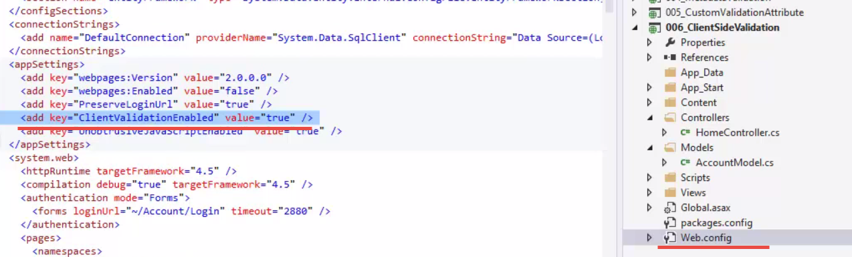

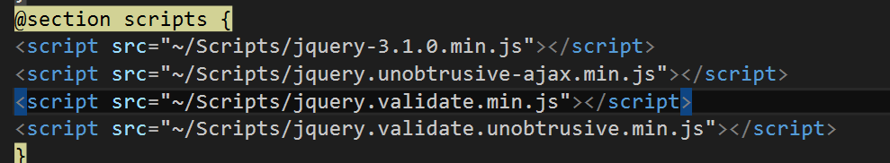



### Filter

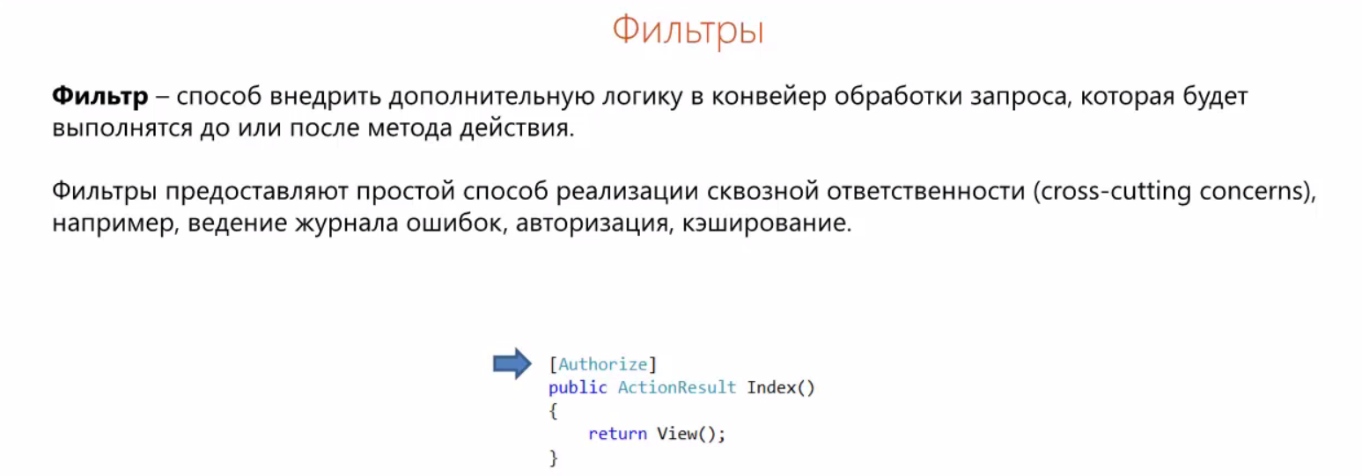

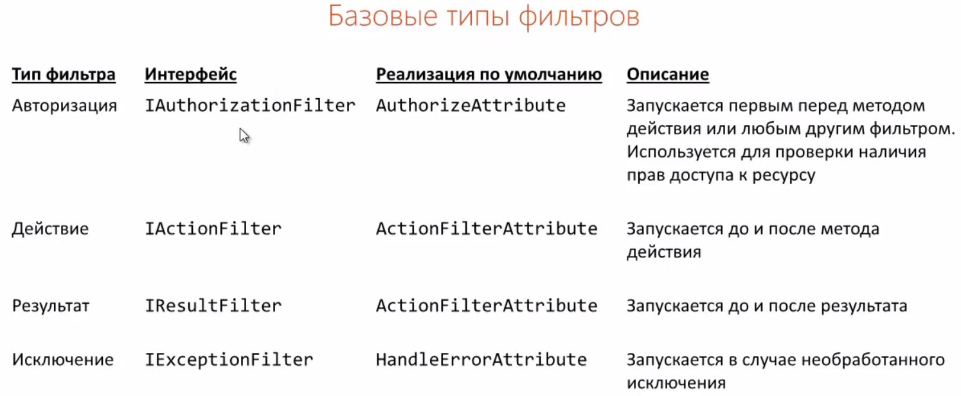

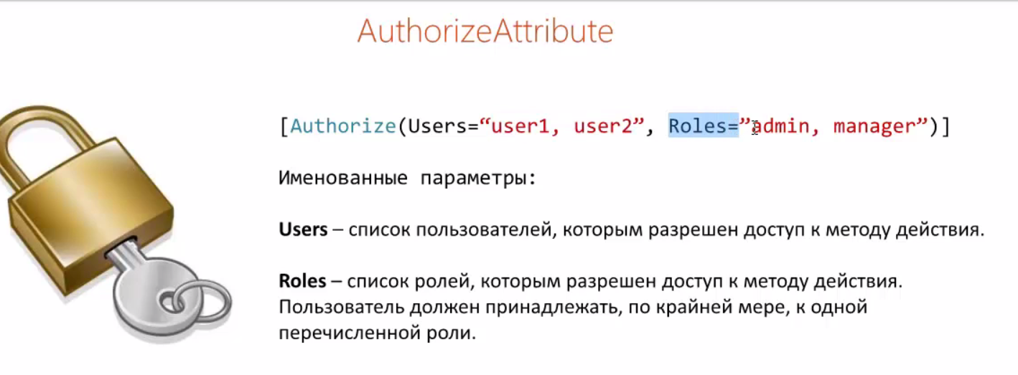

### Cache

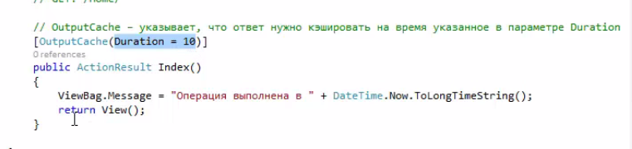

### Authorization

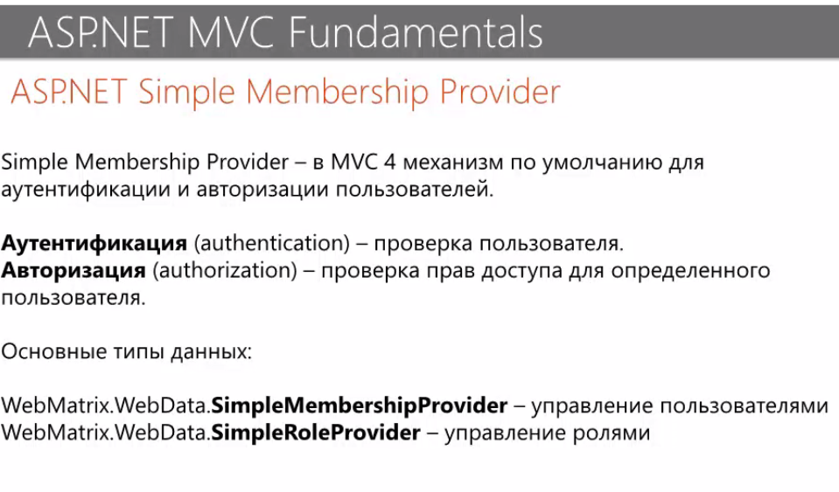

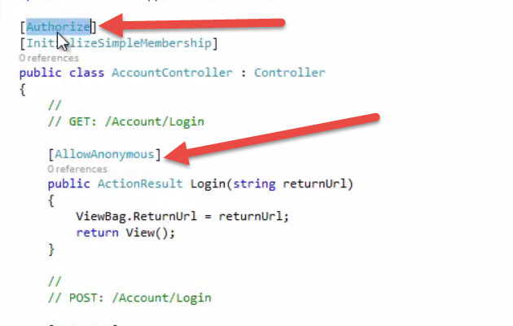

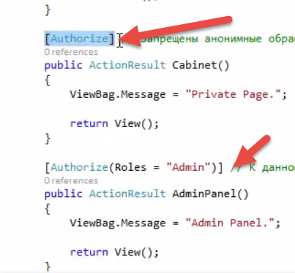

### AJAX

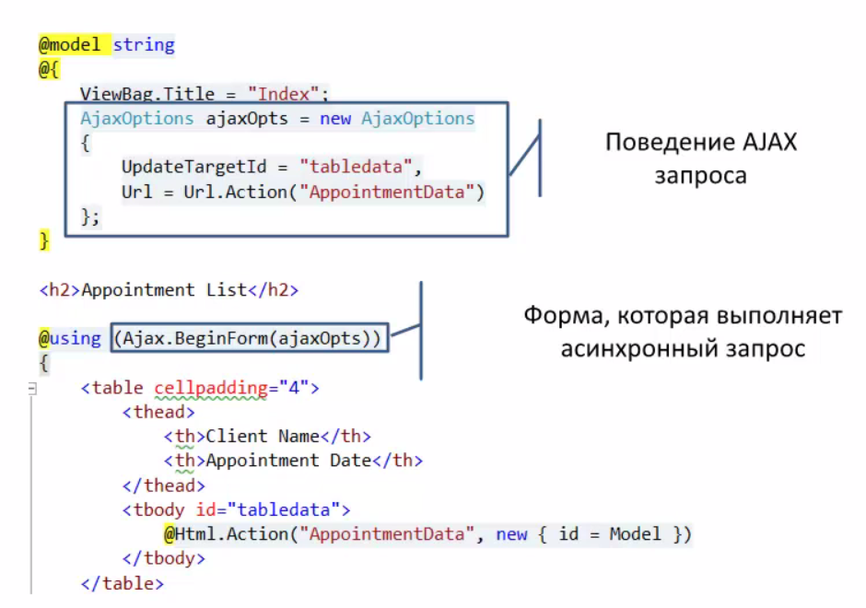

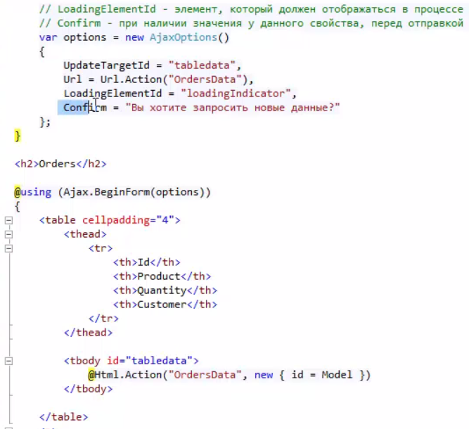

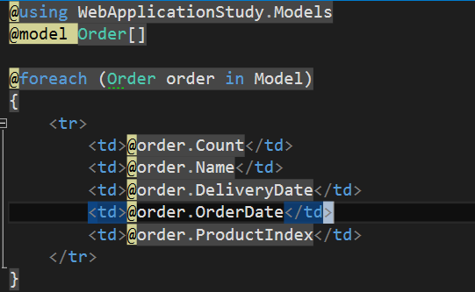

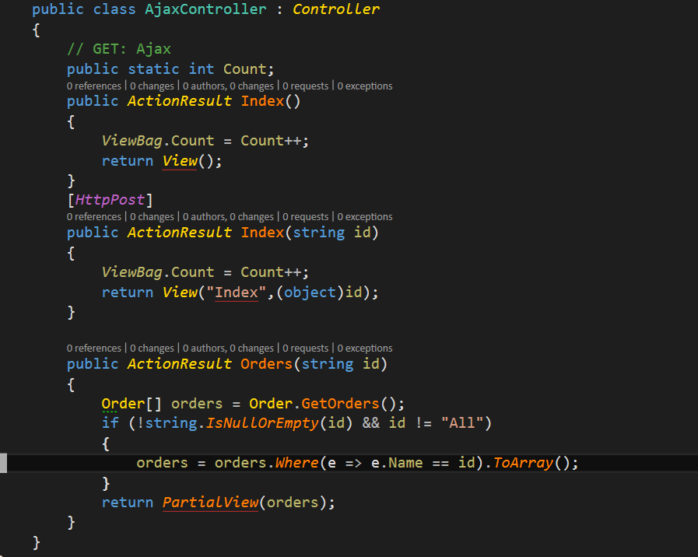

### Call method On

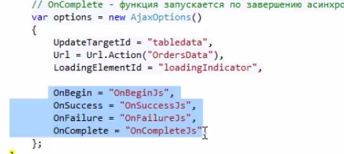

### Security

#### Requsts

Для безопасности можно шифровать данные или подписывать.

#### XSS

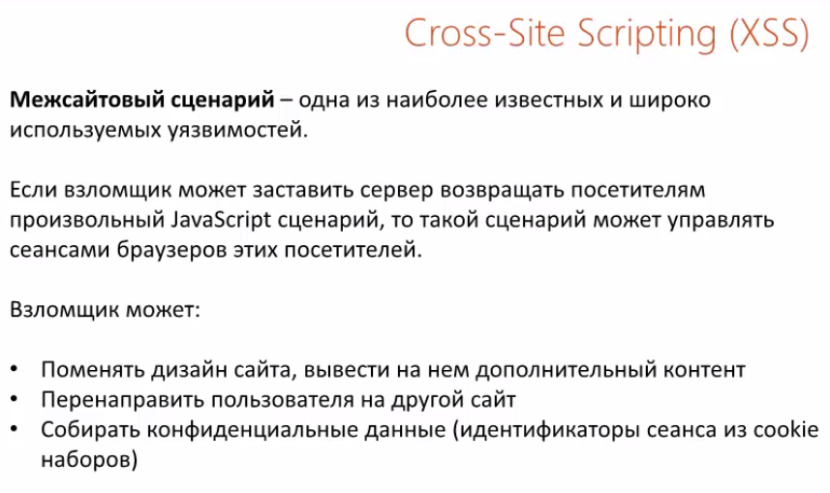

Microsoft Web protection library – for protection from XSS

AntiXSS – also you can use that for protextion from XSS.

#### SQL injections

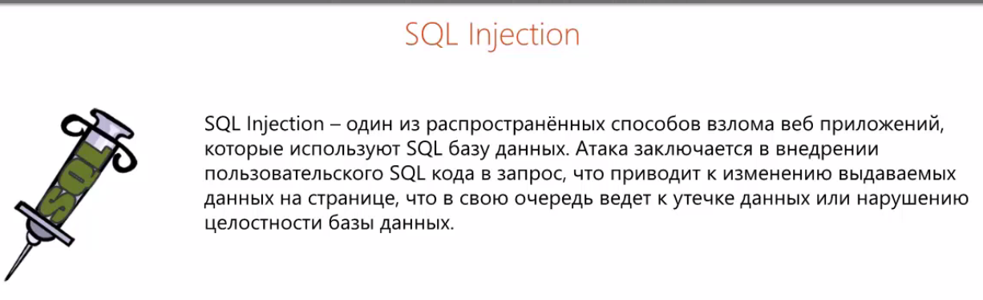

#### CSRF

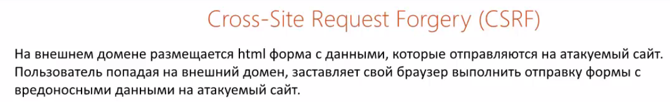

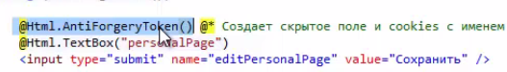

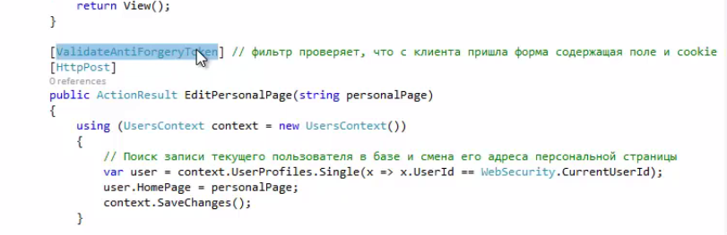



#### Recommendations

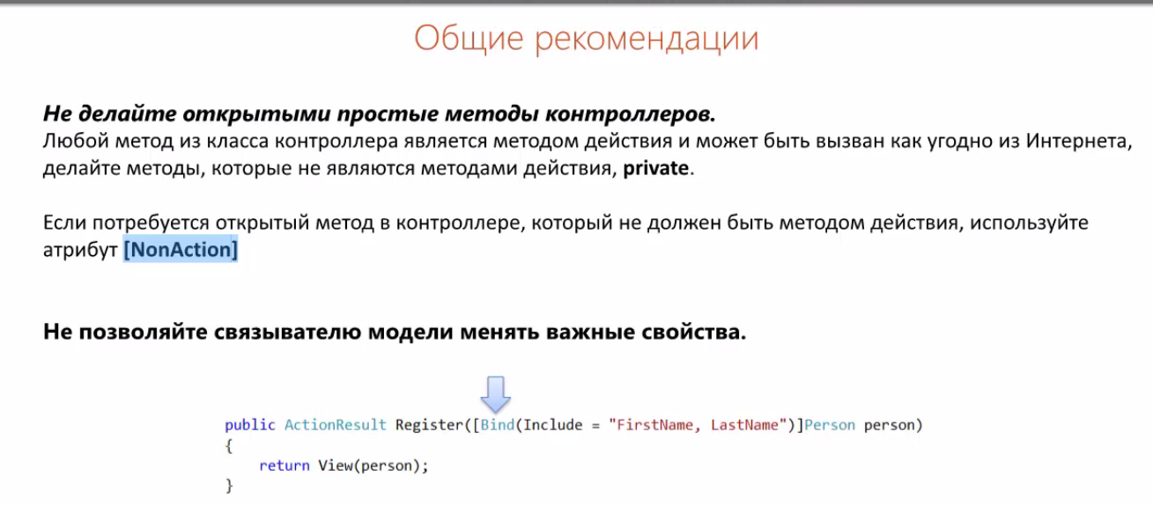

## Asp .NET Core

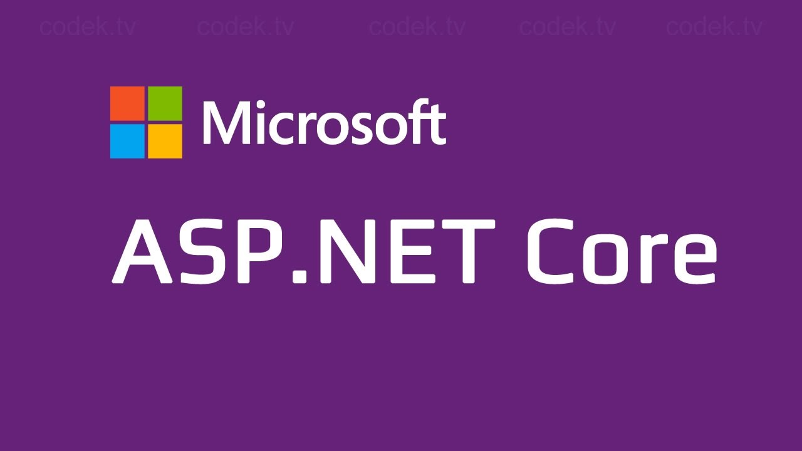

### Localization